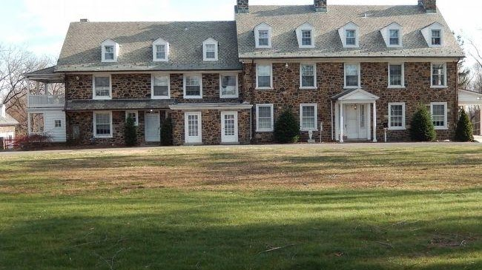

Grubb-Worth Mansion

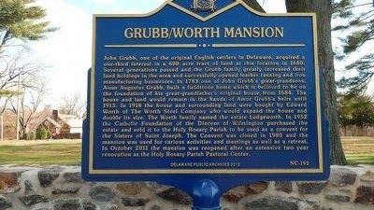

Grubb Historical Marker
John Grubb, one of the original English settlers in Delaware, acquired a one-third interest in a 600 acre tract of land at this location in 1680. Several generations passed and the Grubb family greatly increased their land holdings in the area and successfully opened leather tanning and iron manufacturing businesses. In 1783 one of John Grubb’s great-grandsons, Amor Augustus Grubb, built a fieldstone home which is believed to be on the foundation of his great-grandfather’s original house from 1684. The house and land would remain in the hands of Amor Grubb’s heirs until 1913. In 1918 the house and surrounding land were bought by Edward Worth of The Worth Steel Company who would expand the house and double its size. The Worth family named the estate Ledgeworth. In 1952 the Catholic Foundation of the Diocese of Wilmington purchased the estate and sold it to the Holy Rosary Parish to be used as a convent for the Sisters of Saint Joseph. The Convent was closed in 1980 and the mansion was used for various activities and meetings as well as a retreat.

