Ecumenical

This National Council of Churches members include Evangelical Lutheran Church in America, American Baptist Churches USA, Moravian Church in America, Polish National Catholic Church, Presbyterian Church USA, Friends United Meeting, Philadelphia Yearly Meeting, United Church of Christ, Reformed Church in America, United Methodist Church and the Episcopal Church USA

Westminster Savoy Philadelphia Confessions of Faith

In England in 1646 the Presbyterians wrote the Westminster Confession of Faith. In 1658 the Congregationalists took the Westminster Confession of Faith and added "Congregational governance" and called it the Savoy Declaration of Faith. In 1689 the Baptist took the Savoy Declaration of Faith and added "Believers Baptism" and called it the London Baptist Confession of Faith. In Pennsylvania, in 1742 the Baptist took the London Baptist Confession of Faith and added 2 more ordinances: "Signing" and the "Laying on of Hands" and called it the Philadelphia Confession of Faith.

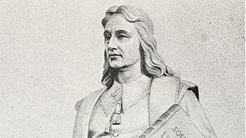

Roger William
Roger Williams (c. 1603 – March 1683) was an English-born New England Puritan minister, theologian, and author who founded Providence Plantations, which became the Colony of Rhode Island and Providence Plantations and later the State of Rhode Island and Providence Plantations. He was a staunch advocate for religious freedom, separation of church and state, and fair dealings with the Native Americans

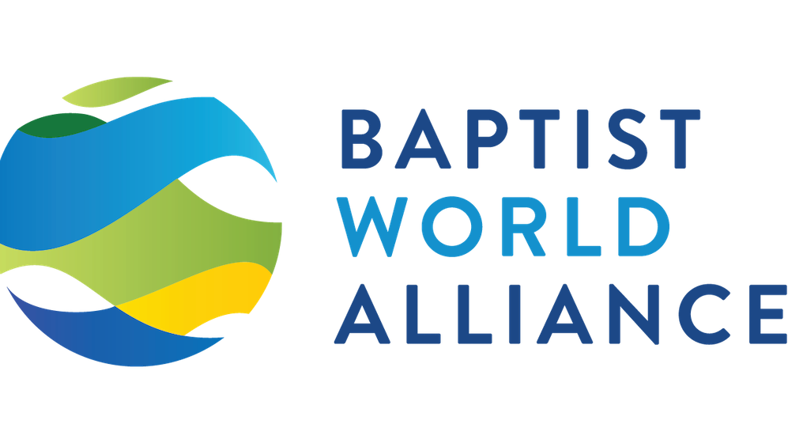

Baptist World Alliance

Modern Baptist churches trace their history to the English Separatist movement in the 17th century, over a century after the foundation of the Church of England during the Protestant Reformation. This view of Baptist origins has the most historical support and is the most widely accepted. Adherents to this position consider the influence of Anabaptists upon early Baptists to be minimal. It was a time of considerable political and religious turmoil. Both individuals and churches were willing to give up their theological roots if they became convinced that a more biblical "truth" had been discovered. During the Reformation, the Church of England (Anglicans) separated from the Roman Catholic Church. There were some Christians who were not content with the achievements of the mainstream Protestant Reformation. There also were Christians who were disappointed that the Church of England had not made corrections of what some considered to be errors and abuses. Of those most critical of the church's direction, some chose to stay and try to make constructive changes from within the Anglican Church. They became known as "Puritans" and are described by Gourley as cousins of the English Separatists. Others decided they must leave the church because of their dissatisfaction and became known as the Separatists. In 1579, Faustus Socinus founded the Unitarians in Poland, which was a tolerant country. The Unitarians taught baptism by immersion. When Poland ceased to be tolerant, they fled to Holland. In Holland, the Unitarians introduced immersion baptism to the Dutch Mennonites.

Baptist Catechism

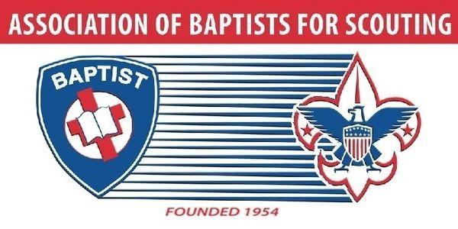

Baptist Scouts
The Association of Baptists for Scouting was founded in 1954 on the principles of the common goals of scouting and the moral teachings of faith-based (Baptist) churches
membership@baptistscouters.org

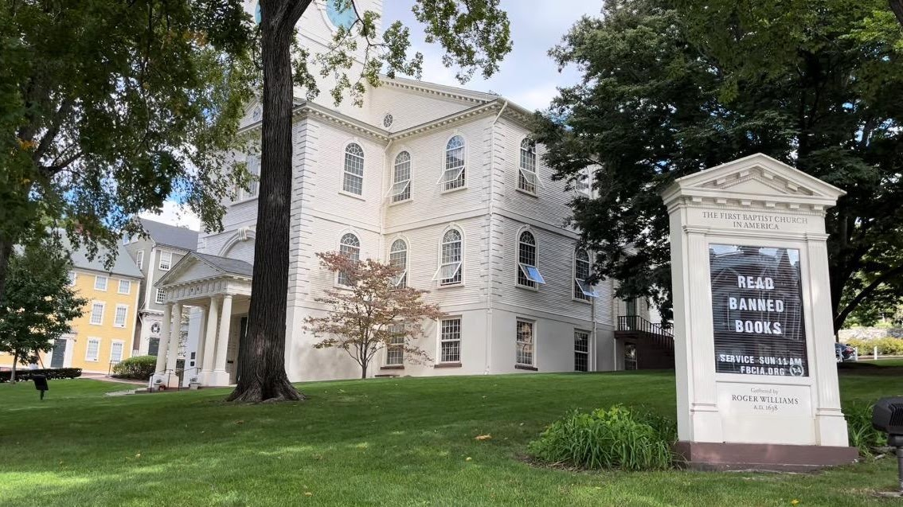

First Baptist Church
The First Baptist Church in America is the First Baptist Church of Providence, Rhode Island, also known as the First Baptist Meetinghouse. It is the oldest Baptist church congregation in the United States, founded in 1638 by Roger Williams in Providence, Rhode Island. The present church building was erected between 1774 and 75 and held its first meetings in May 1775. It is located at 75 North Main Street in Providence's College Hill neighborhood. It was designated a National Historic Landmark in 1960. It is affiliated with the American Baptist Churches USA.

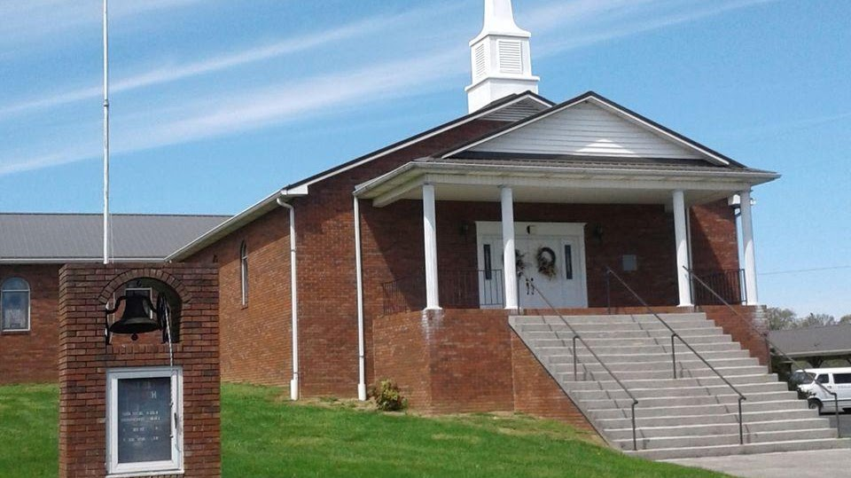

Whitesburg Baptist Church
- 201 Graves Ln, Whitesburg, TN, United States, Tennessee
- (423) 586-5534
- wilsonbrian565@yahoo.com

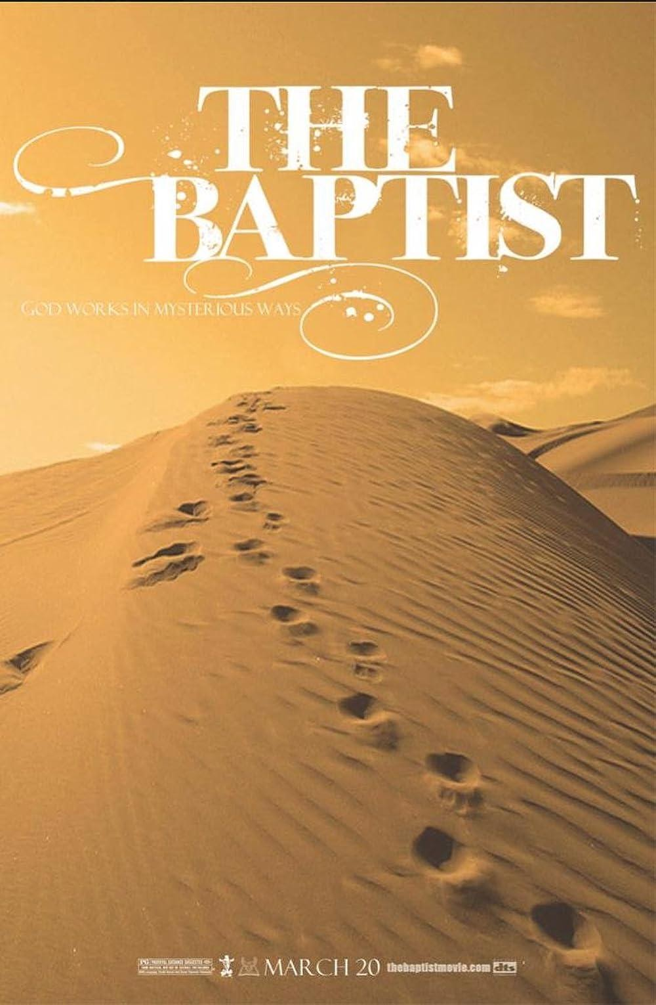

St. John the Baptist
1st century BC – c. AD 30) was a Judaean preacher active in the area of the Jordan River in the early 1st century AD. He is also known as John the Forerunner in Eastern Orthodoxy, John the Immerser in some Baptist Christian traditions, and Prophet Yahya in Islam. He is sometimes alternatively referred to as John the Baptiser.

