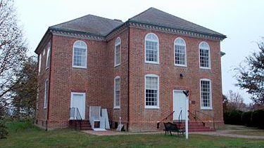

St. Pauls Parish

Gather under our large festhaus tent to eat, drink, and enjoy activities, including live music performed by a German oompah band. Shop at our Christkindlmarkt featuring local crafts and artisans. Children’s activities and more for all ages. Prost!
St. Paul’s Episcopal Church
5486 St. Pauls Road King George, VA 22485
(540) 663-3085

