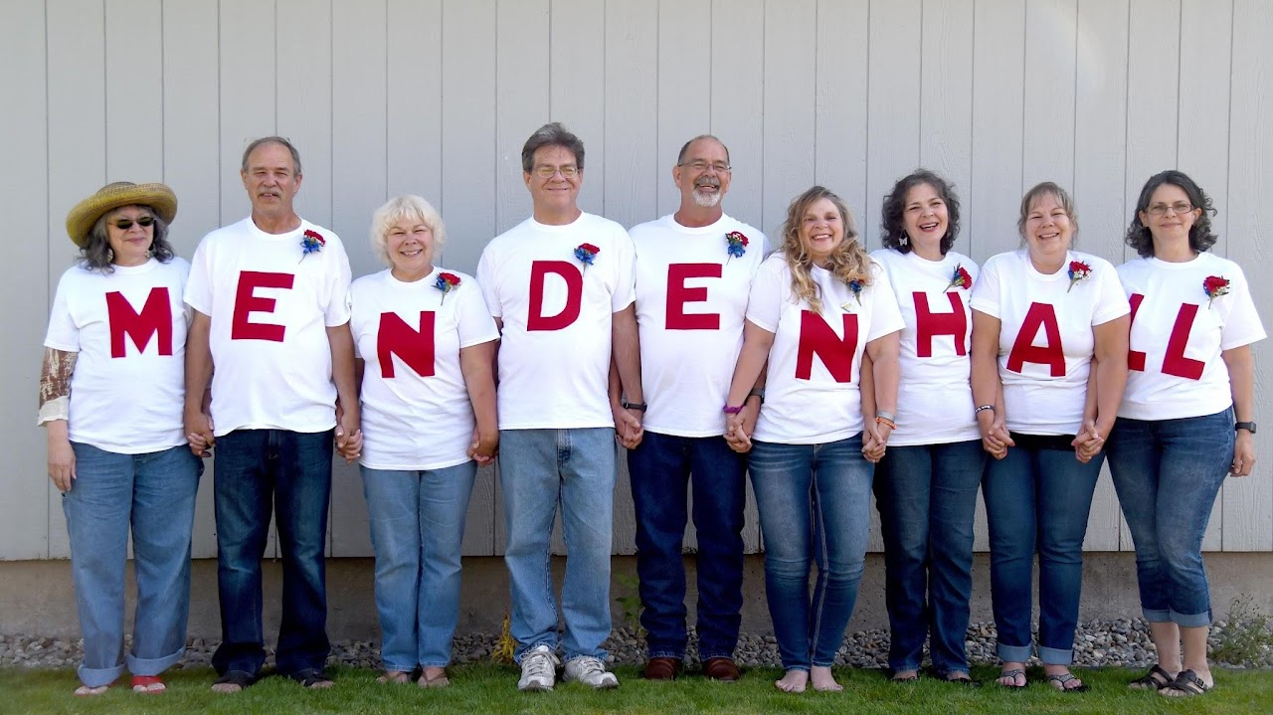

Mendenhall Family Association

This is a forum for sharing genealogy information among the membership of the Mendenhall Family Association (MFA).
- See us on Facebook too, at: MFA on Facebook

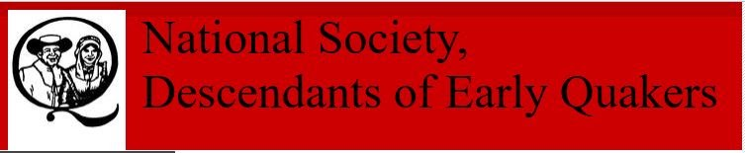

John Mendenhall Sr.
Mendenhall, Sr., John PA



Alveron Mendenhall
Mendenhall, Alveron P. NC/IN



Benjamin Mendenhall
Mendenhall, Benjamin PA



John Mendenhall
Mendenhall, John PA/VA



John Mendenhall Sr.
Mendenhall, Sr. John NC



Mordecai Mendenhall Sr.
Mendenhall, Benjamin PA



Robert Mendenhall Sr.
Mendenhall, Robert PA



Thomas Mendenhall Sr.
Mendenhall, Thomas PA

