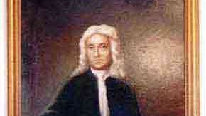

Major Edward Dale
(1628-1695)
National Society of The Colonial Dames of America

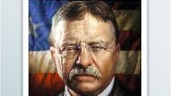

Theodore Roosevelt
26th U.S. President
7th great-grandson

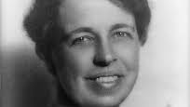

Eleanor Roosevelt
First Lady of President Franklin D. Roosevelt
8th great-granddaughter

