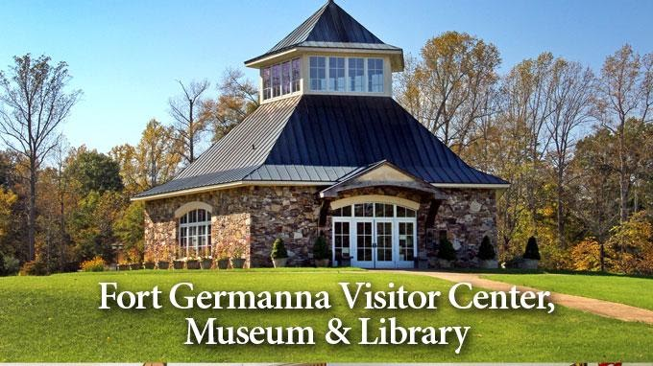

Germanna Visitor Center
Historic Germanna
2062 Germanna Highway Locust Grove, VA 22508-0279
Phone: 540-423-1700
Contact

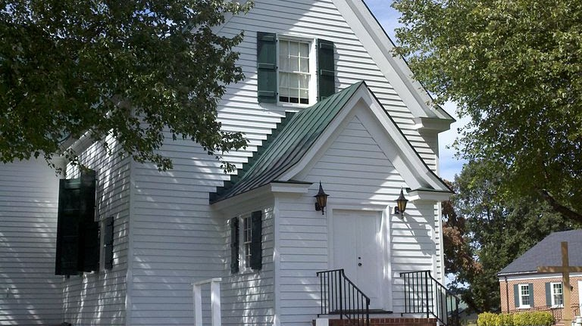

Hebron Lutheran Church
Hebron Lutheran Church is a historic Lutheran church located in the countryside northeast of Madison, Madison County, Virginia. The original section was built about 1740, with the south wing added about 1800. It is a one-story, "T" shaped, frame building on a stone foundation. Wikipedia
Address: 899 Blankenbaker Rd, Madison, VA 22727
Phone: (540) 948-4381

