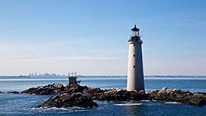
Boston Harbor Islands
34 islands form a partnership that protect vital natural resources and preserve a cultural history that spans millennia
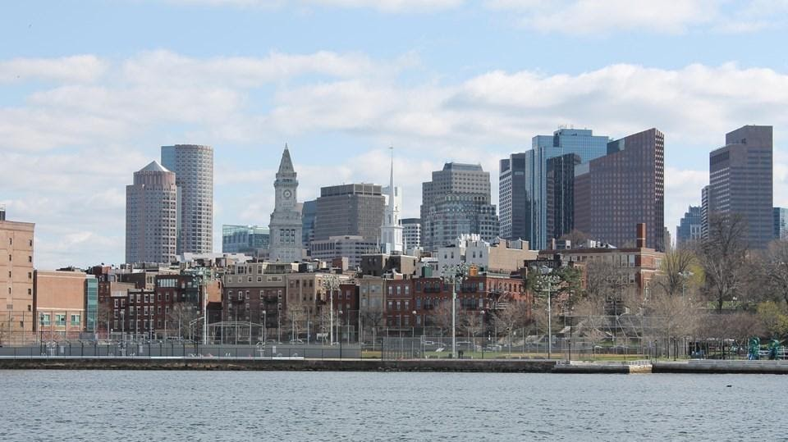
Boston National Historical Park
This 43 acre historical park encompasses portions of Downtown Boston, Charlestown, and South Boston. In addition to managing its properties that are a part of the park, the Park operates two visitor centers at Faneuil Hall and in the Charlestown Navy Yard. The park also works and cooperates with many different partner organizations which comprise the Freedom Trail. There are many different ways to explore Boston's past. At our visitor centers you can collect free maps and information about Boston and the Park. Here you can also participate in any scheduled free Ranger-Guided Talks and Tours.

Bunker Hill
The Bunker Hill Monument, Lodge, and Museum are National Park Service sites.
Learn about the history of the site at the Bunker Hill Museum. Here, park staff are available to answer questions and there are restrooms open to the public. Additionally, explore views from the top of the monument through 360 degree Live Webcams. For more information to help you prepare for your visit to the park, see Know Before You Go.

Junior Ranger
Explore Spectacle Island through the activities in this book.
Explore Georges Island through the activities in this book.
Explore Peddocks Island through the activities in this book.
Explore Lovells, Grape, and/or Bumpkin Island through the activities in this book.

