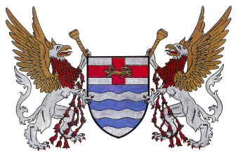

Hereditary Order of the First Families of Massachusetts

Men and women over the age of 18 years, who are lineal descendants of men or women who settled within the bounds of the Massachusetts Bay Colony before the year 1650 may be eligible for membership. For purposes of this Order, the term “settler” refers to one who lived in the Colony for at least one year, although possibly in more than one town during that time.

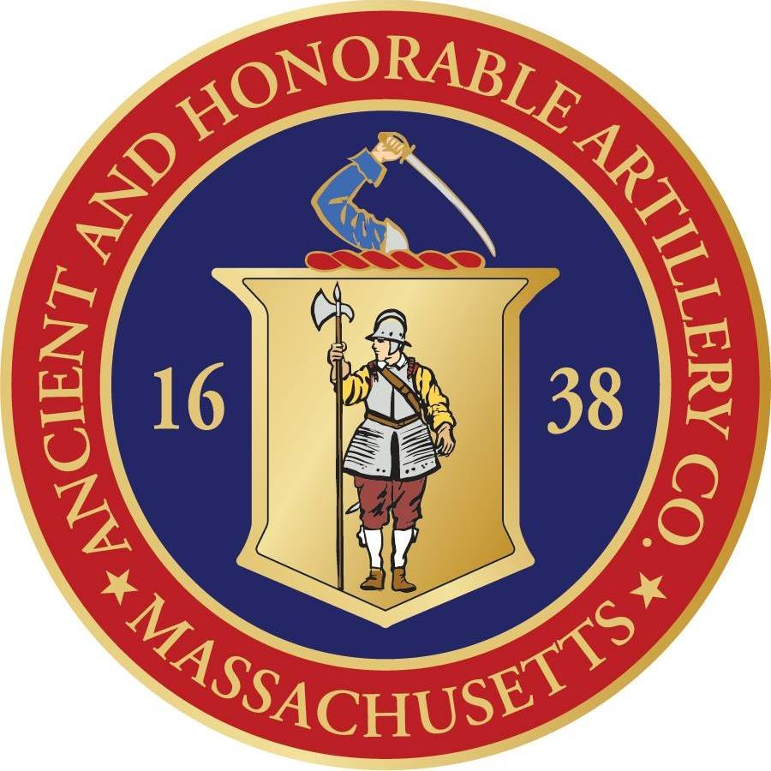

Ancient and Honorable Artillery Company of Massachusetts

Those individuals eligible for membership shall be at least eighteen years of age with legitimate descent from (1) a member of The Ancient and Honorable Artillery Company of Massachusetts who served between the years 1637-1774; (2) a minister who preached the Election Sermon during the years 1638-1774; (3) Governor John Winthrop, (4) Deputy Governor Thomas Dudley, (5) a member of the Council or a delegate to the General Court in 1638 when the Company Charter was granted, (6) members of the Ancient and Honorable Artillery Company of Massachusetts “by right of descent,” or (7) members of the National Society of Women Descendants of The Ancient and Honorable Artillery Company.

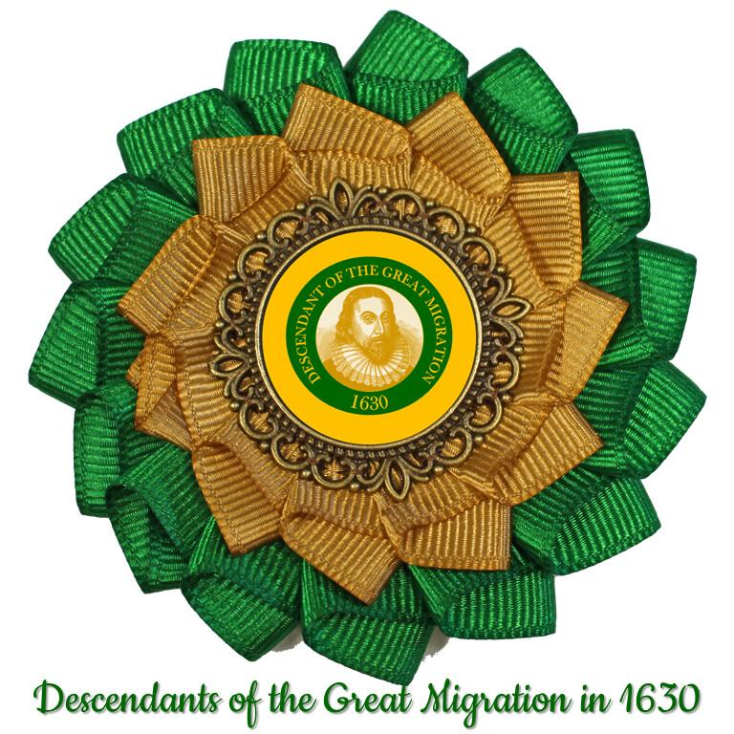

The Winthrop Society

The Winthrop Society currently consists of proven descendants of the first settlers of the Massachusetts Bay Colony. It is open to all men and women of good character and proven descent from one or more passengers of the Winthrop fleet, or of others who settled in the Bay Colony and Down East* by the end of 1640.

