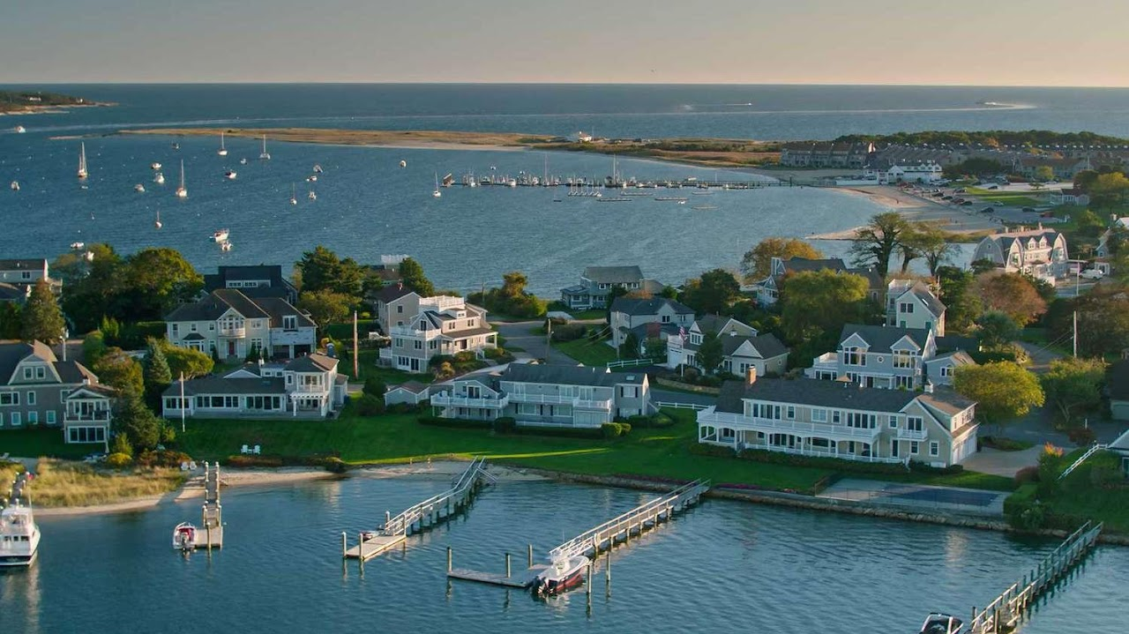

Cape Cod National Seashore

Cape Cod National Seashore has an abundance of natural and cultural resource spread throughout its 44,000 acres.
600 US-6, Provincetown, MA 02657

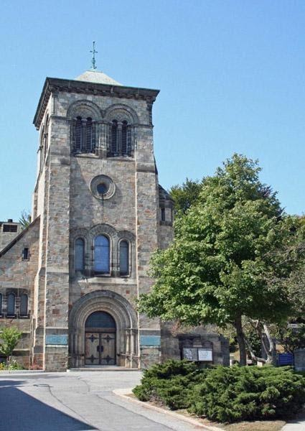

First Parish Plymouth

First Parish Church in Plymouth is a historic Unitarian church at the base of Burial Hill on the town square off Leyden Street in Plymouth, Massachusetts. The congregation was founded in 1620 by the Pilgrims in Plymouth. The current building was constructed in 1899.
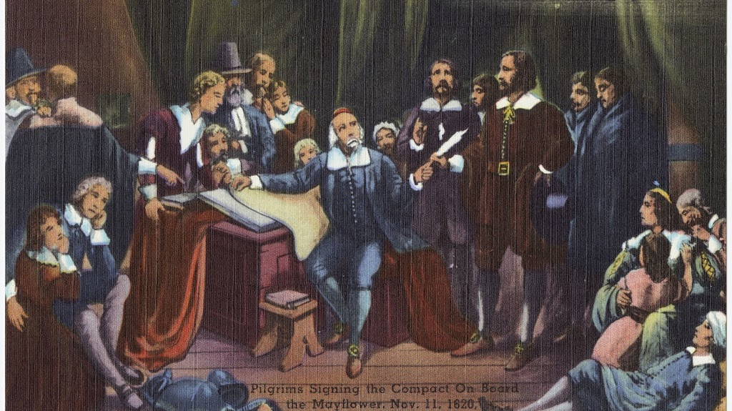

Mayflower Pilgrims

The Pilgrims, also known as the Pilgrim Fathers, were the English settlers who traveled to America on the Mayflower and established the Plymouth Colony in Plymouth, Massachusetts (John Smith had named this territory New Plymouth in 1616, coincidentally sharing the name of the Pilgrims' final departure port of Plymouth, Devon.). The Pilgrims' leadership came from the religious congregations of Brownists, or Separatist Puritans, who had fled religious persecution in England for the tolerance of 17th-century Holland in the Netherlands.

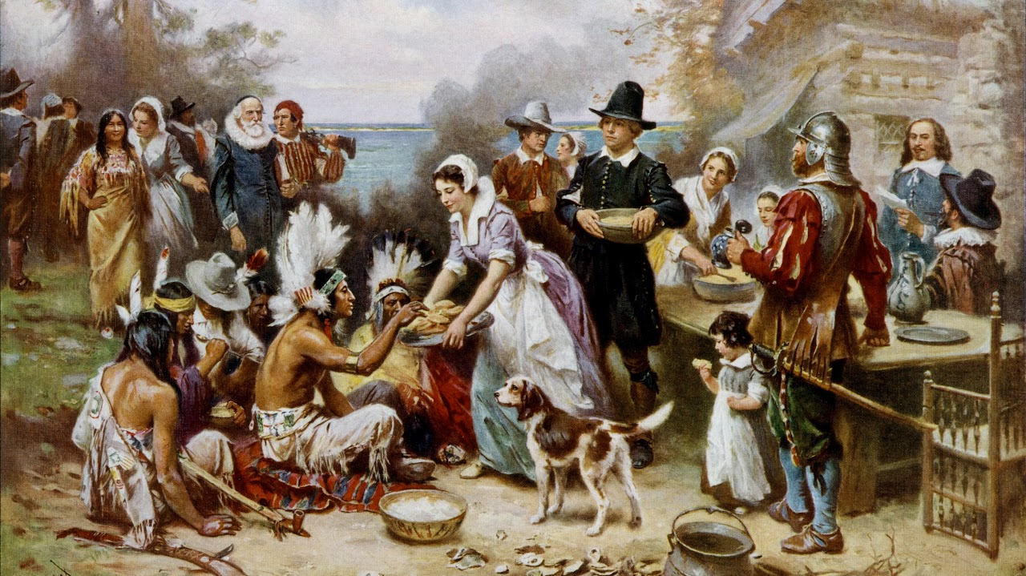

Thanksgiving

Thanksgiving is a federal holiday in the United States celebrated on the fourth Thursday of November. It is sometimes called American Thanksgiving (outside the United States) to distinguish it from the Canadian holiday of the same name and related celebrations in other regions. It originated as a day of thanksgiving and harvest festival, with the theme of the holiday revolving around giving thanks and the centerpiece of Thanksgiving celebrations remaining a Thanksgiving dinner. The dinner traditionally consists of foods and dishes indigenous to the Americas, namely turkey, potatoes (usually mashed or sweet), stuffing, squash, corn (maize), green beans, cranberries (typically in sauce form), and pumpkin pie. Other Thanksgiving customs include charitable organizations offering Thanksgiving dinner for the poor, attending religious services, and watching television events such as Macy's Thanksgiving Day Parade and NFL football games.



General Society of Mayflower Descendants

The General Society of Mayflower Descendants is committed to research on the lineal descent of the Mayflower Pilgrims and education about the Pilgrims who traveled aboard the Mayflower in 1620. The Society provides education and understanding of why the Mayflower Pilgrims were important, how they shaped western civilization, and what their 1620 voyage means today and its impact on the world.

