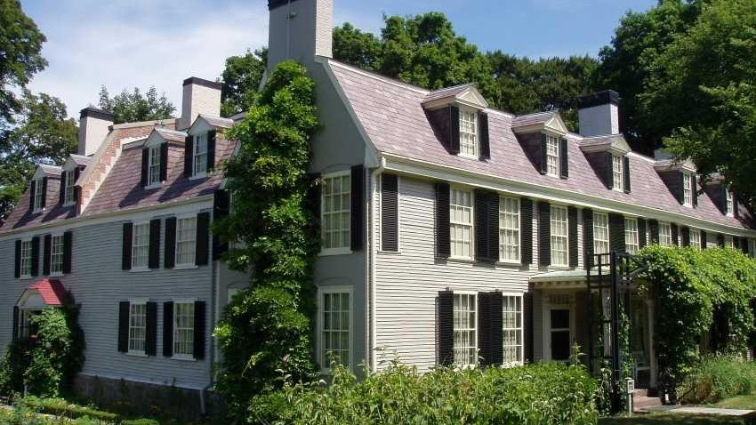

Adams National Historic Park

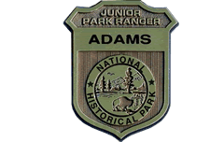

Adams Junior Ranger
Junior Ranger Booklet for Ages 6 to 8
Junior Ranger Booklet for Ages 9 and Up
If you'd like to complete the Junior Ranger booklet remotely, be sure to check out our virtual tour.

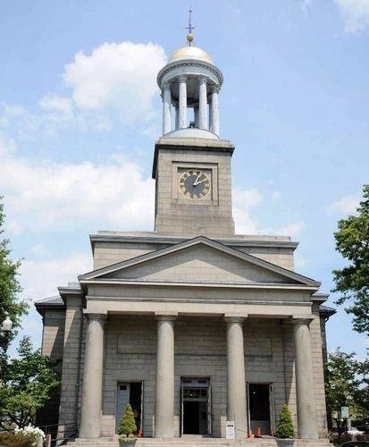

United First Parish Church

Honoring the Adams Presidents as a part of a national wreath-laying tradition. Twice each year the President of the United States sends a wreath to the United First Parish Church to be placed on the tomb of the Adams Presidents. This national tradition started during the administration of President Lyndon Johnson in 1967. Each year, wreaths of red, white and blue flowers are sent to the burial places of all deceased presidents on the anniversary of their birthday. The United First Parish Church, Church of the Presidents is the proud keeper of this important annual recognition of our Presidential heritage. Admission to the wreath-laying ceremony, the Adams Crypt and Church Sanctuary are free. Donations to support the History and Visitors Program are greatly appreciated. United First Parish Church is located at 1306 Hancock Street, Quincy, MA 02169.

For more information about the ceremonies, please email office@ufpc.org or call 617-773-1290.

