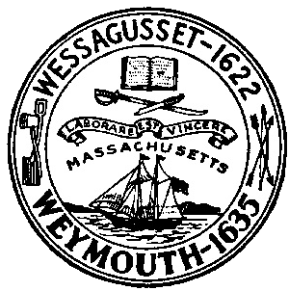

Weymouth
Weymouth is the second oldest town in Massachusetts. It was first inhabited by natives from the Massachusetts tribe before being settled by English colonists and then abandoned in the early 1620s. It was eventually absorbed into the Massachusetts Bay Colony.
1674: The Matthew Pratt II House is built on Green Street.
1676: On April 19, Weymouth is attacked again during King Philip’s War when natives burn down seven houses in Weymouth and kill Sergeant Thomas Pratt while en route to attack Plymouth.

