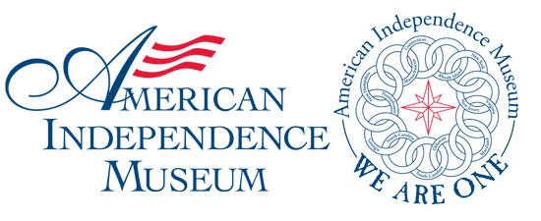

American Independence Museum

Founded in 1991 in historic Exeter, NH, the American Independence Museum develops programs, exhibits, tours, and events that advance a more inclusive understanding of the fight for Independence

