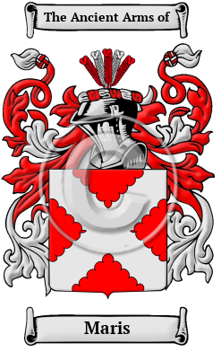

Maris

The surname Maris was first found in Kent where the surname is descended from the tenant of the lands of Maris, Richard of Maris held estates and who was recorded in the Domesday Book census of 1086. Family name include: Marris, Marriss, Maris, Mariss, Mares, Marais and many more.
In the United States, the name Maris is the 9,531st most popular surname with an estimated 2,487 people with that name

