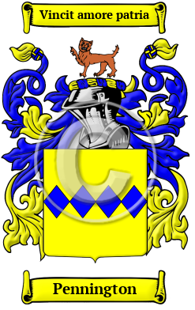
Pennington
The Anglo-Saxon name Pennington comes from the family having resided in Lancashire at Pennington. Interestingly, two sources claim the name literally means "farmstead paying a penny rent." Spelling variants included: Pennington, Penington and others.
In the United States, the name Pennington is the 732nd most popular surname with an estimated 39,792 people with that name.

