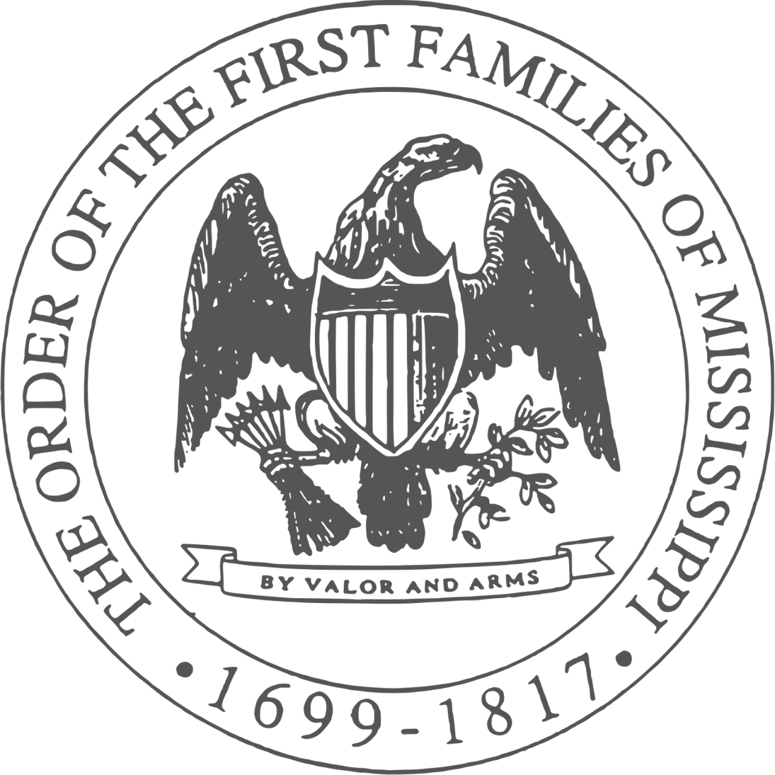

Order of the First Families of Mississippi

OFFM is committed to genealogical documentation, historical education, and recognition of the achievements of our state, not only from the colonial period of 1699 through 1817

