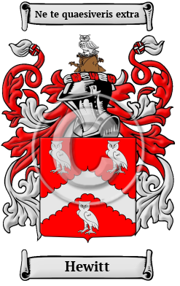

Hewitt

Hewitt is a name that was brought to England by the ancestors of the Hewitt family when they migrated to the region after the Norman Conquest in 1066. The Hewitt family lived in Huet or Huest near Evreux in Normandy, France. Many variations of the name Hewitt have been found, including Hewitt, Hewett, Hewatt, Hewet, Hewit, Hewat and others.
In the United States, the name Hewitt is the 973rd most popular surname with an estimated 29,844 people with that name

