Freemasonry or Masonry refers to fraternal organisations that trace their origins to the local guilds of stonemasons that, from the end of the 14th century, regulated the qualifications of stonemasons and their interaction with authorities and clients. Many Freemasons trace the roots of the craft further back in history, accepting the Knights Templar as the conduit between the ancient mysteries and the beginnings of operative and speculative Freemasonry. Modern Freemasonry broadly consists of two main recognition groups: Regular Freemasonry, which insists that a volume of scripture be open in a working lodge, that every member professes belief in a Supreme Being, that no women be admitted, and that the discussion of religion and politics do not take place within the lodge
Freemason Bible

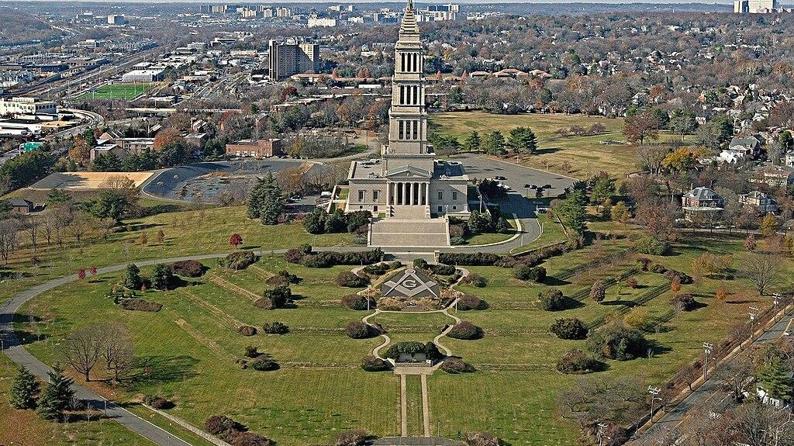

George Washington Masonic National Memorial

The George Washington Masonic National Memorial is a Masonic building and memorial located in Alexandria, Virginia, outside Washington, D.C. It is dedicated to the memory of George Washington, the first president of the United States and a Mason. The tower is fashioned after the ancient Lighthouse of Ostia in Ostia Antica (or Rome). The 333-foot (101 m) tall memorial sits atop Shooter's Hill (also known as Shuter's Hill) at 101 Callahan Drive. Construction began in 1922, the building was dedicated in 1932, and the interior finally completed in 1970. In July 2015, it was designated a National Historic Landmark for its architecture, and as one of the largest-scale private memorials to honor Washington

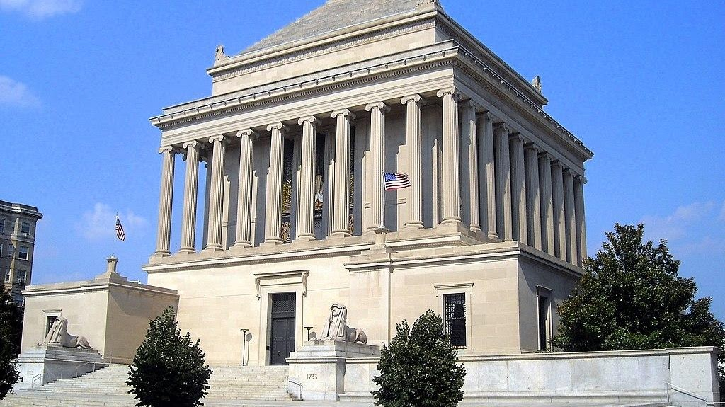

House of the Temple

The House of the Temple (officially, Home of The Supreme Council, 33°, Ancient & Accepted Scottish Rite of Freemasonry, Southern Jurisdiction, Washington D.C., U.S.A.) is a Masonic temple in Washington, D.C., United States, that serves as the headquarters of the Scottish Rite of Freemasonry, Southern Jurisdiction, U.S.A.

