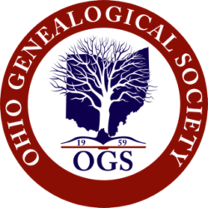

Military Order of the Daughters and Sons of Ohio

Any member of OGS who can prove satisfactory lineal descent from a resident of the State of Ohio who served in the armed forces of the United States or the British colonial forces of the original thirteen colonies prior to the American Revolutionary War, according to the Society’s rules and guidelines, is eligible to become a member of the Military Order of the Daughters and Sons of Ohio (MODSO).

