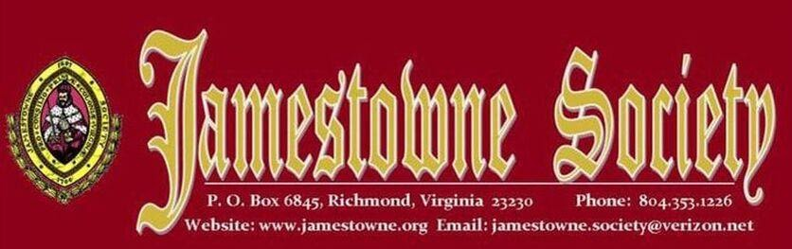

Jamestowne Society

10 April 1606 stock was sold in London Company or the Virginia Company
Resident in Virginia at the time of the 1624/25 Muster or earlier
Governor, Secretary of State, Treasurer, Attorney General, Clerk of the General Court, Member of the Council or House of Burgesses; Anglican Church (Church of England) minister in Virginia; served as an official Indian Interpreter in Virginia or owned land on Jamestown Island or lived on the Island on or before 1699

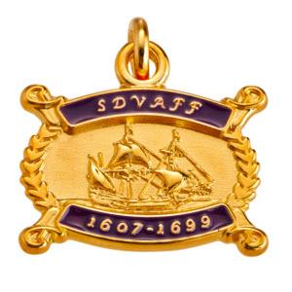

Sons and Daughters of Virginia Founding Fathers

The Sons and Daughters of Virginia Founding Fathers (SDVAFF) is a lineage society that is a non-profit, charitable organization dedicated: To honor those hardy and enterprising early ancestors who concentrated their efforts, labor and skills in building the enduring greatness of the Colony of Virginia. To recognize and record the names of those individuals who were residents within the boundaries of the Virginia Colony on or before 31 December 1699.



Virginia Huguenot Society
The Edict of Nantes, signed by Henry IV in April, 1598, ended the Wars of Religion, and allowed the Huguenots some religious freedoms, including exercise of their religion in 20 specified towns in France. The Revocation of the Edict of Nantes by Louis XIV in October, 1685, began a new persecution of the Huguenots. Hundreds of thousands of them fled France for other countries.

Resources
Societies
Wikitree
FamilySearch
Wikipedia

