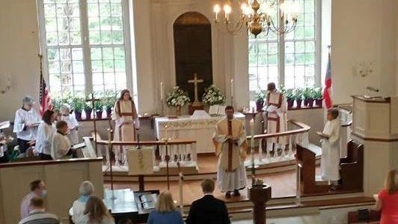
Ware Episcopal Church
Address: 7825 John Clayton Memorial Hwy, Gloucester, VA 23061
Phone: (804) 693-3821
Opened: 1690
NRHP Reference Number: 73002018

Hugh Gwynn
Gwin/Gwinne/Gwyn, Hugh - A3303; Charles River: 1640, York Co.: 1646, Gloucester Co.: 1652 (Burgess).

