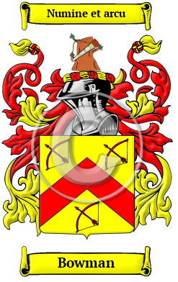
Bowman
The name Bowman is another word for the occupational "archer." Or in other words, "a fighting man armed with a bow; one who made bows." This family name include: Bowman, Boeman, Boyman, Boman and others.
In the United States, the name Bowman is the 248th most popular surname with an estimated 106,941 people with that name.

