Research
JCHS: Preserving Jefferson County's History Since 1927 (jeffersonhistoricalwv.org)
Jefferson County, West Virginia Genealogy • FamilySearch
Jefferson County, West Virginia - Wikipedia
Map
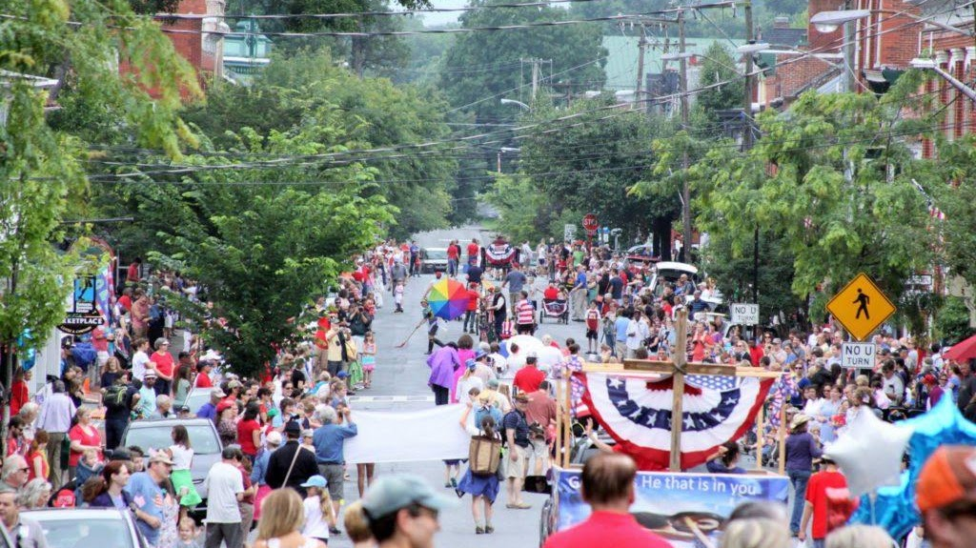

Shepherdstown
Shepherdstown is a town in Jefferson County, West Virginia, United States, located in the lower Shenandoah Valley along the Potomac River. Home to Shepherd University, the town's population was 1,531 at the time of the 2020 census. The town was established in 1762 along with Romney; they are the oldest towns in West Virginia.

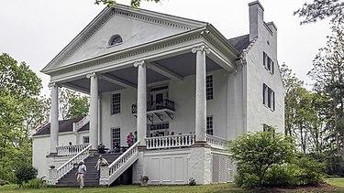
Morgan's Spring
Falling Spring was completed by 1837 as a large, house and farm complex. The property was first settled by Richard Morgan, who noted several springs on the property, including "Bubbling Spring" and "Morgan's Spring", the starting point of the 1775 Bee-Line March. The house was built by Jacob Morgan, Richard's grandson

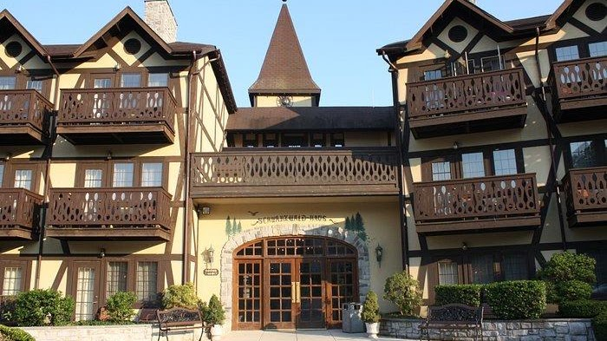

Bavarian Inn
For over 45 years, the Asam family has been hosting friends and neighbors for relaxing getaways, gourmet meals, special occasions, and the finest in guest comforts. Perched on a spectacular bluff overlooking the Potomac River, our 11-acre European Inspired Boutique Resort offers comfort, elegance, and world-class food and service. The Bavarian Inn has proudly won many awards, including the AAA Four Diamond and Wine Spectator's Best of Award of Excellence . We invite you to experience our hospitality and enjoy this place we live and love.
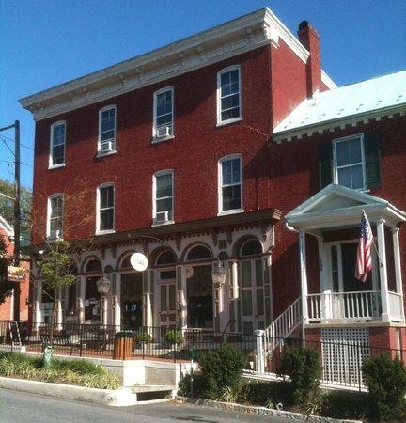

Shepherdstown Museum
surname research
The Museum is open! Hours through October will be Saturdays 11 – 5 and Sunday 1-4.
Special tours are possible if a volunteer docent is available. Call 304-876-0910 on Tuesday, Wednesday or Friday to inquire.
Suggested donation: $5.00 per person. FREE admission to Historic Shepherdstown members, children, students and military.
129 E. German Street
(corner of German and Princess Streets)
Shepherdstown, WV
Google Maps

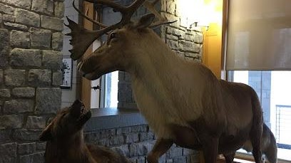
National Conservation Training Center
698 Conservation Way, Shepherdstown, WV 25443
+13048761600
Near Terrapin Neck
Families
Tingle
York

