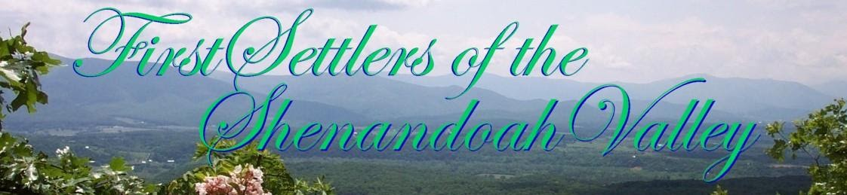

First Settlers of Shenandoah Valley
The qualifying FIRST SETTLER ancestor needed for FSSV membership is a person who resided in an area that is located in present-day Shenandoah Valley before 31 December 1799.

First Governor was Arthur Boreman. West Virginia Day is 20 June

