List of Historical Churches
Huguenot Memorial Chapel and Monument



John Calvin
10 July 1509 – 27 May 1564) was a French theologian, pastor and reformer in Geneva during the Protestant Reformation. He was a principal figure in the development of the system of Christian theology later called Calvinism, including its doctrines of predestination and of God's absolute sovereignty in the salvation of the human soul from death and eternal damnation. Calvinist doctrines were influenced by and elaborated upon the Augustinian and other Christian traditions. Various Congregational, Reformed and Presbyterian churches, which look to Calvin as the chief expositor of their beliefs, have spread throughout the world.



Huguenot Memorial Bridge

The Huguenot Memorial Bridge was named in honor of the French Huguenot settlers who came to the area in the 18th century to escape religious persecution in France. It is owned by the Virginia Department of Transportation (VDOT) and is the westernmost bridge over the James River in the metropolitan Richmond area that is open to pedestrians.

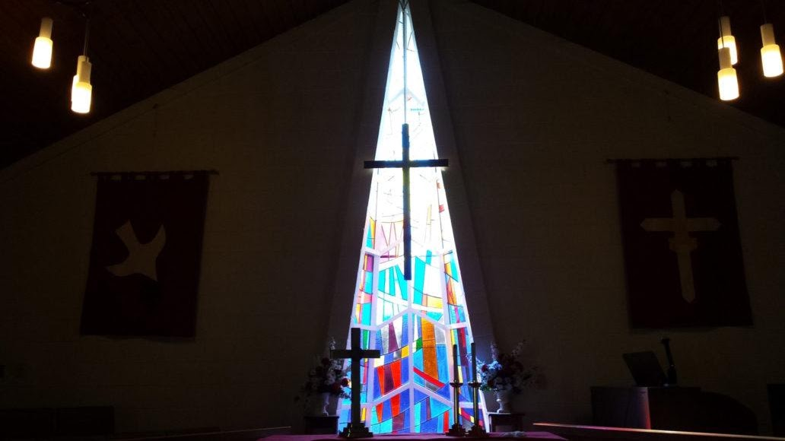

Huguenot UMC
10661 Duryea Dr Richmond, VA 23235-2106
Phone: 804-272-6820 Fax: 804 272-2517
​Email: huguenotumc@gmail.com

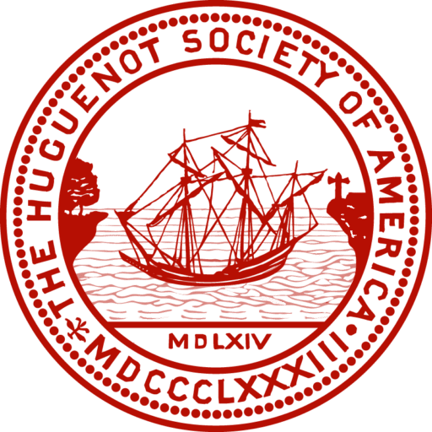

Huguenot Society of America
Applicants must be above the age of eighteen and a lineal descendant in the male or female line of a Huguenot who emigrated from France, and that such Huguenot émigré or one of his or her descendants in the same line either settled in what is now the United States of America or left France for countries other than America prior to the promulgation of the Edict of Toleration on November 28, 1787.



National Huguenot Society
The objectives of The National Huguenot Society are patriotic, religious, historical, and educational. Their design is to perpetuate the memory, the spirit, and the deeds of the men and women in France known as Huguenots who were persecuted in the 16th and 17th centuries because of their adherence to the basic tenets of the Protestant faith and their devotion to liberty, and who emigrated either directly or through other countries to North America and contributed by their character and ability to the development of the United States.

French Confession of Faith

Huguenot Memorial Chapel

