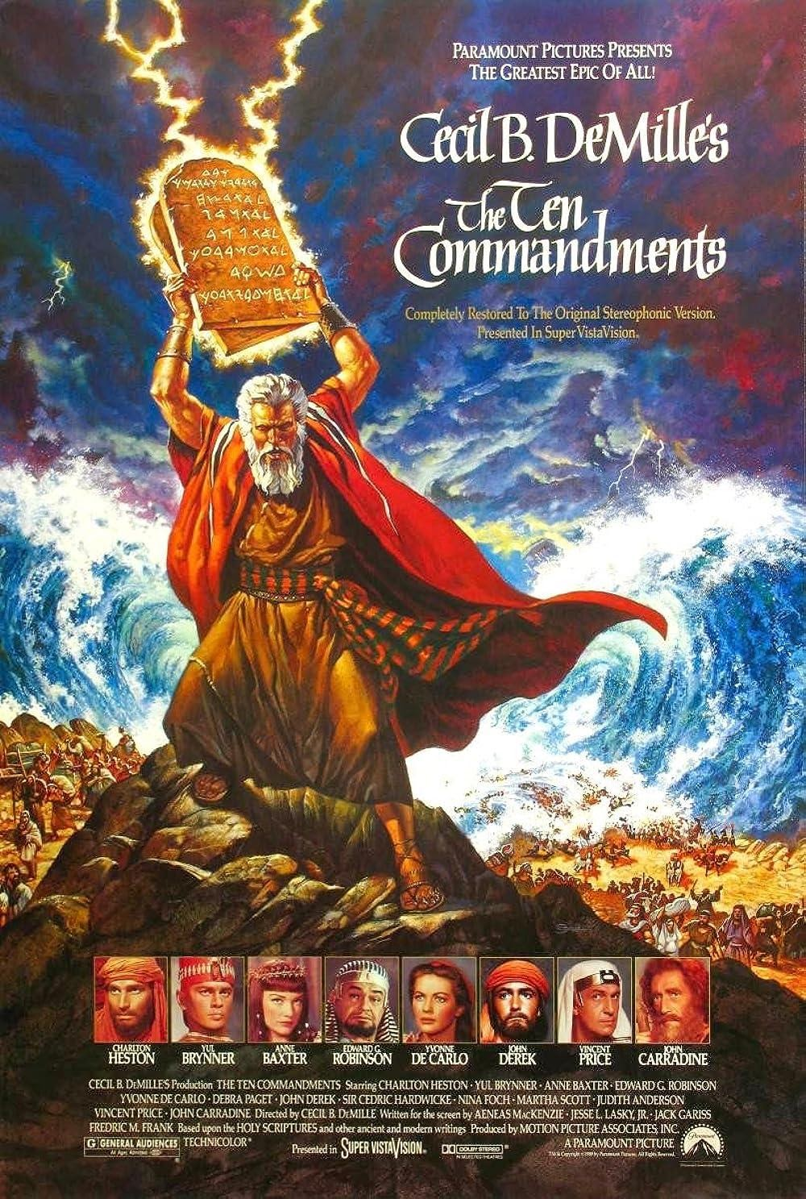
Moses

Moses is considered the most important prophet in Judaism and one of the most important prophets in Christianity, Islam, the Druze faith, the Baháʼí Faith, and other Abrahamic religions. According to both the Bible and the Quran, Moses was the leader of the Israelites and lawgiver to whom the authorship, or "acquisition from heaven", of the Torah (the first five books of the Bible) is attributed.

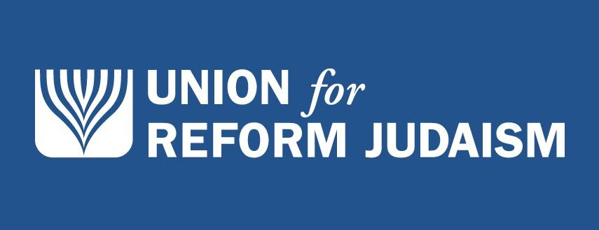

Reformed Judaism

Various regional branches exist, including the Union for Reform Judaism (URJ) in the United States, the Movement for Reform Judaism (MRJ) and Liberal Judaism in the United Kingdom, the Israel Movement for Reform and Progressive Judaism (IMPJ) in Israel and the UJR-AmLat in Latin America; these are united under the banner of the international World Union for Progressive Judaism (WUPJ). Founded in 1926, the WUPJ estimates it represents at least 1.8 million people in 50 countries, just under 1 million of which are registered adult congregants, as well as many unaffiliated individuals who identify with the denomination. This makes it the second-largest Jewish denomination worldwide, after Orthodox Judaism.
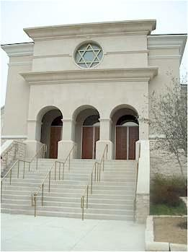

Messianic Judaism

Efforts by Jewish Christians to proselytize to Jews began in the 1st century, when Paul the Apostle preached at the synagogues in each city that he visited.[28] However, by the 4th century CE, non-biblical accounts of missions to the Jews[b] do not mention converted Jews playing any leading role in proselytization. Notable converts from Judaism who attempted to convert other Jews are more visible in historical sources beginning around the 13th century, when Jewish convert Pablo Christiani attempted to convert other Jews. This activity, however, typically lacked any independent Jewish-Christian congregations, and was often imposed through force by organized Christian churches.

