Ecumenical

This National Council of Churches members include Evangelical Lutheran Church in America, American Baptist Churches USA, Moravian Church in America, Polish National Catholic Church, Presbyterian Church USA, Friends United Meeting, Philadelphia Yearly Meeting, United Church of Christ, Reformed Church in America, United Methodist Church and the Episcopal Church USA

List of Historical Lutheran Churches
Zion Lutheran Church Baltimore Maryland

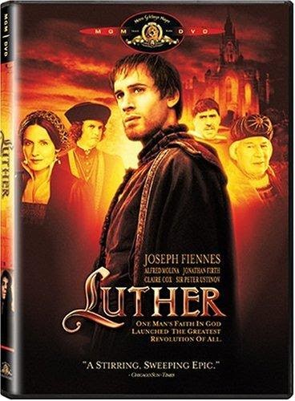

Dr. Martin Luther

10 November 1483 – 18 February 1546) was a German priest, theologian, author, hymnwriter, professor, and Augustinian friar. He was the seminal figure of the Protestant Reformation, and his theological beliefs form the basis of Lutheranism.
Book of Concord
Luther's Small Catechism
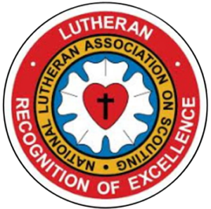

Lutheran Scouting Association

National Lutheran Association on Scouting provide resources for Lutheran youth who are involved in the BSA, GSUSA or AHG organizations.



Lay Schools for Ministry

The Lay Schools for Ministry program creates a communal and virtual meeting place where life-long learning intentionally happens. Our task is to promote and nourish this meeting place where all can share our stories – stories of multigenerational Christian and Lutheran families dining together and sharing their long-day experiences at the fireplace and stories of recent immigrant families rebuilding their lives in a new place. In this communal and virtual place, we will also share the many talents and gifts that the Spirit has given the church for the sake of the world. Our goals are to develop and maintain avenues for life-long learning, to create and share resources, and to sustain accountable processes that help our denomination be a good and efficacious steward of its mission and vocation. Our partners in Select Learning provide an avenue to access and share current and future resources.

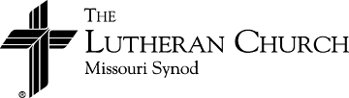

Lay Ministry Associates

There is a recognized need to provide pastoral services to congregations whose circumstances make it impossible for them to support the ministry of a full-time, seminary trained pastor. A program has been established to place qualified laymen to serve in a congregation under the supervision of an ordained pastor. This program is called “Lay Ministry Associates” formerly called The Licensed Lay Deacon program.

