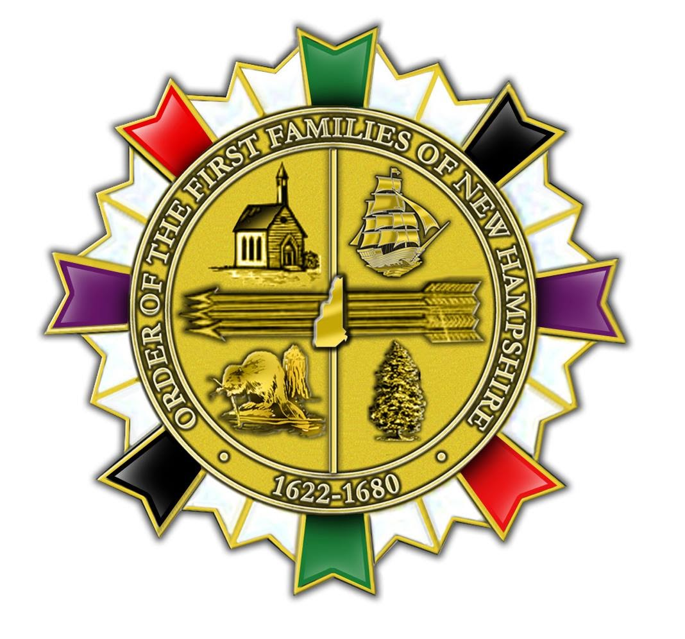

Order of the First Families of New Hampshire

Honor those hardy and enterprising early ancestors who concentrated their efforts, labor and skills in building the enduring greatness of the State of New Hampshire. Recognize and record those individuals who established residency, owned land or businesses within the boundaries of present day New Hampshire between 1622 - 1680.

