Research Resources
https://www.familysearch.org/en/wiki/Frederick_County,_Virginia_Genealogy

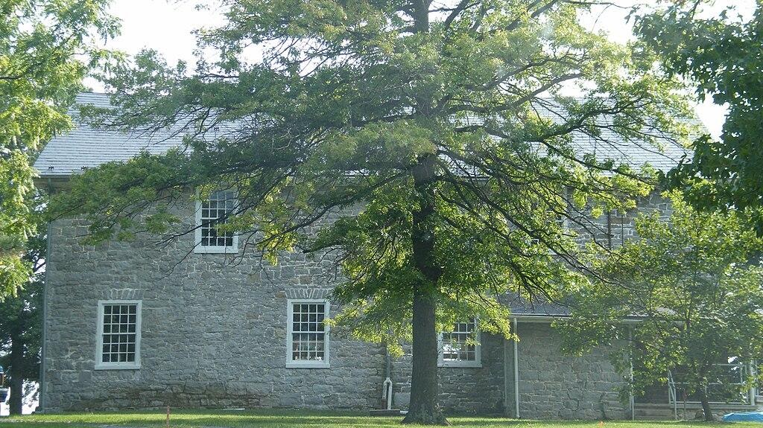

Hopewell Friends Meeting House
Hopewell Friends Meeting House is an 18th-century Quaker meeting house located the northern Frederick County, Virginia one mile west of the community of Clear Brook at 604 Hopewell Road (formerly State Route 672). Clear Brook, VA 22624. The Hopewell Meeting House was listed on the Virginia Landmarks Register in 1977. It was listed on the National Register of Historic Places by the National Park Service in 1980. In 1995 it was designated as a Frederick County Historic Site.
Sunday Services 10 AM
540-667-9114


Opequon Quaker Camp
2710 Brucetown Rd, Clear Brook, VA 22624
+15406784900


Frederick County Fair
Frederick County Fair
​250 Fairgrounds Rd Clear Brook, VA 22624
(540) 313-4911

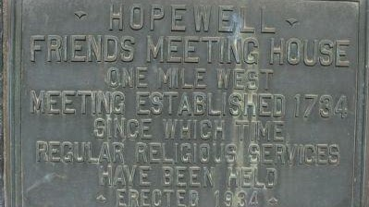

Hopewell Friends Marker
39° 15.379′ N, 78° 5.794′ W. Marker is in Clear Brook, Virginia, in Frederick County. Marker is at the intersection of Martinsburg Turnpike (U.S. 11) and Hopewell Road (County Route 672), on the right when traveling south on Martinsburg Turnpike. Touch for map. Marker is in this post office area: Clear Brook VA 22624, United States of America. Touch for directions.

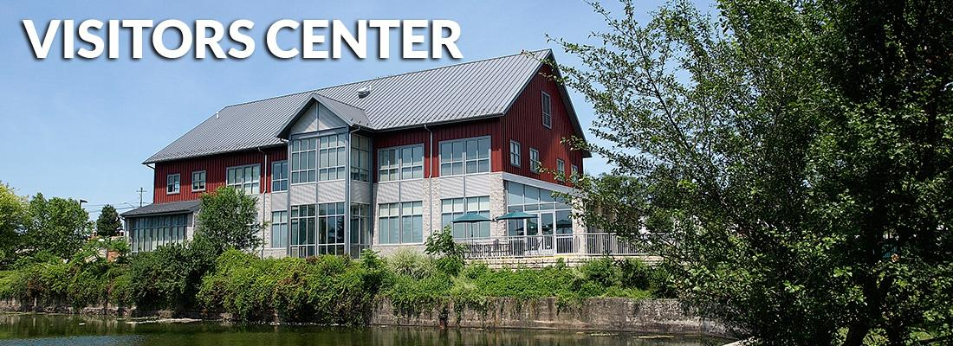
Winchester-Frederick County Visitors Center
Winchester-Frederick County Convention & Visitors Bureau |
1400 S. Pleasant Valley Road, Winchester, VA 22601
(540) 542-1326 | Toll Free (877) 871-1326
info@visitwinchesterva.com | GPS coordinates: 39.1689, -78.1615
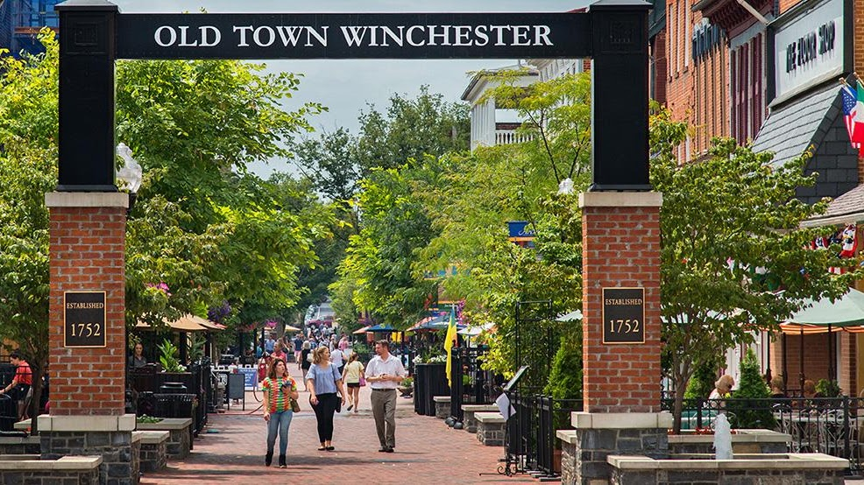

Old Town Winchester
A vital marketplace for more than 250 years, Old Town Winchester cherishes its heritage. Visitors are welcomed here with the grace and style typical of Virginia hospitality. Old Town Winchester is located within the heart of a 45-block National Register Historic District and features a quaint pedestrian walking mall bursting with outdoor cafes, fun & specialty retail shops, historic attractions and family-oriented activities throughout the year. The Loudoun Street Pedestrian Mall has earned a listing on the National Register of Historic Places Travel Itinerary. A 7 million dollar renovation of the Mall was completed in 2013.

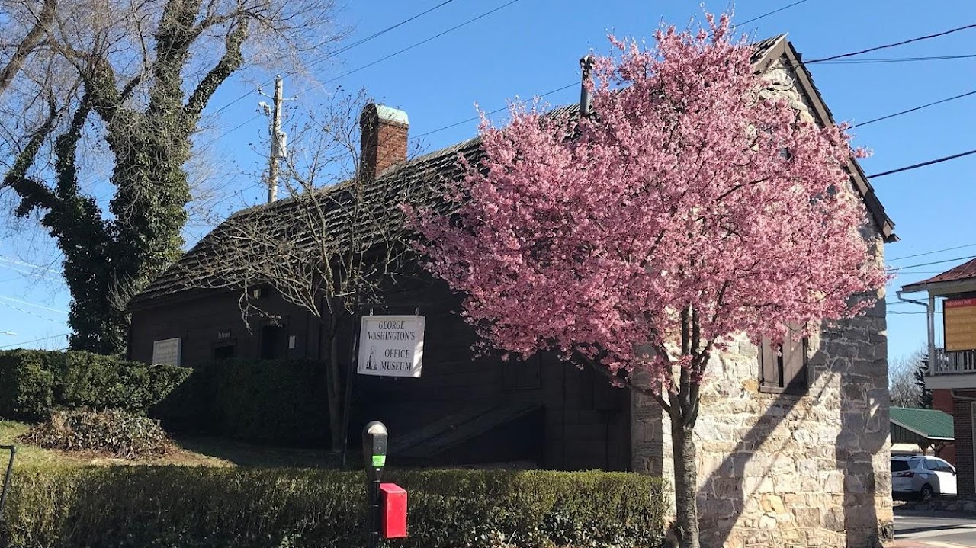
George Washington Office Museum
32 West Cork St. Winchester, Virginia

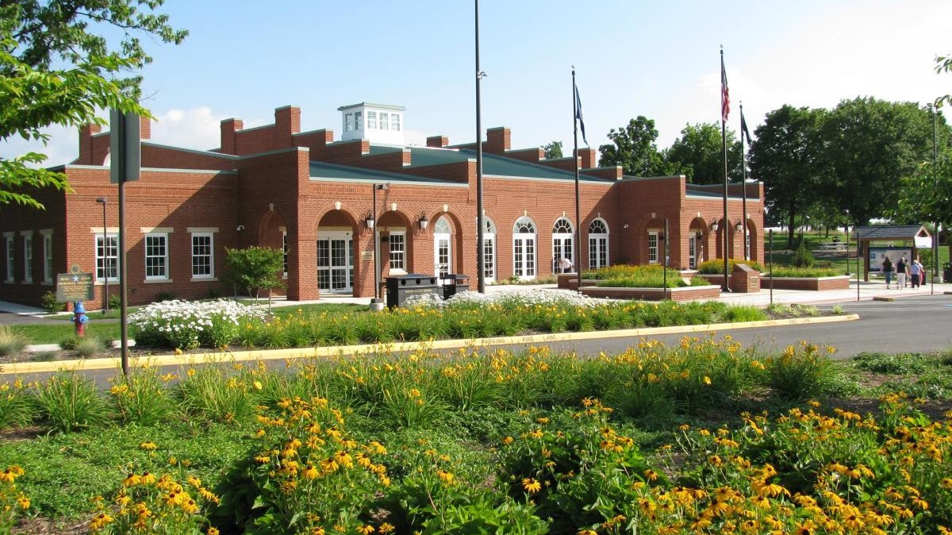

Clear Brook Welcome Center
I-81, Mile Marker 320 Clearbrook, VA 22624

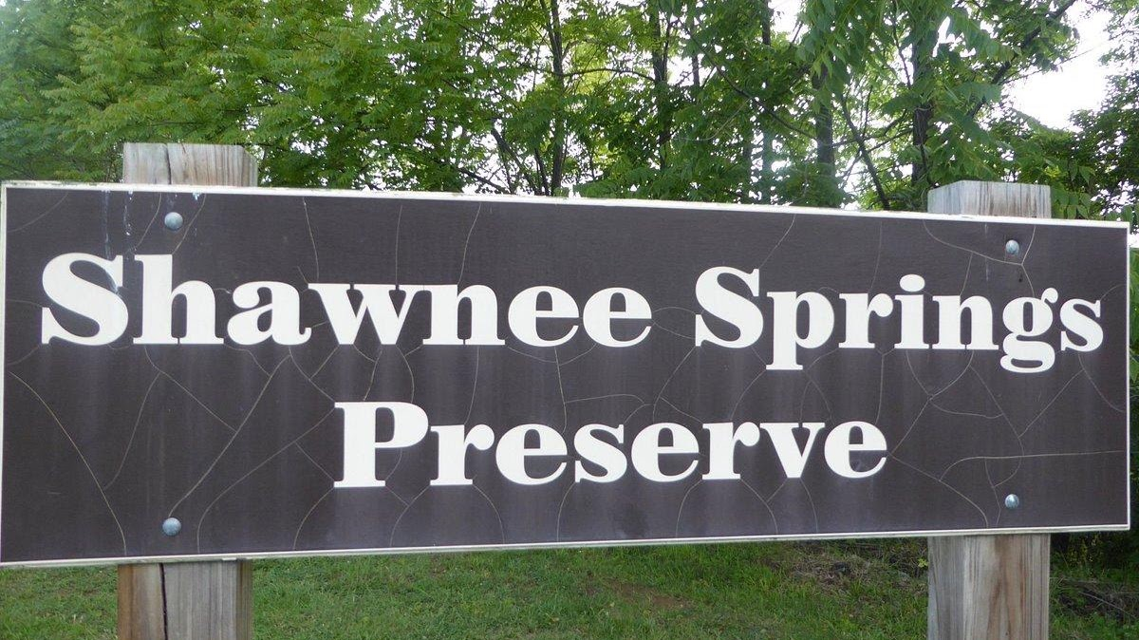

Shawnee Springs

Located between downtown Winchester and Jim Barnett Park, the 14-acre Shawnee Preserve protects natural springs, wetlands, and rocky upland forested areas. It also contains the site of an old Civil War hospital, Sheridan's Field Hospital. The Shawnee Springs Trail is a 0.26-mile long trail provides a more natural trail option in the form of a gravel trail meandering through the wooded heart of the Springs where trail users can see remnants of the City’s old waterworks settlement basins. The trail is a spur off of the Green Circle Trail and the two trails connect up again at mile marker 1.0 on the north end so there is no need to double-back. The main trail and the spur trail are almost the same distance.
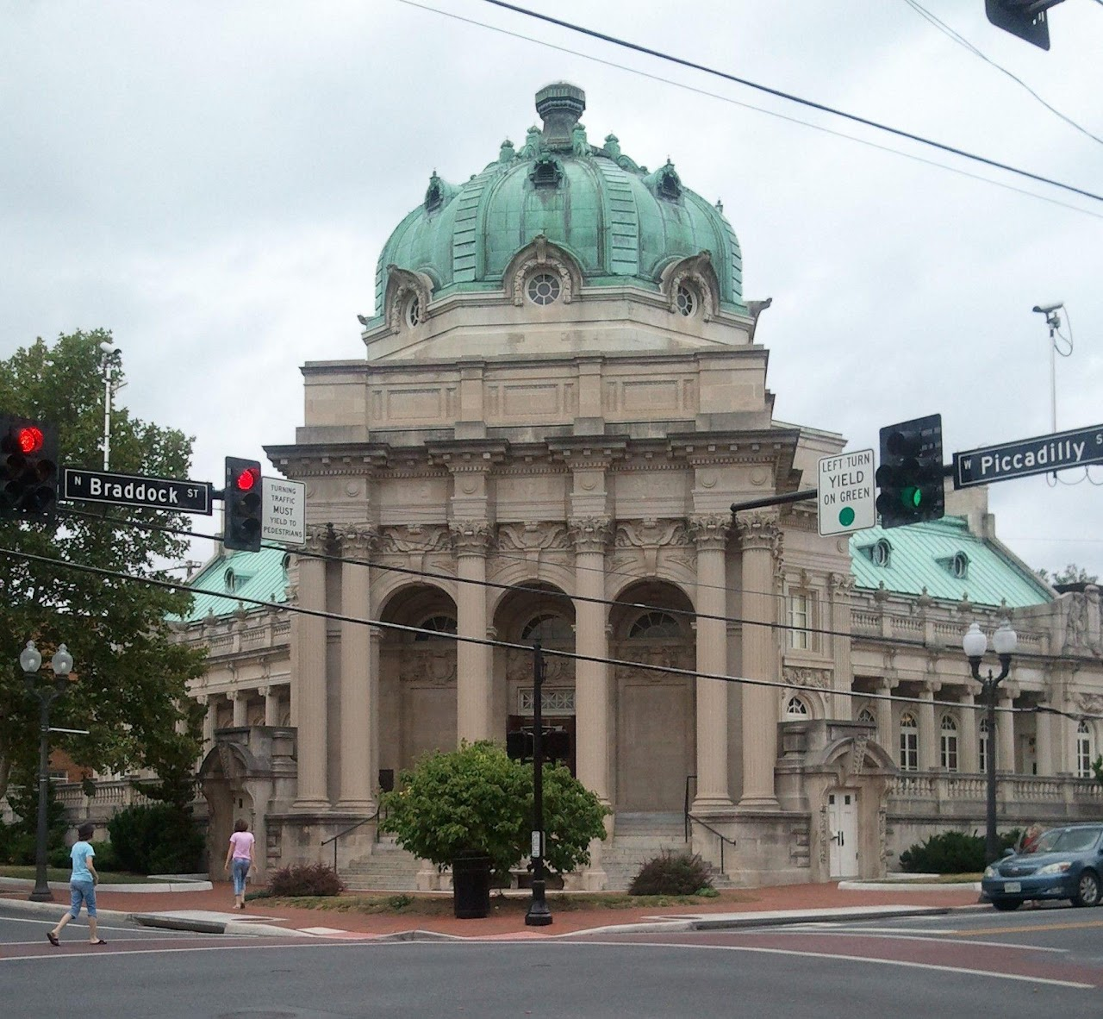

Handley Library
Family Files
100 West Piccadilly St. Winchester, VA 22601
Phone: 540-662-9041

