1. 01.AJAX Tutorial 1 - Introduction
   1. 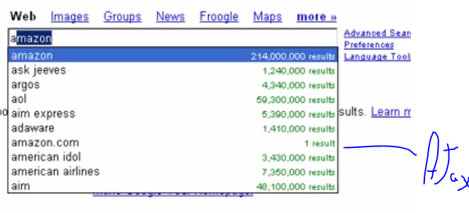
2. 02.Ajax Tutorial 2 System Requirements
3. 03.Ajax Tutorial 3 - Getting to know Ajax
4. 04.Ajax tutorials 5 Searching in Real Time with Live Searches
5. 05.Ajax Tutorial 6 Getting the Answer With Autocomplete
6. 06.Dragging and Dropping HTML Elements With Ajax - 7
7. 07.Getting instant login feedback Ajax Tutorial 8
8. 08.Working With JavaScript in Browsers - Ajax training 9
9. 09..Creating an XMLHttpRequest Object in JavaScript - 10
   1. 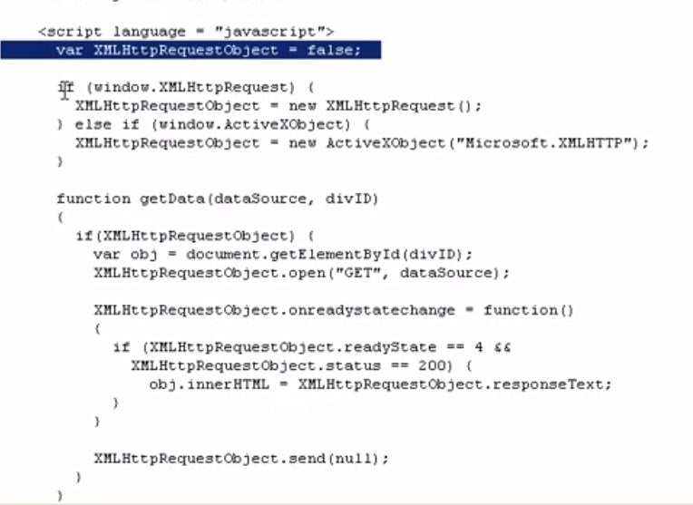
10. 10.Checking the XMLHttpRequest Object s readyState property 11
11. 11.Checking the XMLHttpRequest Object s status property - 12
    1. 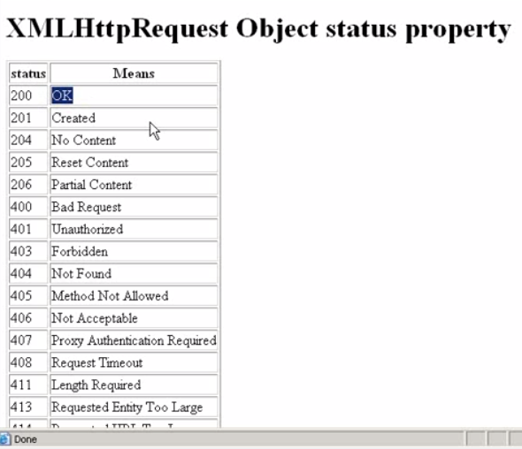
12. 13.Problems creating an XMLHttpRequest Object -Ajax tutorial 14
    1. 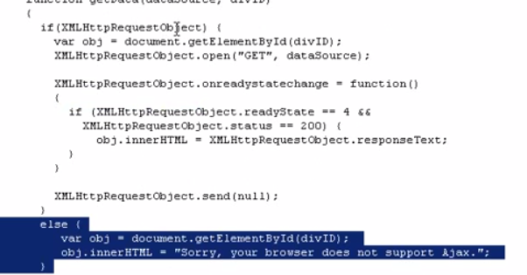
13. 13.Problems creating an XMLHttpRequest Object -Ajax tutorial 14
14. 14.Fetching Text Data From the Browser - Ajax training 15
15. 14.Fetching Text Data From the Browser - Ajax training 15
16. 16.Selecting Relative or Absolute URLs - Ajax tutorial - 17
17. 17.Getting XMLHttpRequest Objects in Other Ways Ajaxtutorial 18
    1. 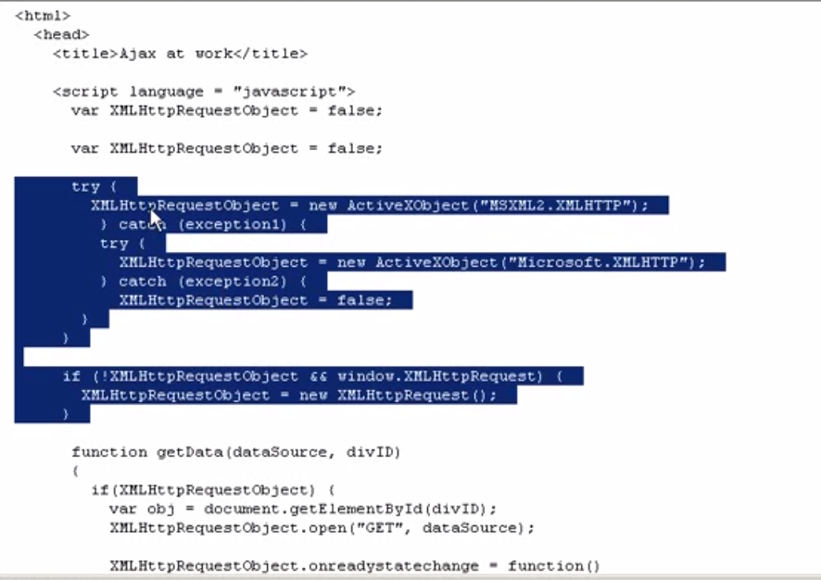
18. 18.Using Server-Side Scripting - Ajaxtraining.blogspot.com -19
    1. 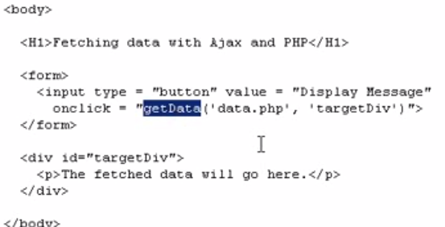
    2. 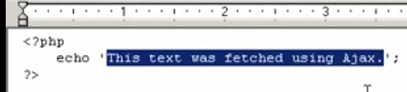
19. 19.Storing Ajax Data in XML - Ajaxtraining.blogspot.com - 20
20. 20.Fetching XML Data From the Server - Ajax Training - 21
    1. 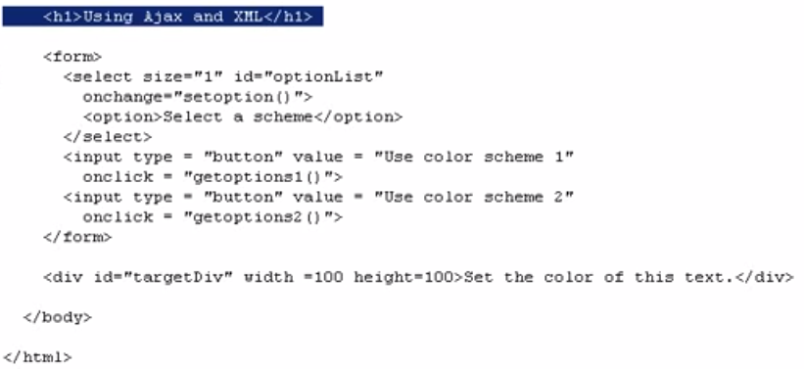
    2. 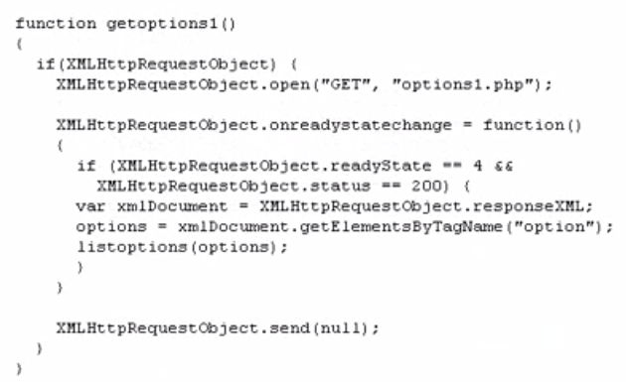
21. 21.Extracting Data From XML - ajaxtraining.blogspot.com - 22
    1. 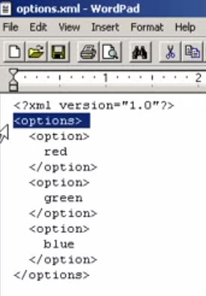
    2. 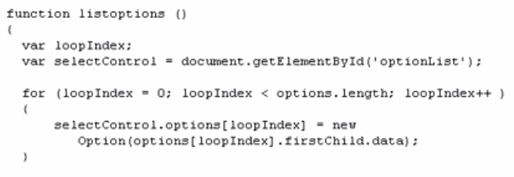
22. 22.Passing Data to the Server with GET - AJAX TUTORIAL - 23
23. 23.Passing Data to the Server with POST - Ajax Training - 24
24. 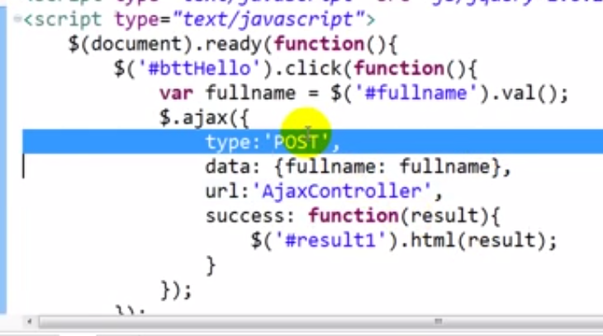
25. 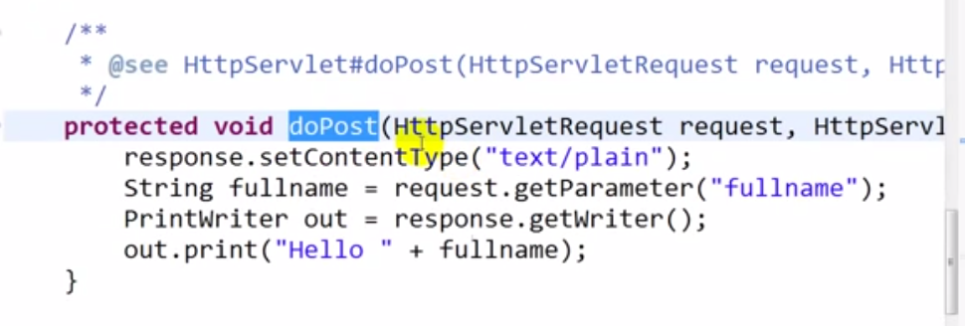
26. 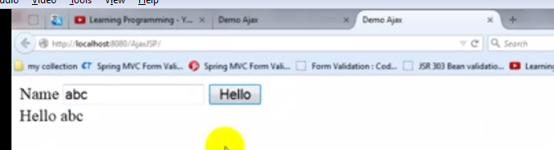
27. 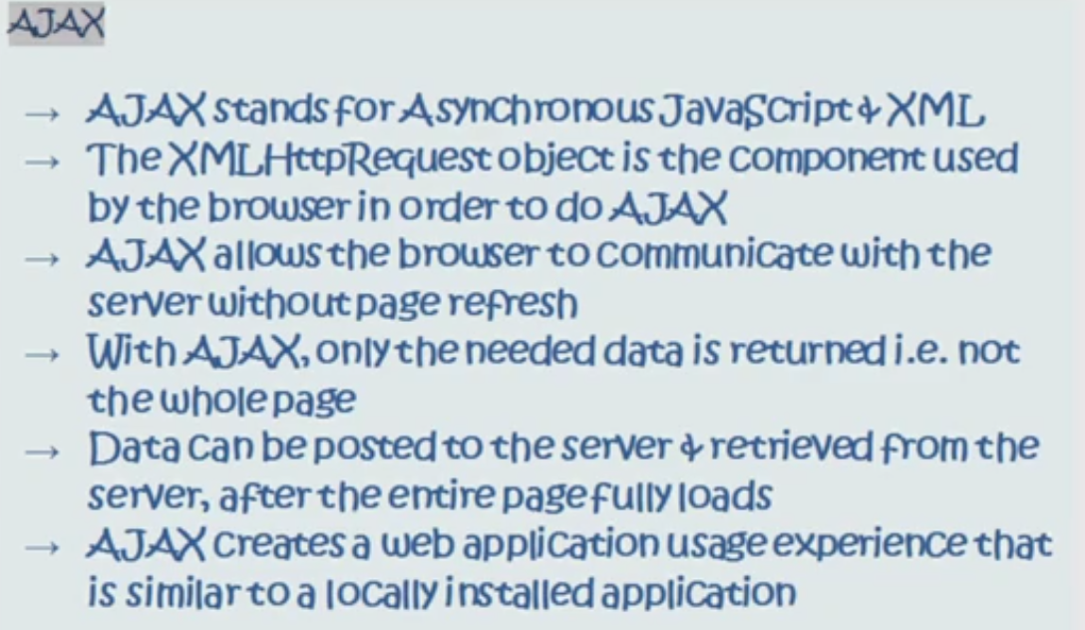
28. 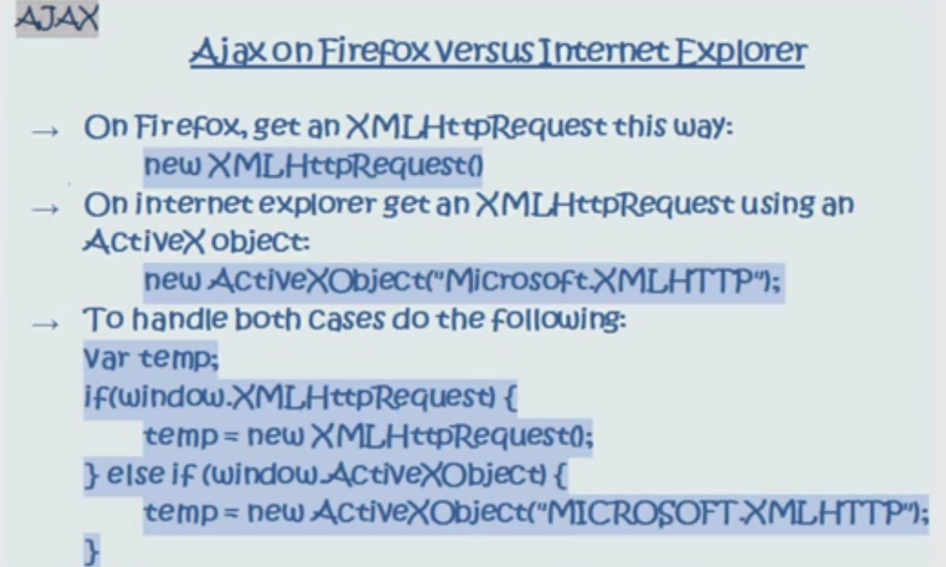
29. 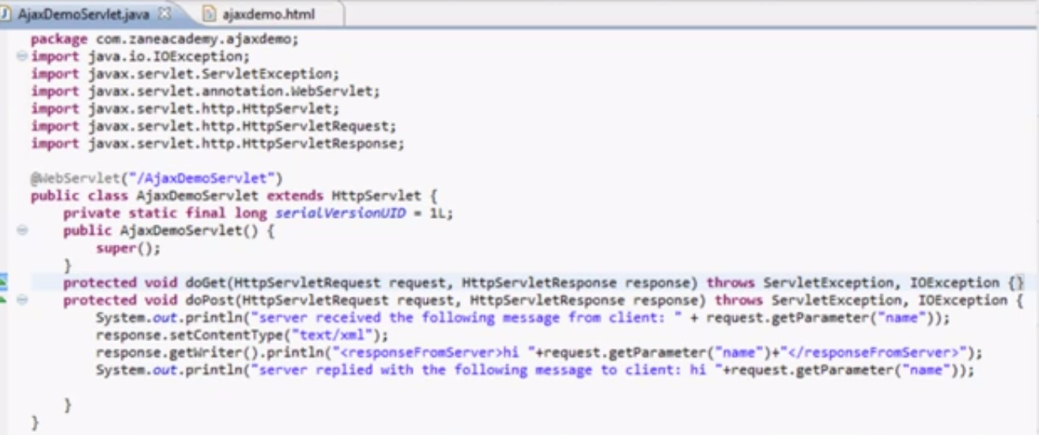
30. 