1. 01.JUnit tutorial in Eclipse part 1 javavids
   1. 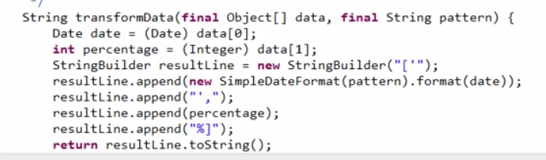
2. 02.JUnit tutorial in Eclipse part 2 javavids
   1. 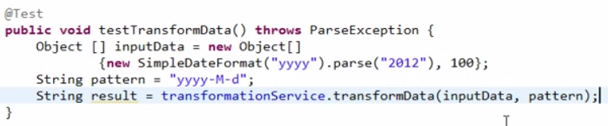
   2. 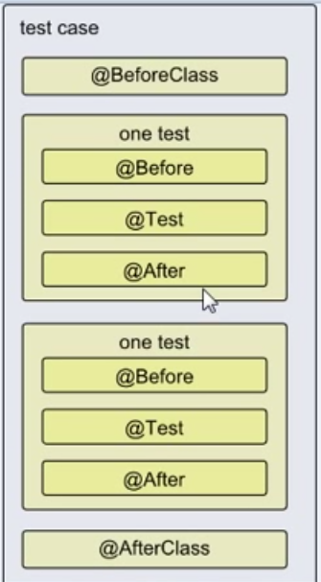
3. 03.JUnit assertions methods javavids
   1. 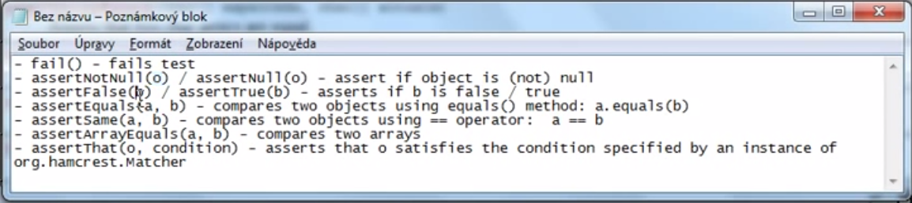
4. 04.JUnit expected exceptions, timeout and ignoring tests javavids
   1. 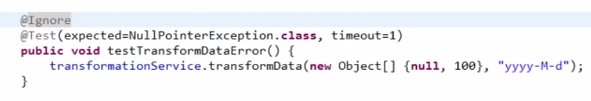
5. 05.JUnit & stub example javavids
6. 06.JUnit & Spring, integration testing javavids
   1. 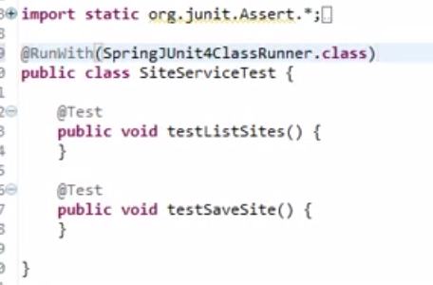
7. 07.JUnit test suite in Eclipse tutorial javavids
8. 08.JUnit and Maven in Eclipse javavids
9. 09.JUnit & Eclipse tip Content Assist javavids
10. 10.JUnit & Eclipse tip rerun test javavids

# JUNIT Mock IT

1. Unit Testing in Java - JUnit & Mockito Tutorial for Beginners (Complete)
   1. 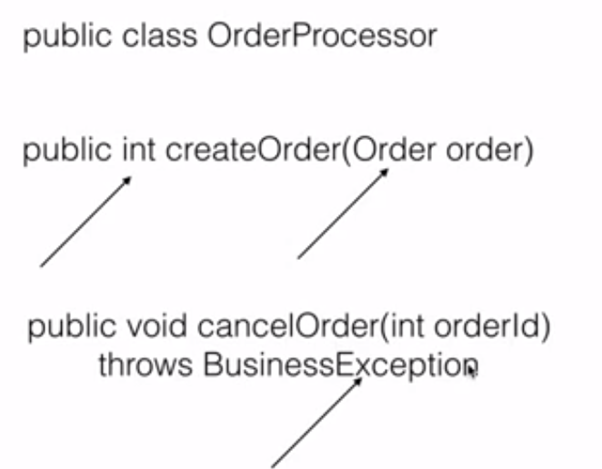
   2. 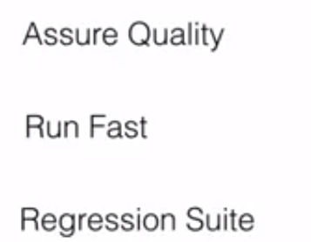
   3. Testing Framework
      1. Easy API
      2. A way to assert the result
      3. Run and report result
   4. JUnit 3
      1. need to extend Testcase
   5. JUnit 4
      1. Use annotation
      2. @Test
      3. @Before
      4. @After
      5. @BeforeClass
      6. @Ignore
   6. JUnit Assert
      1. AssertNotNull
      2. AssertSame
      3. AssetEquals
      4. etc
   7. 
   8. Mocking
   9. 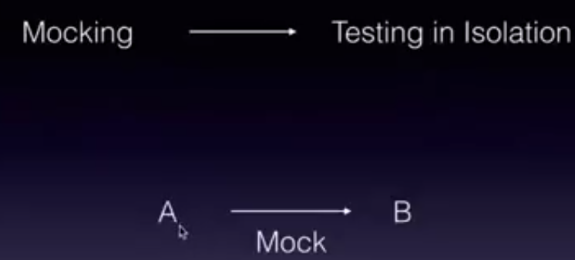
   10. Mocking involves three steps: Stubbing, Setting Expectation and Verifying
   11. Mockito is one of the tool to achieve this
   12. 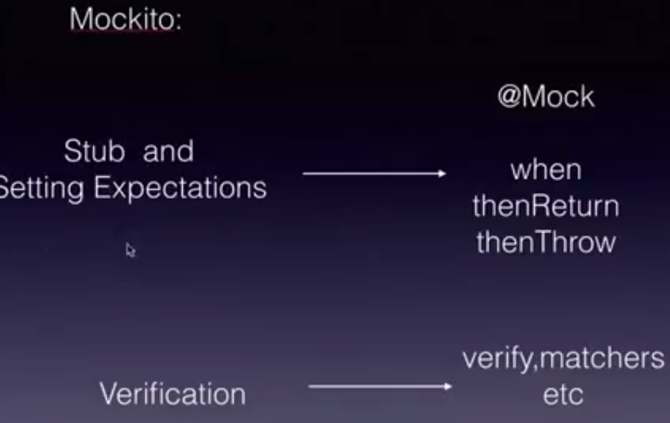
   13. An ecommerce application for order processor
   14. 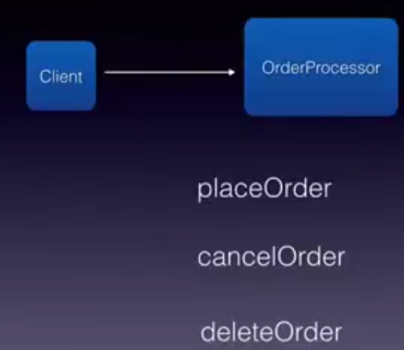
   15. 