1. It is a build tool and Project management tool
   1. 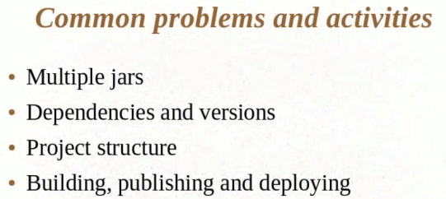
   2. Download the maven zip file
   3. set environment variables
   4. 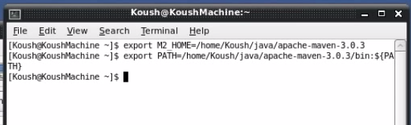
   5. Maven archetype:generate - to download all plugins
2. Part 2
   1. MVN compile
   2. 