The History and Evolution of Java
- Java was conceived by James Gosling, Patrick Naughton, Chris Warth, Ed Frank, and Mike
Sheridan at Sun Microsystems, Inc. in 1991.
- Advantages:
- • Simple
- • Secure
- • Portable
- • Object-oriented
- • Robust
- • Multithreaded
- • Architecture-neutral
- • Interpreted
- • High performance
- • Distributed
- • Dynamic
- Evolution of java
- Java 1.1, - new library elements,redefined the way events are handled
- Java 2,(1.2) - such as Swing and the Collections Framework, and it enhanced the Java Virtual Machine and various programming tools. Java 2 also contained a few deprecations. The most important affected the Thread class in which the methods suspend( ), resume( ), and stop( ) were deprecated.
- J2SE 1.3 - smaller set of changes
- J2SE 1.4 - it added the new keyword assert,chained exceptions, and a channel-based I/O subsystem. It also made changes to the Collections Framework and the networking classes.
- J2SE 5,
• Generics
• Annotations
• Autoboxing and auto-unboxing
• Enumerations
• Enhanced, for-each style for loop
• Variable-length arguments (varargs)
• Static import
• Formatted I/O
• Concurrency utilities

- Java SE 6,- the API libraries, add several new packages, and offer improvements to the run time.

ok

An Overview of Java

Two Paradigms -code and data.
Abstraction
Encapsulation
Inheritance
Polymorphism
Two Control Statements
If
For

ok

Data Types, Variables and Arrays
Integers
Name Width Range
long 64 –9,223,372,036,854,775,808 to 9,223,372,036,854,775,807
int 32 –2,147,483,648 to 2,147,483,647
short 16 –32,768 to 32,767
byte 8 –128 to 127

Floating-Point Types
Name Width in Bits Approximate Range
double 64 4.9e–324 to 1.8e+308
float 32 1.4e–045 to 3.4e+038

Characters
Booleans
Literals
Variables
The Scope and Lifetime of Variables
Type Conversion and Casting
Arrays
Multidimensional Arrays

New ex:
int twoD[][] = new int[4][];
twoD[0] = new int[1];
twoD[1] = new int[2];
twoD[2] = new int[3];
twoD[3] = new int[4];
array structure
*
* *
* * *
* * * *
ok

Operators
Arithmetic Operators
Operator Result
+ Addition
– Subtraction (also unary minus)
* Multiplication
/ Division
% Modulus
++ Increment
+= Addition assignment
–= Subtraction assignment
*= Multiplication assignment
/= Division assignment
%= Modulus assignment
– – Decrement

The Bitwise Operators
Operator Result
~ Bitwise unary NOT
& Bitwise AND
| Bitwise OR
^ Bitwise exclusive OR
>> Shift right
>>> Shift right zero fill
<< Shift left
&= Bitwise AND assignment
|= Bitwise OR assignment
^= Bitwise exclusive OR assignment
>>= Shift right assignment
>>>= Shift right zero fill assignment
<<= Shift left assignment

Relational Operators
Operator Result
== Equal to
!= Not equal to
> Greater than
< Less than
>= Greater than or equal to
<= Less than or equal to

Boolean Logical Operators
Operator Result
& Logical AND
| Logical OR
^ Logical XOR (exclusive OR)
|| Short-circuit OR
&& Short-circuit AND
! Logical unary NOT
&= AND assignment
|= OR assignment
^= XOR assignment
== Equal to
!= Not equal to
?: Ternary if-then-else

The ? Operator
Operator Precedence
ok

Control Statements
Conditional Statements
if
Nested ifs
The if-else-if Ladder
switch
Nested switch Statements

Iteration Statements
while
do-while
for
The For-Each Version of the for Loop (for(type itr-var : collection) statement-block)
Iterating Over Multidimensional Arrays
Nested Loops
Jump Statements
Using break
Using continue
return

ok

Introducing Classes
Class Fundamentals
Declaring Objects
Introducing Methods
Returning a Value
Adding a Method That Takes Parameters
Constructors
Parameterized Constructors
The this Keyword
Garbage Collection
The finalize( ) Method
protected void finalize( )
{
// finalization code here
}
A Stack Class
ok

A Closer Look at Methods and Classes

Overloading Methods
Overloading Constructors
Using Objects as Parameters
A Closer Look at Argument Passing
Returning Objects
Recursion
Introducing Access Control
Understanding static
Introducing final
Arrays Revisited
Exploring the String Class
Using Command-Line Arguments
Varargs: Variable-Length Arguments
Varargs and Ambiguity
ok

Inheritance
Inheritance Basics
Using super
Creating a Multilevel Hierarchy
When Constructors Are Called
Dynamic Method Dispatch
Applying Method Overriding
Using Abstract Classes
Using final with Inheritance
The Object Class

Packages and Interfaces

Packages
Defining a Package
Finding Packages and CLASSPATH
Access Protection (ref page 187)
Importing Packages
Interfaces
Defining an Interface
Implementing Interfaces
Variables in Interfaces
Interfaces Can Be Extended

Exception Handling
Exception-Handling Fundamentals
Exception Types
Using try and catch
Displaying a Description of an Exception
Multiple catch Clauses
Nested try Statements
throw
throws
finally
Java’s Built-in Exceptions(ref page 218)
Creating Your Own Exception Subclasses
Chained Exceptions
Using Exceptions

Multithreaded Programming
The Java Thread Model
Thread Priorities
Synchronization
Messaging
The Thread Class and the Runnable Interface
The Main Thread
Creating a Thread
• You can implement the Runnable interface.
• You can extend the Thread class, itself

Creating Multiple Threads
Using isAlive( ) and join( )
Thread Priorities
Synchronization
Using Synchronized Methods
The synchronized Statement
Interthread Communication
• wait( ) tells the calling thread to give up the monitor and go to sleep until some
other thread enters the same monitor and calls notify( ).
• notify( ) wakes up a thread that called wait( ) on the same object.
• notifyAll( ) wakes up all the threads that called wait( ) on the same object. One of
The threads will be granted access.

Deadlock
The Modern Way of Suspending, Resuming, and Stopping Threads
Using Multithreading

OK

Enumerations, Autoboxing, and Annotations (Metadata)

Enumerations
The values( ) and valueOf( ) Methods
Java Enumerations Are Class Types
Enumerations Inherit Enum
Type Wrappers
Character - char charValue( )
Boolean - Boolean(boolean boolValue), Boolean(String boolString)
The Numeric Type Wrappers
- byte byteValue( )
- double doubleValue( )
- float floatValue( )
- int intValue( )
- long longValue( )
- short shortValue( )

Autoboxing
Annotations (Metadata)
Annotation Basics
Specifying a Retention Policy
Obtaining Annotations at Run Time by Use of Reflection
Obtaining All Annotations
Using Default Values
Marker Annotations
The Built-In Annotations
@Retention
@Documented
@Target
@Inherited
@Override
@Deprecated
@SuppressWarnings
Some Restrictions

I/O, Applets, and Other Topics
I/O Basics
Streams
Byte Streams and Character Streams
The Byte Stream Classes
The Character Stream Classes
The Predefined Streams

Reading Console Input
Reading Characters -br.read();
Reading Strings -br.readLine()

Writing Console Output
The PrintWriter Class
Reading and Writing Files

Applet Fundamentals
The transient and volatile Modifiers
Using instanceof
strictfp
Native Methods
Using assert
Static Import
Invoking Overloaded Constructors Through this( )

Generics
What Are Generics?
A Simple Generics Example
A Generic Class with Two Type Parameters
The General Form of a Generic Class
Bounded Types
Using Wildcard Arguments
Bounded Wildcards
Creating a Generic Method
Generic Constructors
Generic Interfaces
Raw Types and Legacy Code
Generic Class Hierarchies
A Generic Subclass
Overriding Methods in a Generic Class
Erasure
Ambiguity Errors
Some Generic Restrictions

The Java Library
CHAPTER 15
String Handling
CHAPTER 16
Exploring java.lang
CHAPTER 17
java.util Part 1: The
Collections Framework
CHAPTER 18
java.util Part 2: More
Utility Classes
CHAPTER 19
Input/Output: Exploring
java.io
CHAPTER 20
Networking
CHAPTER 21
The Applet Class
CHAPTER 22
Event Handling
CHAPTER 23
Introducing the AWT:
Working with Windows,
Graphics, and Text
CHAPTER 24
Using AWT Controls, Layout
Managers, and Menus
CHAPTER 25
Images
CHAPTER 26
The Concurrency Utilities
CHAPTER 27
NIO, Regular Expressions,
and Other Packages

String Handling

The String Constructors
- String s = new String();
- char chars[] = { 'a', 'b', 'c' }; String s = new String(chars);
- char chars[] = { 'a', 'b', 'c', 'd', 'e', 'f' }; String s = new String(chars, 2, 3);

String Length
Special String Operations
  - String Literals
  - String Concatenation
  - String Concatenation with Other Data Types
  - String Conversion and toString( )
Character Extraction
- charAt( )
- getChars( )
- getBytes( )
- toCharArray( )

String Comparison
  - equals( ) and equalsIgnoreCase( )
  - regionMatches( )
  - startsWith( ) and endsWith( )
  - equals( ) Versus ==
  - compareTo( )

Searching Strings
- indexOf( ) Searches for the first occurrence of a character or substring.
- lastIndexOf( ) Searches for the last occurrence of a character or substring.

Modifying a String
  - substring( )
  - concat( )
  - replace( )
  - trim( )

Data Conversion Using valueOf( )
Changing the Case of Characters Within a String
Additional String Methods

StringBuffer
  - length( ) and capacity( )
  - ensureCapacity( )
  - setLength( )
  - charAt( ) and setCharAt( )
  - getChars( )
  - append( )
  - insert( )
  - reverse( )
  - replace( )
  - substring( )

StringBuilder

OK

Exploring java.lang
java.lang includes the following classes:
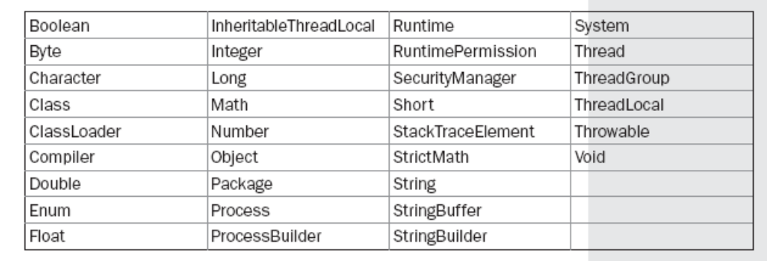
Primitive Type Wrappers
Number - Double,Float, Byte, Short, Integer, and Long.
Double and Float
Byte, Short, Integer, and Long
Character
Boolean
Void
Process
Runtime
ProcessBuilder
System
Object - clone( )
Class
ClassLoader
Math
Transcendental Functions
Exponential Functions
Rounding Functions
Miscellaneous Math Methods
StrictMath
Compiler
Thread, ThreadGroup, and Runnable
Package
RuntimePermission
Throwable
SecurityManager
StackTraceElement
Enum
The CharSequence Interface
The Comparable Interface
The Appendable Interface
The Iterable Interface
The Readable Interface
The java.lang Subpackages
  - java.lang.annotation
  - java.lang.instrument
  - java.lang.management
  - java.lang.ref
  - java.lang.reflect

ok

java.util Part 1:The Collections Framework
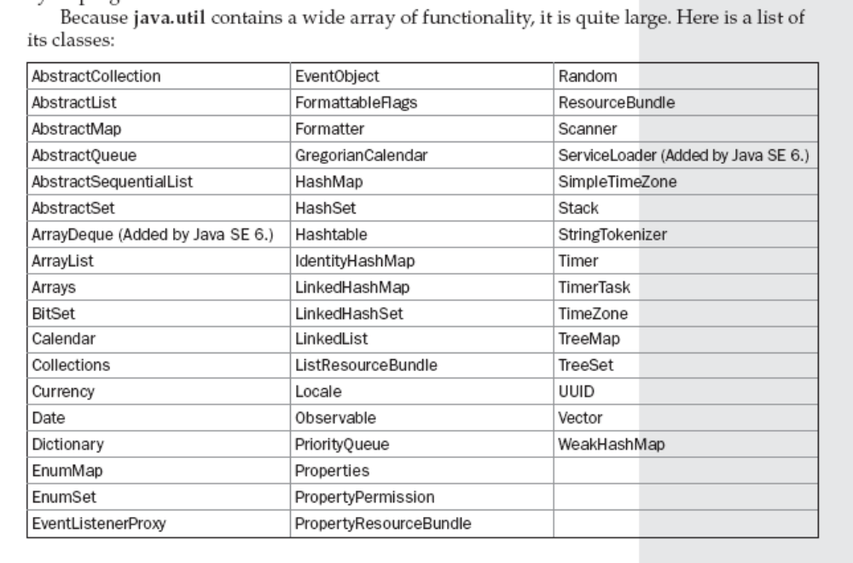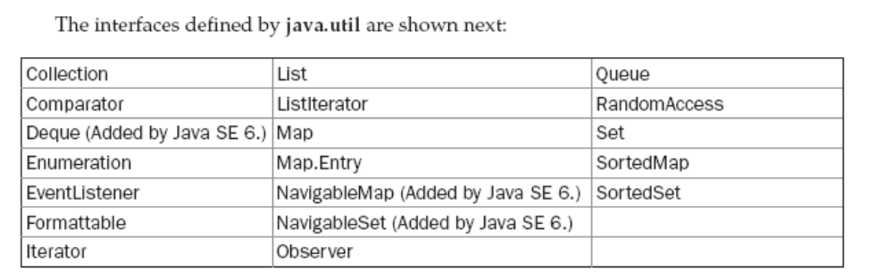Collections Overview
Dictionary,Vector, Stack, and Properties
Recent Changes to Collections
Generics Fundamentally Change the Collections Framework
Autoboxing Facilitates the Use of Primitive Types
The For-Each Style for Loop

The Collection Interfaces
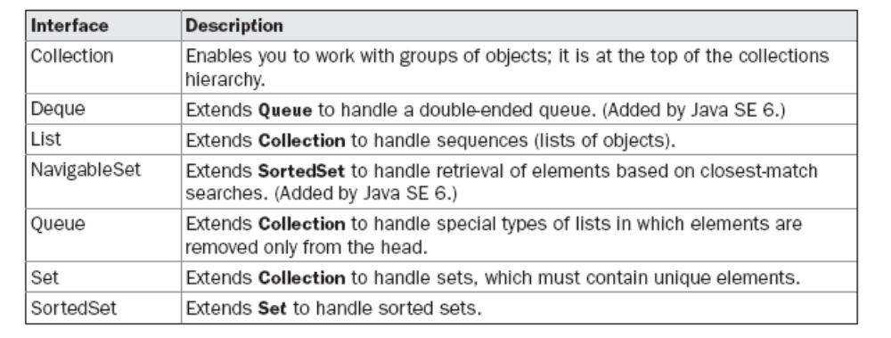
The List Interface
The Set Interface
The SortedSet Interface
The NavigableSet Interface
The Queue Interface
The Deque Interface

The Collection Classes
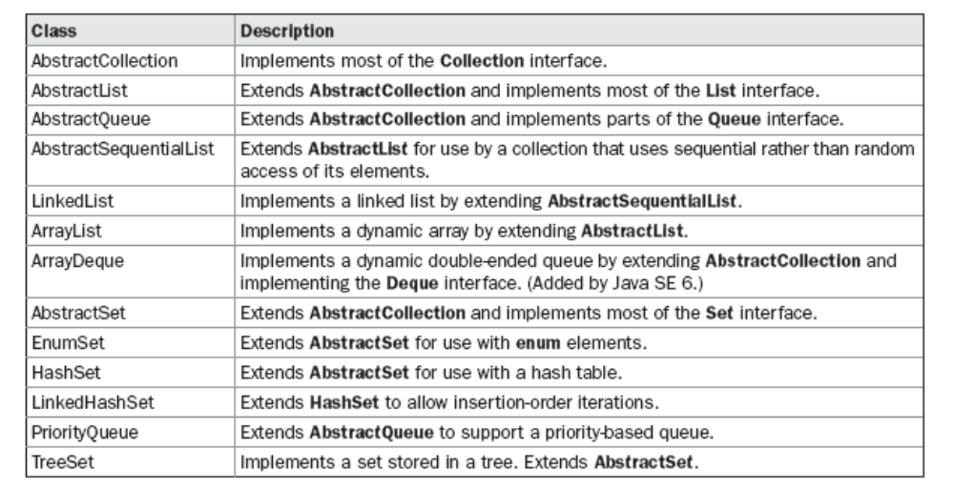
The ArrayList Class
The LinkedList Class
The HashSet Class
The LinkedHashSet Class
The TreeSet Class
The PriorityQueue Class
The ArrayDeque Class
The EnumSet Class
Accessing a Collection via an Iterator
Storing User-Defined Classes in Collections
The RandomAccess Interface
Working with Maps
Comparators
The Collection Algorithms
Arrays
Why Generic Collections?
The Legacy Classes and Interfaces
Parting Thoughts on Collections

java.util Part 2: More Utility Classes
StringTokenizer
BitSet
Date
Calendar
GregorianCalendar
TimeZone
SimpleTimeZone
Locale
Random
Observable
Timer and TimerTask
Currency
Formatter
Scanner
The ResourceBundle, ListResourceBundle,and PropertyResourceBundle Classes
Miscellaneous Utility Classes and Interfaces
The java.util Subpackages

Input/Output: Exploring java.io
The Java I/O Classes and Interfaces
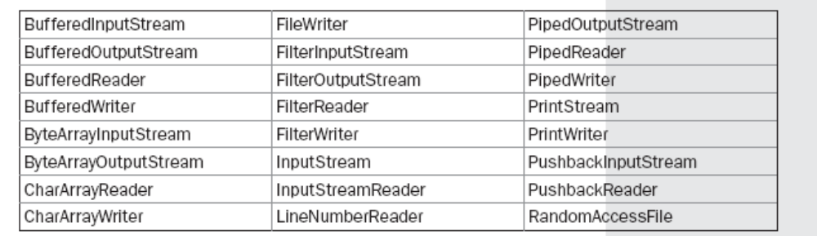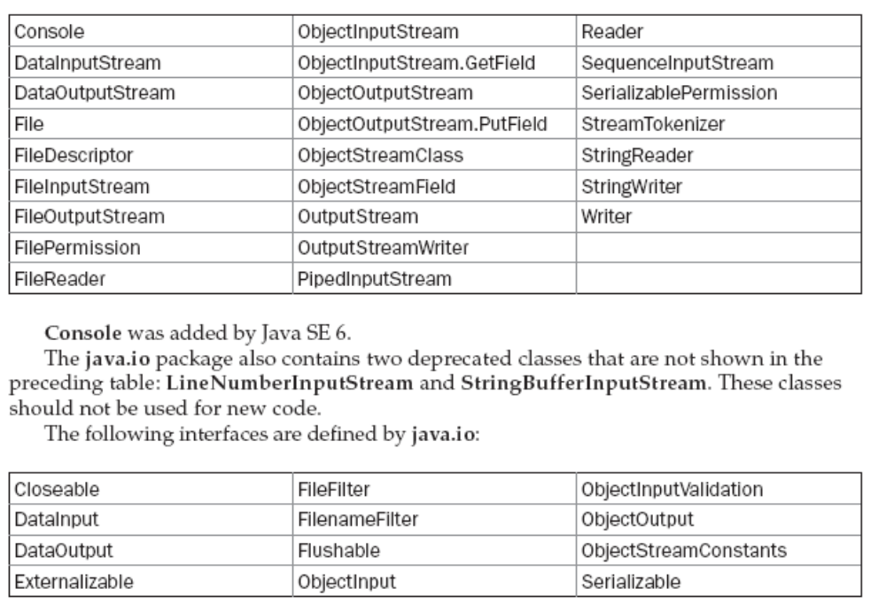File
Directories
Using FilenameFilter
The listFiles( ) Alternative
Creating Directories
The Closeable and Flushable Interfaces
The Stream Classes
The Byte Streams
InputStream
OutputStream
FileInputStream
FileOutputStream
ByteArrayInputStream
ByteArrayOutputStream
Filtered Byte Streams
Buffered Byte Streams
Filtered Byte Stream
Buffered Byte Streams
BufferedOutputStream
PushbackInputStream
SequenceInputStream
PrintStream
DataOutputStream and DataInputStream
RandomAccessFile
The Character Streams
Reader
Writer
FileReader
FileWriter
CharArrayReader
CharArrayWriter
BufferedReader
BufferedWriter
PushbackReader
PrintWriter
The Console Class
Using Stream I/O
Serialization
Stream Benefits
Ok

Networking
Networking Basics
The Networking Classes and Interfaces
java.net package are shown here:
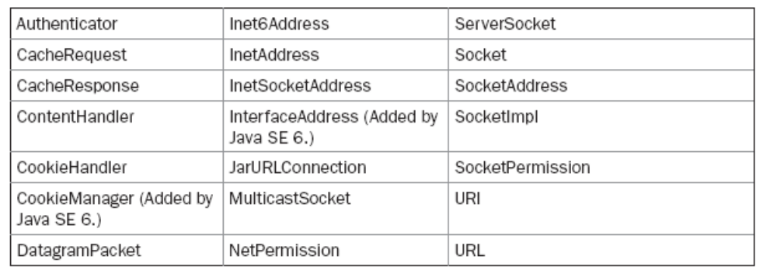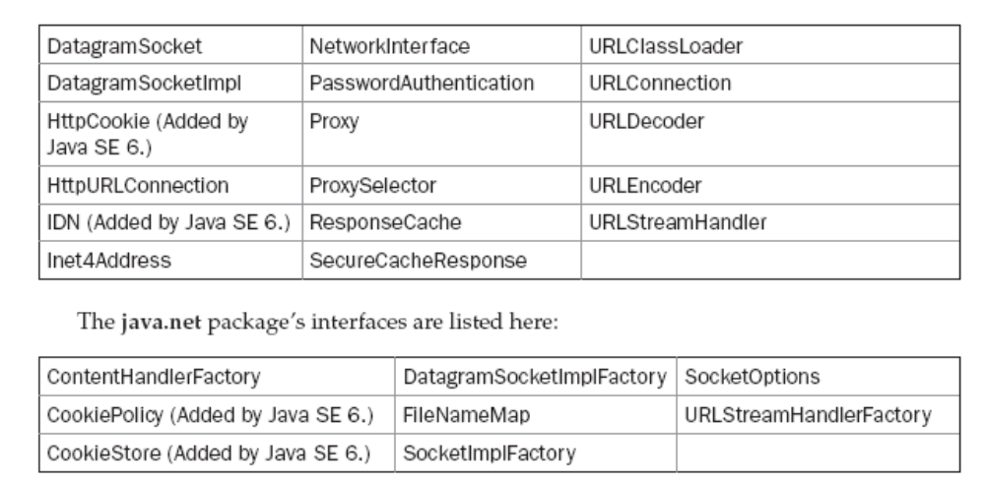InetAddress
Factory Methods
Instance Methods
Inet4Address and Inet6Address
TCP/IP Client Sockets
URL
HttpURLConnection
The URI Class
Cookies
TCP/IP Server Sockets
Datagrams
DatagramSocket
DatagramPacket

The Applet Class
Two Types of Applets
Applet Basics
The Applet Class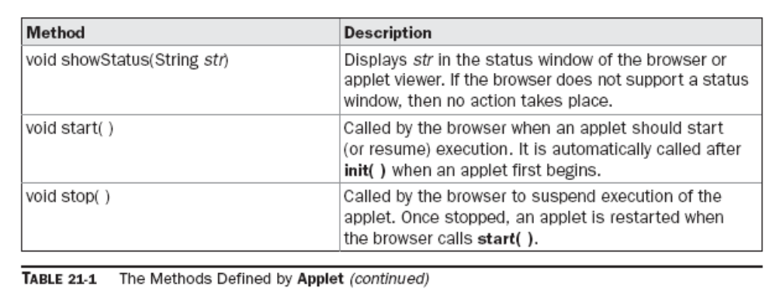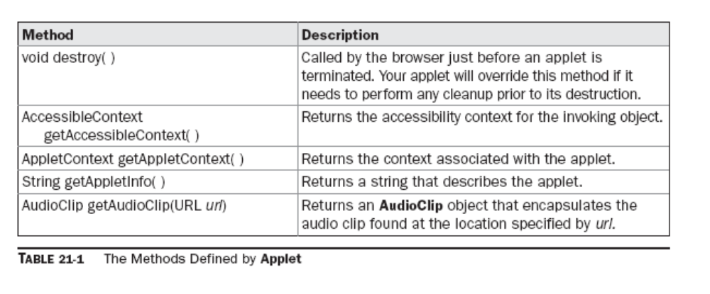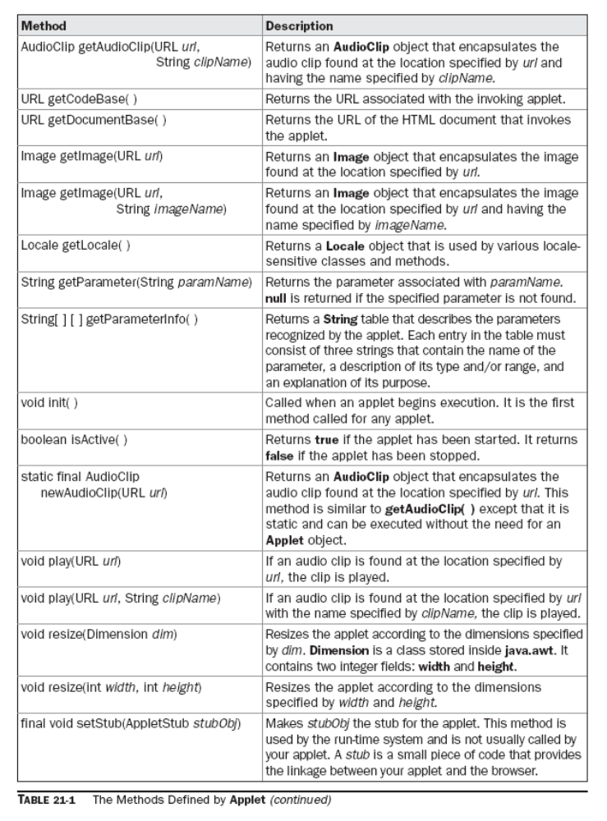
Applet Architecture
An Applet Skeleton
init( ), start( ), stop( ), and destroy( ),
Applet Initialization and Termination
It is important to understand the order in which the various methods shown in the skeleton
are called. When an applet begins, the following methods are called, in this sequence:
1. init( )
2. start( )
3. paint( )
When an applet is terminated, the following sequence of method calls takes place:
1. stop( )
2. destroy( )
Simple Applet Display Methods
Requesting Repainting
void repaint( )
Using the Status Window
showStatus("This is shown in the status window.");
The HTML APPLET Tag
Passing Parameters to Applets
getDocumentBase( ) and getCodeBase( )
AppletContext and showDocument( )
The AudioClip Interface
The AppletStub Interface
Outputting to the Console

Event Handling
Two Event Handling Mechanisms
The Delegation Event Model
Events
Event Sources
Event Listeners
Event Classes
The ActionEvent Class
The AdjustmentEvent Class
The ComponentEvent Class
The ContainerEvent Class
The FocusEvent Class
The InputEvent Class
The ItemEvent Class
The KeyEvent Class
The MouseEvent Class
The MouseWheelEvent Class
The TextEvent Class
The WindowEvent Class

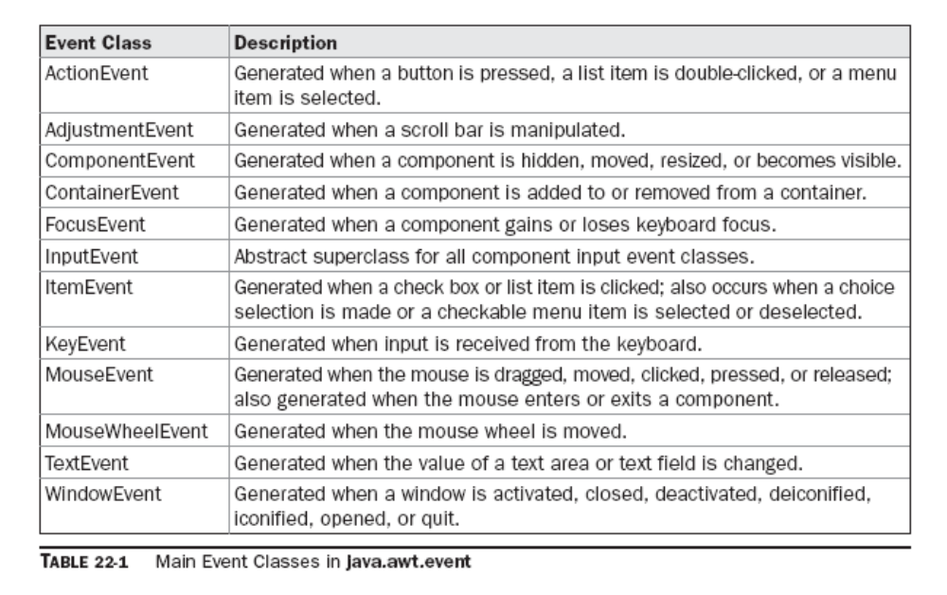

Sources of Events
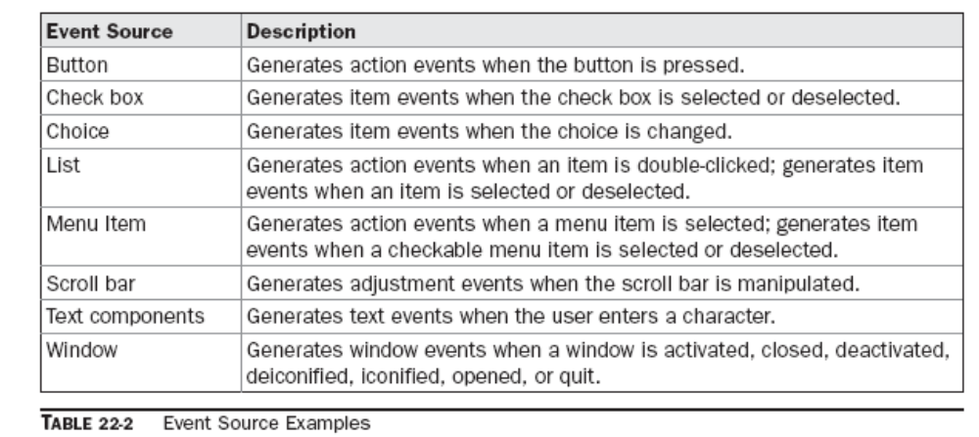

Event Listener Interfaces
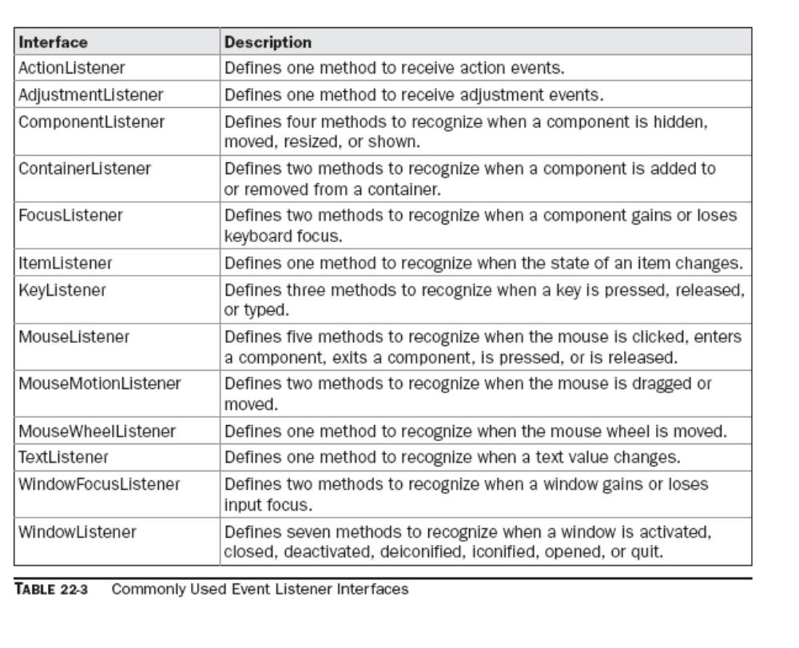
Using the Delegation Event Model
Handling Mouse Events

Adapter Classes
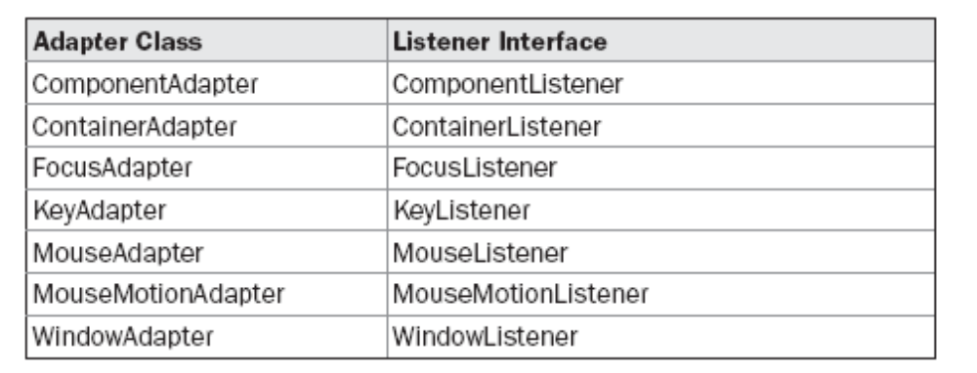
Inner Classes
Anonymous Inner Classes

Introducing the AWT: Working with Windows, Graphics, and Text
AWT Classes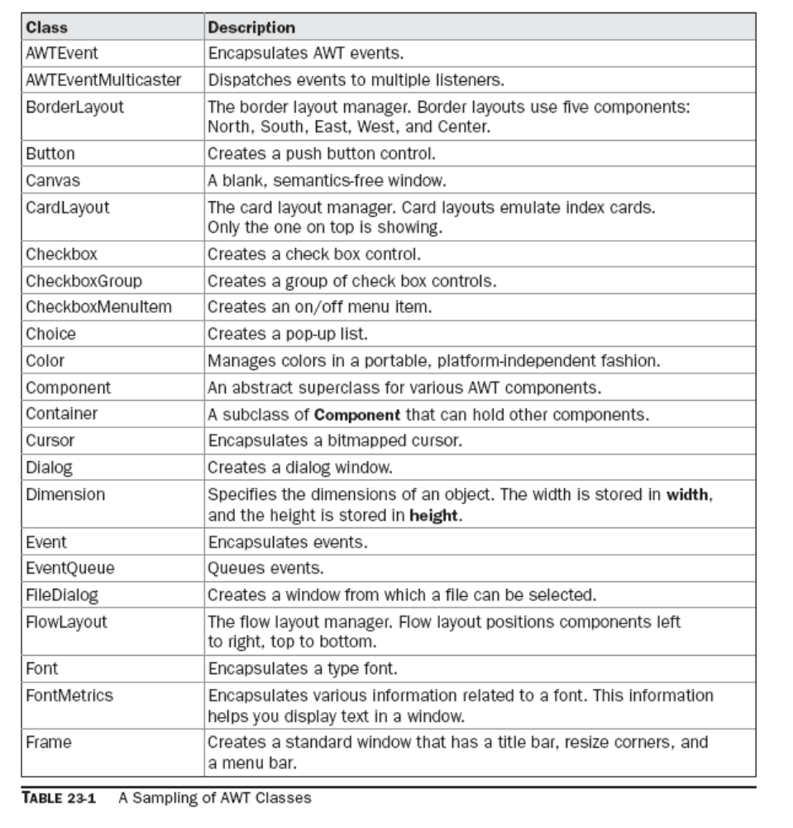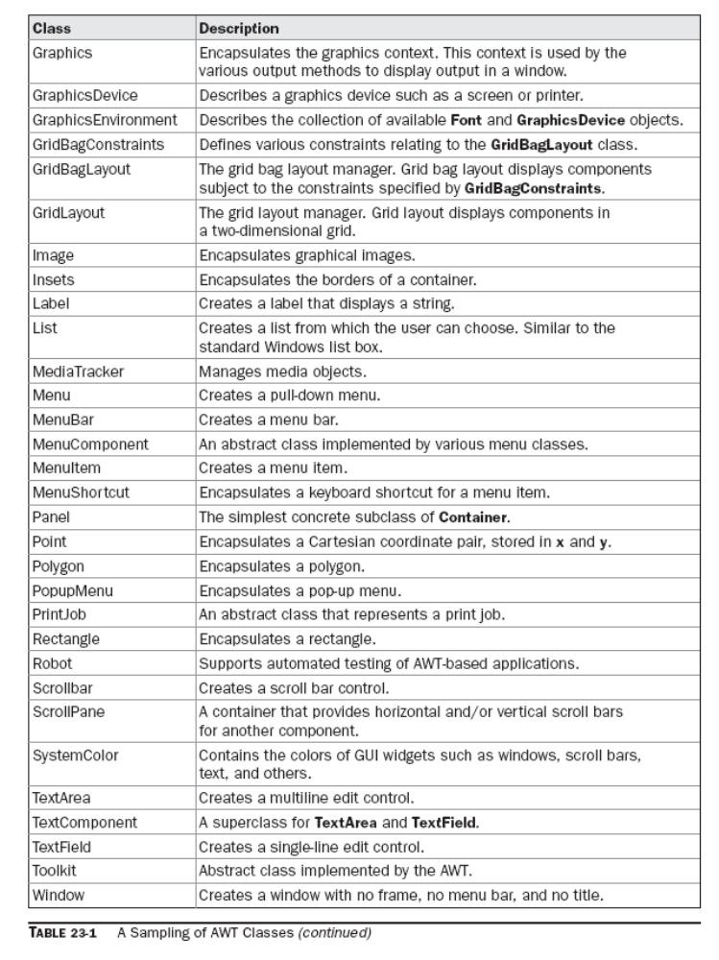
Window Fundamentals
Component
Container
Panel
Panel
Frame
Canvas
Working with Frame Windows
Setting the Window’s Dimensions
Hiding and Showing a Window
Setting a Window’s Title
Closing a Frame Window
Creating a Frame Window in an Applet
Displaying Information Within a Window
Working with Graphics
Drawing Lines
Drawing Rectangles
Drawing Ellipses and Circles
Drawing Arcs
Drawing Polygons
Sizing Graphics
Working with Color
Color Methods
Using Hue, Saturation, and Brightness
getRed( ), getGreen( ), getBlue( )
Working with Fonts
Determining the Available Fonts
String[ ] getAvailableFontFamilyNames( )
Creating and Selecting a Font
Obtaining Font Information
Managing Text Output Using “FontMetrics”
FontMetrics

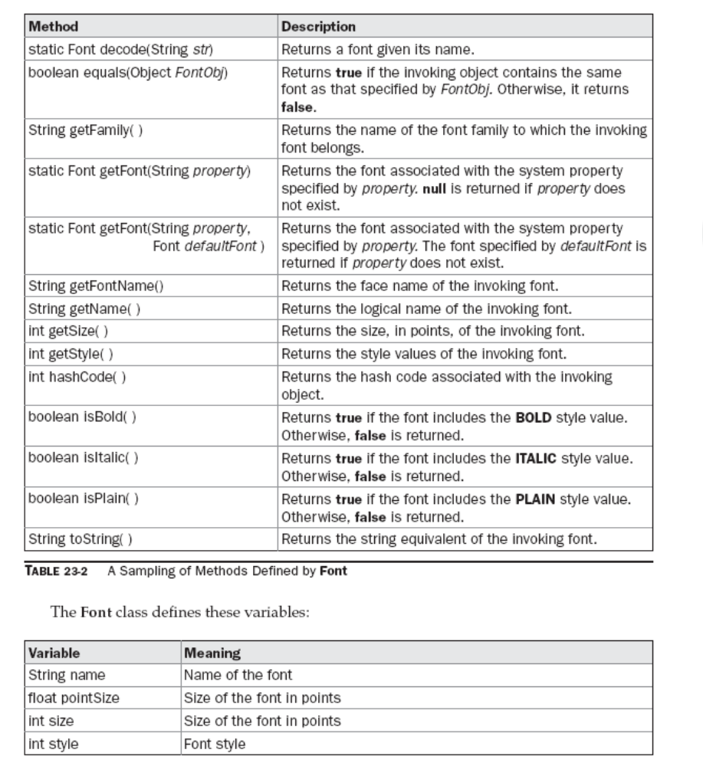

Using AWT Controls, Layout Managers, and Menus
Control Fundamentals
Adding and Removing Controls
Responding to Controls
The HeadlessException
Labels
Using Buttons
Handling Buttons
Applying Check Boxes
Handling Check Boxes
CheckboxGroup
Choice Controls
Using Lists
Managing Scroll Bars
Using a TextField
Using a TextArea

Understanding Layout Managers
FlowLayout (FlowLayout.LEFT, FlowLayout.CENTER, FlowLayout.RIGHT, FlowLayout.LEADING, FlowLayout.TRAILING)
BorderLayout(BorderLayout.CENTER, BorderLayout.SOUTH ,BorderLayout.EAST , BorderLayout.WEST, BorderLayout.NORTH)
Using Insets
GridLayout
CardLayout
GridBagLayout
Menu Bars and Menus
Dialog Boxes
FileDialog
Handling Events by Extending AWT Components
Extending Button
Extending Checkbox
Extending a Check Box Group
Extending Choice
Extending List
Extending Scrollbar

Images
File Formats
Image Fundamentals: Creating, Loading, and Displaying
ImageObserver
Double Buffering
MediaTracker
ImageProducer
ImageConsumer
ImageFilter
Cell Animation
Additional Imaging Classes

The Concurrency Utilities
The Concurrent API Packages
java.util.concurrent
java.util.concurrent.atomic
java.util.concurrent.locks
Using Synchronization Objects
Semaphore
CountDownLatch
CyclicBarrier
Exchanger
Using Callable and Future
The TimeUnit Enumeration
The Concurrent Collections
Locks
Atomic Operations
The Concurrency Utilities Versus Java’s Traditional Approach

NIO, Regular Expressions, and Other Packages
The Core Java API Packages
NIO
NIO Fundamentals
Buffers
Charsets and Selectors
Using the NIO System
Reading a File
Writing to a File
Copying a File Using NIO
Regular Expression Processing
Pattern
Matcher
Regular Expression Syntax
Demonstrating Pattern Matching
Using Wildcards and Quantifiers
Working with Classes of Characters
Using replaceAll( )
Using split( )
Two Pattern-Matching Options
Exploring Regular Expressions
Reflection
Remote Method Invocation (RMI)
Text Formatting
DateFormat Class
SimpleDateFormat Class

JDBC Tutorial
Application design
Database design
Initializing the database connection
Creating the DataSource object
Prepared statements
Prepared insert
Prepared query
Callable statements
Advanced datatypes
Inserting Blobs(setBinaryStream)
Selecting a Blob
Displaying a Blob
Inserting a Clob(getAsciiStream)
Selecting a Clob
Displaying a Clob
* How to design a database, including creating a database schema
* How to create and use a PreparedStatement
* How to create and use a CallableStatement
* How to use some of the advanced datatypes that were introduced in JDBC 2.0

