结果 X=V * M * 100.8 * 1000 / Vw --------- CEDTA = 0.0089 mol/L --------- VNo.4 = 50 ml = 0.05L

- X: 钙离子浓度(以 CaCO3 计), mg/L;

- V: 滴定时EDTA标准溶液消耗的体积, mL;

- M = 0.0089: EDTA标准溶液的浓度, mol/L;

- Vm = 50$: 水样的体积, mL;

- 100.8: CaCO3 的摩尔质量, g/mol.

1. 新4号 2g/100ml 初始pH为超纯水:

|  |  |  |  |  |  |  |  |
| --- | --- | --- | --- | --- | --- | --- | --- |
| Time | 初始pH | 滤料质量(mg) | 平行样1(ml) | 平行样2(ml) | 平均(ml) | 终点pH | 结果X(mg/L) |
| 0.5h | 7.79 | 3.9434 | 0.16 | 0.30 | 0.23 | 8.00 | 4.094 |
| 1h | 7.45 | 4.0125 | 0.48 | 0.46 | 0.47 | 0.27 | 8.366 |
| 2h | 6.6 | 3.9806 | 0.51 | 0.58 | 0.55 | 9.79 | 9.79 |
| 3h | 7.04 | 3.9820 | 0.95 | 0.90 | 0.93 | 9.84 | 16.554 |
| 6h | 7.56 | 3.9874 | 1.85 | 1.91 | 1.88 | 10.22 | 33.464 |
| 8h | 7.54 | 3.9817 | 2.22 | 2.21 | 2.22 | 10.32 | 39.516 |
| 10h | 7.58 | 3.9999 | 2.31 | 2.30 | 2.31 | 10.34 | 41.118 |
| 12h | 7.21 | 4.0511 | 2.50 | 2.53 | 2.52 | 10.52 | 44.856 |
| 16h | 7.71 | 4.0014 | 2.85 | 2.88 | 2.87j | 10.46 | 51.086 |
| 20h | 7.98 | 4.0470 | 3.32 | 3.38 | 3.35 | 10.50 | 59.63 |
| 24h | 6.64 | 4.0410 | 3.33 | 3.55 | 3.44 | 10.61 | 61.232 |
| 28h | 8.29 | 4.0133 | 4.01 | 3.98 | 4.00 | 10.67 | 71.2 |
| 32h | 7.54 | 4.0612 | 3.98 | 3.90 | 3.94 | 10.68 | 70.132 |
| 40h | 7.54 | 4.0077 | 4.47 | 4.57 | 4.52 | 10.76 | 80.456 |
| 52h | 7.71 | 4.0181 | 4.39 | 4.40 | 4.40 | 10.74 | 78.32 |
| 64h | 7.85 | 3.9628 | 4.62 | 4.80 | 4.71 | 10.84 | 83.838 |
| 88h | 7.77 | 3.9832 | 5.94 | 5.90 | 5.92 | 10.96 | 104.450 |
| 112h |  |  |  |  |  |  |  |
| 136hj | 7.72 | 4.0262 |  |  |  |  |  |
| 160h |  |  |  |  |  |  |  |
| 184h | 7.71 | 3.9474 |  |  |  |  |  |

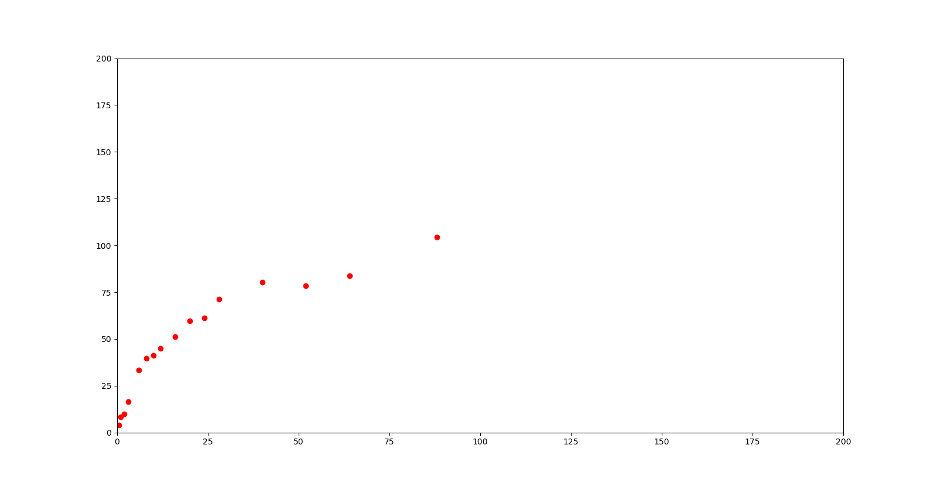

1. 新4号 5g/100ml 初始pH为超纯水:

|  |  |  |  |  |  |  |  |
| --- | --- | --- | --- | --- | --- | --- | --- |
| Time | 初始pH | 滤料质量(mg) | 平行样1(ml) | 平行样2(ml) | 平均(ml) | 终点pH | 结果X(mg/L) |
| 3h | 7.72 | 10.0179 | 2.07 | 2.27 | 2.17 | 10.27 | 38.286 |
| 16h | 7.53 | 9.9756 | 6.47 | 6.39 | 6.43 | 10.78 | 113.446 |
| 40h | 7.34 | 9.9869 | 9.43 | 9.30 | 9.37 | 10.95 |  |
| 88h | 7.73 | 7.73 | 9.9246 |  |  |  |  |

1. L60 2g/100ml 初始pH为超纯水:

|  |  |  |  |  |  |  |  |
| --- | --- | --- | --- | --- | --- | --- | --- |
| Time | 初始pH | 滤料质量(mg) | 平行样1(ml) | 平行样2(ml) | 平均(ml) | 终点pH | 结果X(mg/L) |
| 0.5h | 7.68 | 3.9229 | 0.12 | 0.12 | 0.12 | 9.52 | 2.136 |
| 1h | 7.61 | 4.0753 | 0.47 | 0.51 | 0.49 | 9.66 | 8.722 |
| 2h | 7.78 | 3.9807 | 0.71 | 0.70 | 0.71 | 10.18 | 12.638 |
| 3h | 7.39 | 3.9222 | 0.70 | 0.81 | 0.76 | 10.36 | 13.528 |
| 6h | 7.34 | 4.0430 | 0.92 | 0.91 | 0.92 | 10.38 | 16.376 |
| 8h | 7.40 | 3.9801 | 1.27 | 1.37 | 1.32 | 10.71 | 23.496 |
| 10h | 7.71 | 4.0198 | 1.80 | 1.79 | 1.80 | 10.86 | 32.04 |
| 12h | 7.19 | 3.9577 | 1.80 | 1.62 | 1.71 | 10.74 | 30.438 |
| 16h | 6.88 | 4.0333 | 1.84 | 1.86 | 1.85 | 10.79 | 32.93 |
| 20h | 7.32 | 3.9780 | 2.46 | 2.32 | 2.39 | 10.82 | 42.542 |
| 24h | 7.41 | 4.0010 | 2.58 | 2.56 | 2.57 | 10.95 | 45.746 |
| 32h | 7.34 | 4.0132 | 2.89 | 2.87 | 2.88 | 11.00 | 51.086 |
| 40h | 7.65 | 3.9898 | 3.03 | 3.12 | 3.08 | 11.04 | 54.824 |
| 52h | 7.86 | 3.9730 | 3.60 | 3.76 | 3.68 | 11.00 | 65.504 |
| 64h | 7.45 | 4.0198 | 3.90 | 4.10 | 4.00 | 11.15 | 71.2 |
| 88h | 7.49 | 3.9688 | 4.20 | 4.20 | 4.20 | 11.11 | 74.76 |
| 112h | 7.48 | 4.0028 |  |  |  |  |  |
| 136h | 7.41 | 3.9268 |  |  |  |  |  |

