# **Claw Design Process**

## **Grabber Shape**

Several initial concepts were considered for the grabber’s shape, including:

* **Triangular prism**
* **3D frustums**
* **Cone**

After evaluating these options, the **3D frustums** were chosen as the optimal design. This choice allows the sample to snap into position while enabling gripping in two orientations. In contrast, the cone permitted too much free rotation, reducing control, while the triangular prism could only pick up objects in a single direction.

## **Opening and Closing Mechanism**

The following mechanisms were explored for the claw’s opening and closing functionality:

* **Rack and pinion system**
* **Adjacent gears**

The final design incorporates **two adjacent gears**, as this configuration is the simplest to implement while remaining compact and minimally intrusive to other robot components.

**Initial Sketches of the Final Claw Design**

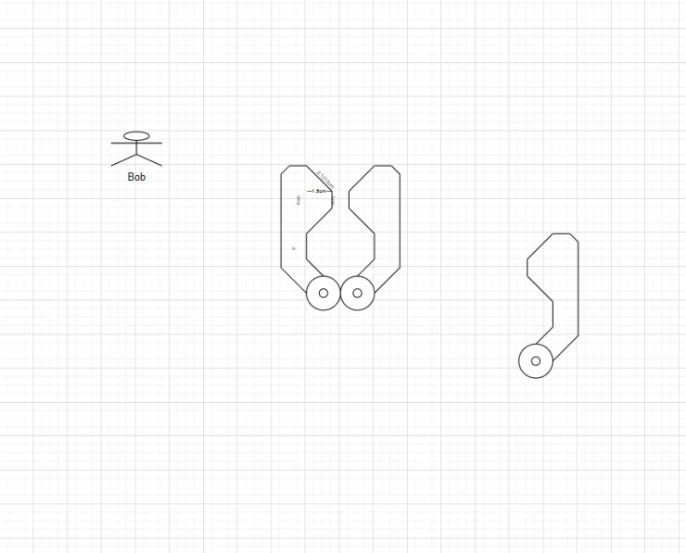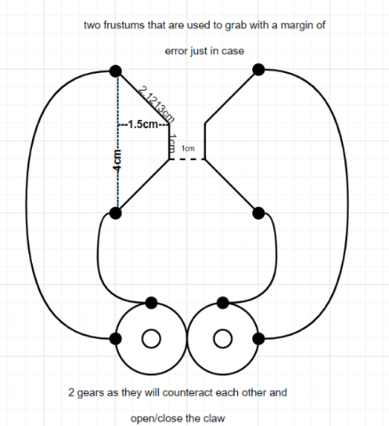

## **First 3D Design**

We used Onshape to make a 3D model of the initial 2D design, enabling us to visualise how the claw would fit into the rest of the robot.

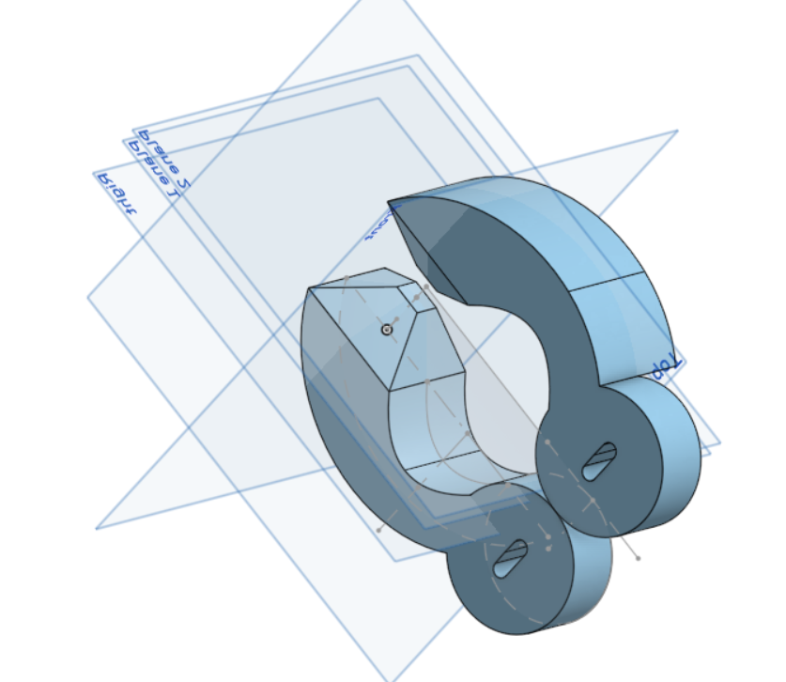

The holes in the circles are long to allow minute adjustments to ensure the gear teeth mesh properly and don’t slip.