INTERCONNECTIO BOARD ASSEMBLY INSTRUCTIONS

This document provides detailed instructions on how to build the InterconnectIO board.
The board has been designed to be assembled by hand or by automatic machine if larger quantities are required. In this document, the instructions are for the hand assembly method.
In the hand assembly method, component sockets will be used for most parts to facilitate component replacement and make repairs easier. Even though the board includes locations for surface mount components, these will not be used. Instead, pre-built modules will be mounted on sockets to simplify the assembly process.
Two types of socket headers will be used:
1. Square header type:
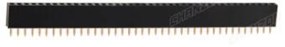

This socket is used when square pins are involved. The pre-built modules use square pins and require a matching socket to ensure a solid mechanical connection.
To minimize the number of different parts to purchase, we selected the longer 40-socket headers, which can be cut to the required length as needed.

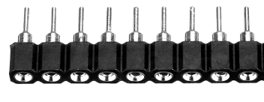
2. Round hole header type:

The round hole header type is preferred due to its smaller size, lower contact resistance and versatility. It can be used directly to mount through-hole electronic components, such as relays and integrated circuits. A round hole male header is required to match with the round hole female header when components do not have pins pre-installed. In the case of the InterconnectIO board, the Raspberry Pi Pico controller will be mounted using a round hole male header.

Assembly Strategy
To facilitate hand soldering of components, the suggested strategy is to solder all the round circular sockets first. Achieving straight alignment of the round sockets can be tricky and requires some practical experience.
Once the round sockets are soldered, the other components can be installed, following the rule of soldering smaller components first, then moving on to larger ones.

ASSEMBLY INSTRUCTIONS
Follow these steps to successfully assemble the PCB:

Preparation
- Ensure you have the required components and tools (e.g., soldering iron, flux, multimeter).
- Review the Bill of Materials (BOM) to ensure all parts are available.
- Refer to the document Interconnect_assembly.pdf to identify the component values to be installed.
- Do not mount components marked N.A. (Not Assembled).
- Do not mount surface-mount technology (SMT) components, as pre-assembled modules will be used in their place.
The picture below of the InterconnectIO Board shows all parts to be soldered.

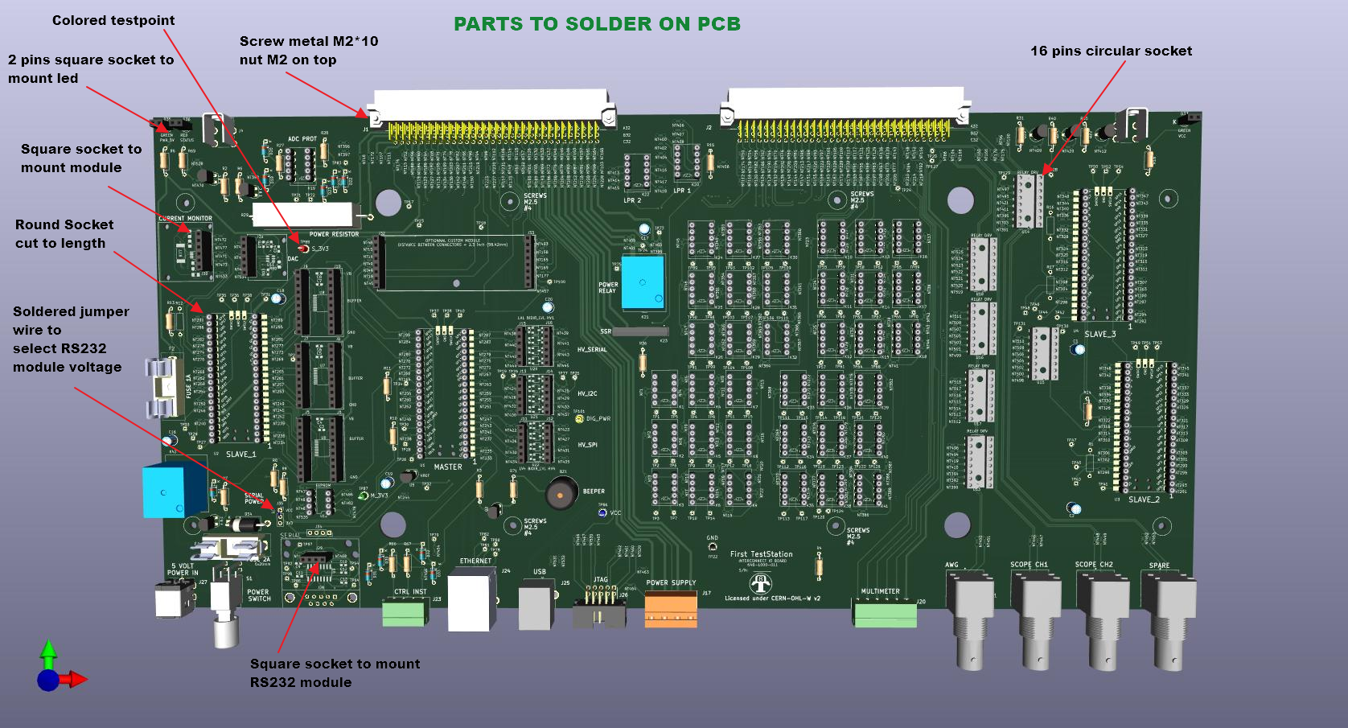
Step-by-Step Soldering Instructions

- Solder Round Pin Sockets: Begin by soldering the round pin sockets (cut to length) for components such as the Microcontroller, ICs, and relays.
- Solder 16-Pin Sockets: Solder the 16-pin sockets to mount integrated circuits. If 16-pin round sockets are unavailable, round socket headers can be used as an alternative.
- Solder Square Pin Sockets: Next, solder the square pin sockets (cut to length) at the pre-assembled module locations. Refer to the board picture for correct placement.
- Solder LED Sockets: The front panel LEDs are mounted on square pins and require 2-pin square socket headers. Solder the 2-pin headers in the LED positions.
- Install Large Connectors: Place large connectors J1 and J2 on the PCB. Install the retaining screws before soldering to ensure they are securely mounted.
- Install Smaller Components: Start by soldering the smaller components, such as resistors, capacitors, and test points, before moving on to larger components.
- Solder Other Connectors: Attach and solder all remaining connectors.
- Solder Pins Header on Pico: Solder 2x20 round pin headers on the bottom of the Pico module. If modifications to the software code are required, solder a 3-pin square header on the top of the module to debug code.
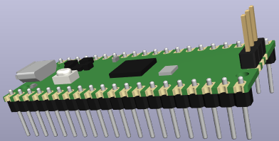

- Solder Module Pins Header: Pre-built modules often come with unsoldered header pins. If this is the case, solder the pin headers onto the module before installation. Solder pins header on the bottom of module.
- Solder LEDs to the 2-Pin Header: Solder each LED to the 2-pin header. Ensure you check the polarity by identifying the flat surface of the LED, which indicates the negative side. Bend the LED at a right angle, as shown in the picture, so that the top of the LED is positioned 11mm from the header base, transforming it into a right-angle LED. Repeat this process for all three LEDs.
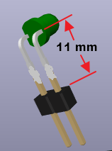

A this point, the soldering is complete and only parts on socket need to be installed.

Step-by-Step Mounting Parts Instructions

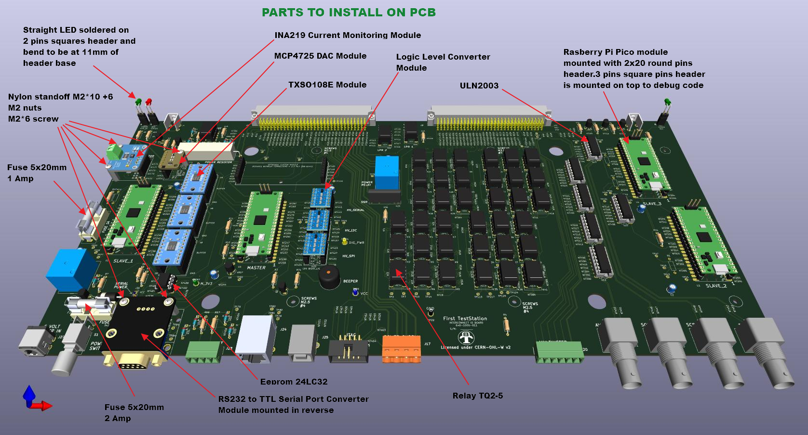
- Mount Relays: Start by installing all the relays. Ensure that each relay is installed with the correct polarity (refer to the picture for guidance).

- Mount Integrated Circuits: Next, install the integrated circuits. Make sure to align pin 1 of each integrated circuit with the pin 1 marking on the board.

- Mount module with double headers: Next install logic level converter module and buffer module TXS0108E.
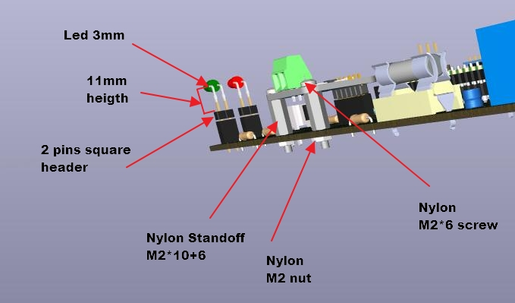

- Mount the standoffs: Install the nylon standoff and secure them with a nut on the bottom of the board (refer to the picture to find location of standoff)

- Mount Single header module: Mount IN219 module and secure them with screws. Repeat procdeure for the DAC module and the RS232 module.

- Mount Pico Master Module: Program one Raspberry Pi Pico with the Master software. Follow the instructions from InterconnectIO_Master GitHub Repository. Once programmed, install the Pico on the Board at the location marked "MASTER." Ensure the module is installed in the correct orientation.

- Mount Pico Slave Modules: Program three Raspberry Pi Pico with the Slave software. Follow the instructions from InterconnectIO_Slave GitHub Repository. Once programmed, install the Pico on the Board at the location marked "SLAVE_x." Ensure the module is installed in the correct orientation.

- Mount Leds module: Finally mount the Led under header to the board following positions and colors.

- Install Fuse: Install the fuse of the specified value (as marked on the board silkscreen) into the fuse sockets.

At this point, the board assembly is complete, and initial testing can be performed.

TESTING
- Shorts Verification: Using a multimeter, verify that there are no shorts present between all the test points: VCC, GND, M_3V3, S_3V3, and DIG_PWR. If any shorts are detected, make the necessary corrections before applying power to the board.

- First Power On:
  - The green LED D37 is ON (5V indicator).
  - The LED on the Pico module is slowly flashing (indicating Pico heartbeat).
  - The RS232 module is powered on (the onboard red LED is ON).
  - Using a multimeter, verify the 5V value between the VCC and GND test points.
  - Using a multimeter, verify the 3.3V value between the M_3V3 and GND test points.
  - Using a multimeter, verify the 3.3V value between the S_3V3 and GND test points.
- Test Serial Communication: Connect the computer's serial port to the InterconnectIO Board's serial port using protocol **N81** and set the baud rate to **115200**. Using a terminal program on the computer, send the SCPI command `*IDN?` and verify if the board responds correctly with an identification message.

Initial testing is complete. Comprehensive testing of the board will require additional hardware and will be included in the First Test Station documentation.

