INTERCONNECTIO_BOX ASSEMBLY INSTRUCTIONS
520-1000-010

This document provides detailed instructions on how to assemble the InterconnectIO_Box.
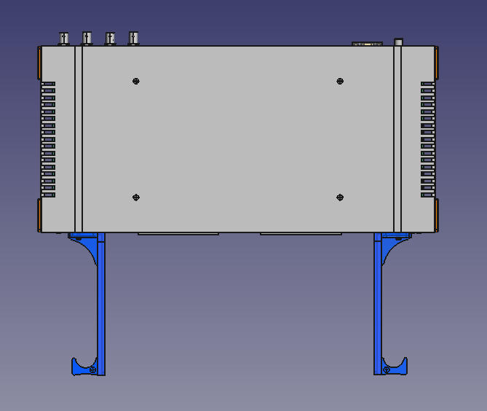
The case was selected based on its cost and its ability to be mounted in a rackmount cabinet. The front and back panels are custom-made for this project and were designed to be laser-cut. The board guide rails were designed to attach to the front panel, with a finger loop added at the top of the guide rails to assist with the insertion and extraction of the interface board.

PREPARATION
Some components are specific to the project and need to be custom-cut or 3D-printed before use. For this project, FabLabs (Fabrication Laboratories) were utilized for 3D printing the parts and laser-cutting the panels.
- Panels
The front and back panels have been laser-cut from 3.175mm plywood. The panel edges must have a maximum thickness of 2.54mm to fit into the case slots designed for the panels.
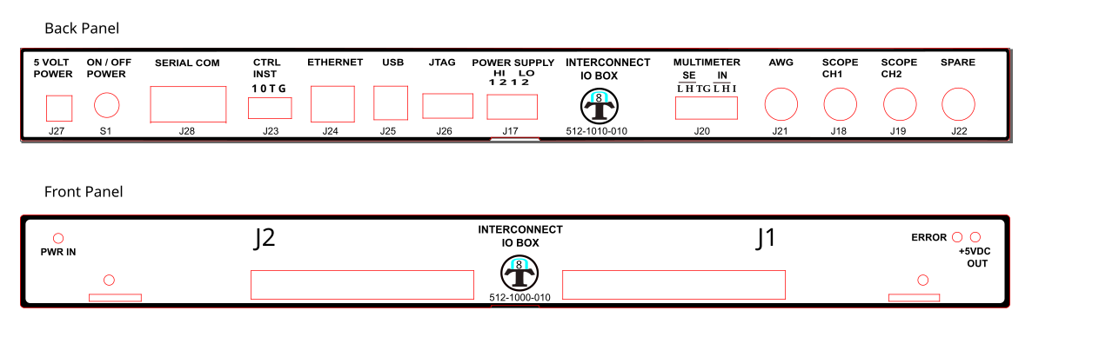
While the panels can be made from other materials (such as aluminum, plastic, etc.), plywood was chosen for this prototype as the most economical option.

- Guide rail
The guide rails are essential for aligning the interface board with the connectors on the InterconnectIO_Box. They have been specially designed to help the operator insert and remove the interface board without applying excessive force.

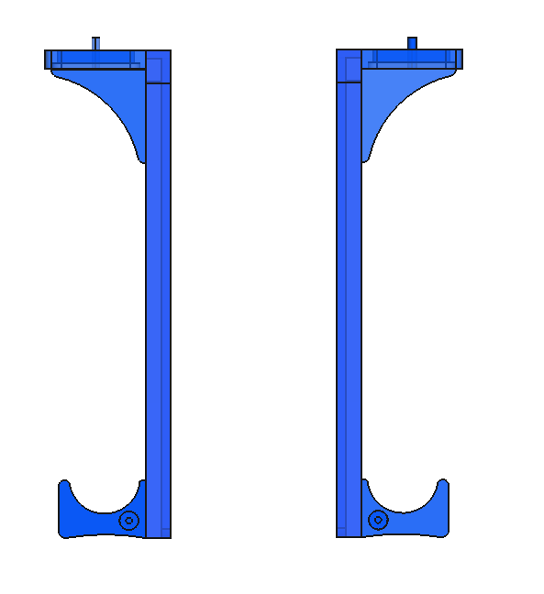
A screw slot has been added to the base of the rails to allow for adjustment according to the size of the interface board. The guide rails were 3D-printed using blue PLA (Polylactic Acid) filament on an Ultimaker S3.

ASSEMBLY INSTRUCTIONS
Follow these steps to successfully assemble the Box:

Preparation
- Ensure you have the required components and tools (Philips screwdriver).
- Review the Bill of Materials (BOM) to ensure all parts are available.

Step-by-Step Instructions
- Front and Back panel: Insert the custom front and back panels into the slots on the bottom of the case.
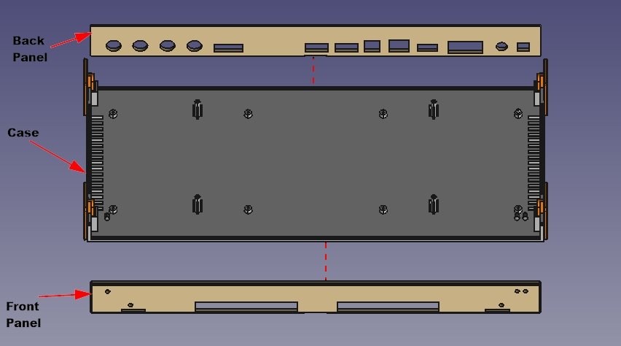
- Insert PCB: Install the InterconnectIO Board into the case, aligning the connectors with the front and back panels. Secure the board using screws.
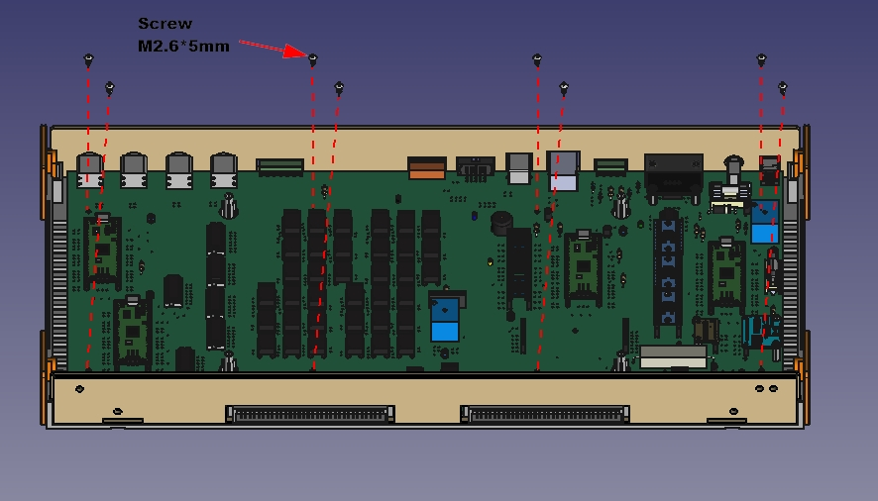
- Insert Led Lens: Insert the LED lens into the front panel, then push the LED into the holder.

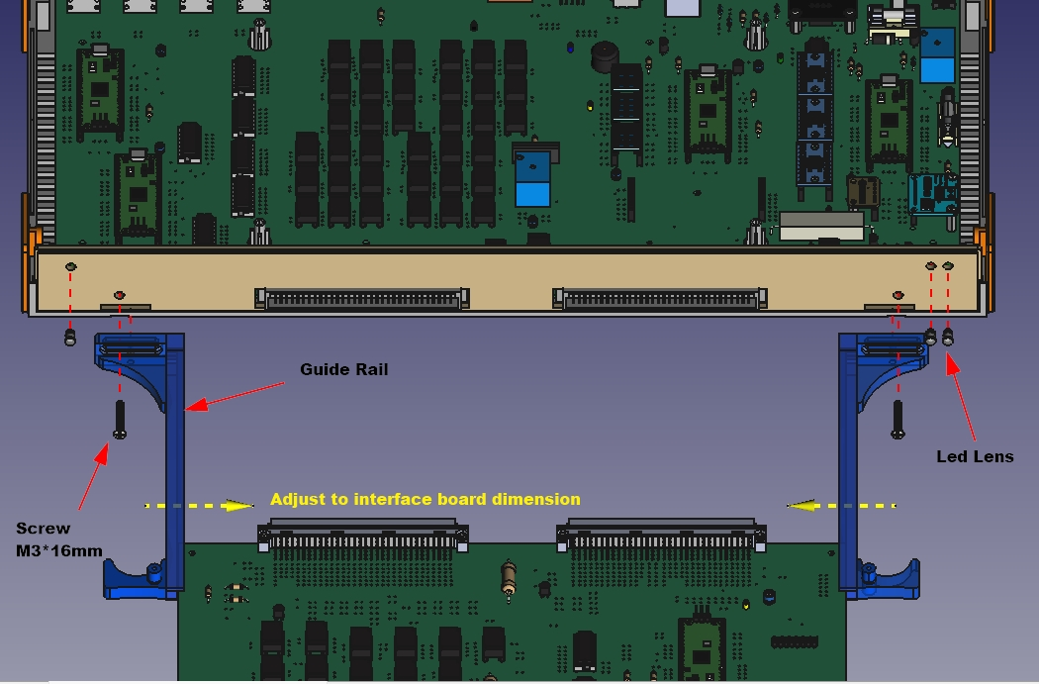
- Install Guide rails: Install the guide rails and secure them with screws. Slide the interface board into the front panel to connect it with the connectors. Adjust the guide rails to ensure the interface board fits properly within the rails, then tighten the guide rail screws. Verify that the interface board slides in and out smoothly.

- Install top case cover: Finally, install the top case cover and secure it with the provided screws.
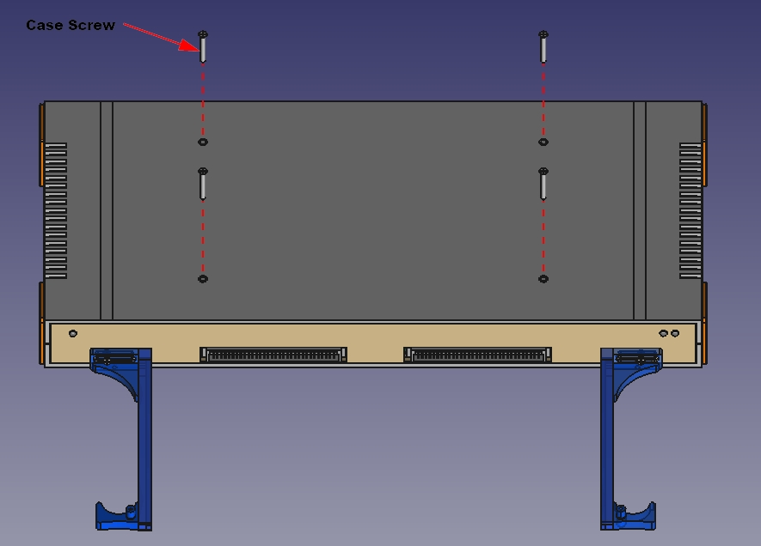

TESTING

- Power On:
  - Connect 5V power pack to the Box
  - Press Power button
  - The green led marked PWR IN is ON (5V indicator).
  - The 4 Pico controller green led is flashing slowly (top cover removed)

- Test Serial Communication: Connect the computer's serial port to the InterconnectIO Box serial port using protocol **N81** and set the baud rate to **115200**. Using a terminal program on the computer, send the SCPI command `*IDN?` and verify if the box responds correctly with an identification message.

Box testing is complete. Comprehensive testing of the board will require additional hardware and will be included in the First Test Station documentation.

