INTERCONNECTIO_BOX TEST INSTRUCTIONS
520-1010-010

This document provides detailed instructions for testing the InterconnectIO_Box to validate its functionality.

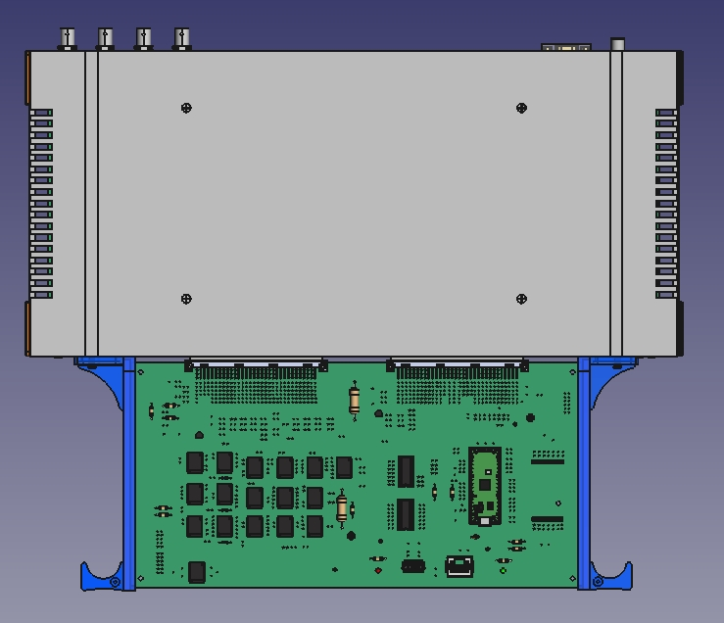

Validation of the InterconnectIO Box using the self-test board was intended to be the first program written with OpenTAP software. However, the designer chose to delay the development of the high-level software, instead incorporating a comprehensive built-in self-test within the Master software to verify both hardware and software functionality."
The built-in selftest can be executed using simple SCPI commands but requires the selftest board to be connected to the InterconnectIO_Box. Additional hardware, such as a loopback connector, and instruments can be added to the InterconnectIO_Box to increase test coverage."

Features
- Built-In SelfTest: A complete self-test can be initiated using the simple SCPI command: SYST:TEST.
- Debug Messages: Detailed messages are sent to the debug serial port (Pico USB port) for troubleshooting.
- Loopback Connectors: Some functions of the InterconnectIO_Box can be validated using loopback connectors.
- Instrument Validation: External instrument functionality is validated manually. Step-by-step instructions are provided to the operator to complete the self-test sequence. Programmable instruments are not required for the built-in selftest.

Hardware
HARDWARE
This section defines the materials required to perform the complete validation test of the InterconnectIO_Box.
The built-in self-test is designed to support different levels of testing. The basic level requires no additional hardware aside from the self-test board, while more advanced levels will require external instruments or loopback connectors.
By dividing the complete test of the InterconnectIO Box into sections, the testing sequence becomes more comprehensible, and debugging is made easier.
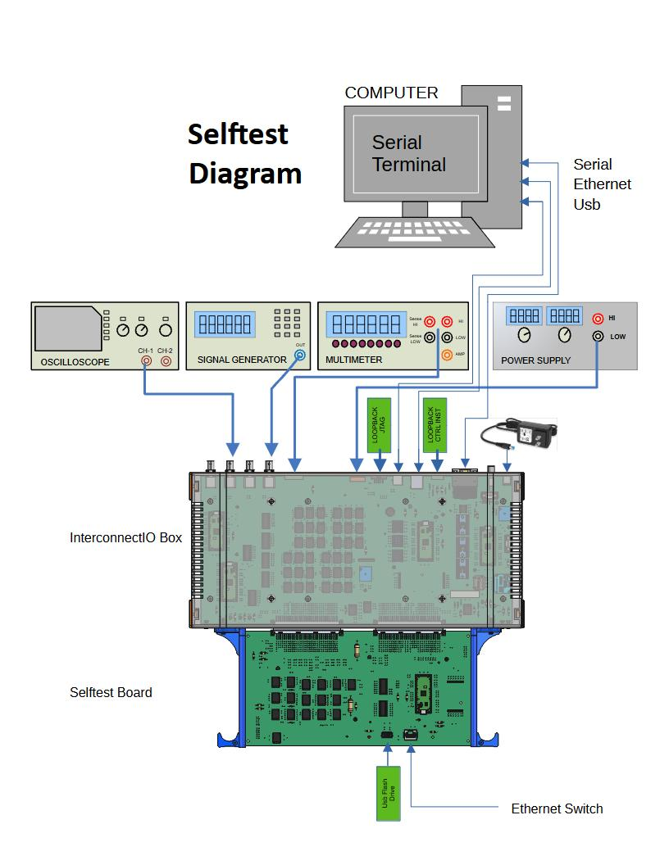
- Level 1 Test: Electronics Validation
The level 1 test the electronic on the board following the defined test strategy. Recommended to run for assembled board, the test is automatic and follow the test strategies.
Material: Selftest Board 600-1010-xxx
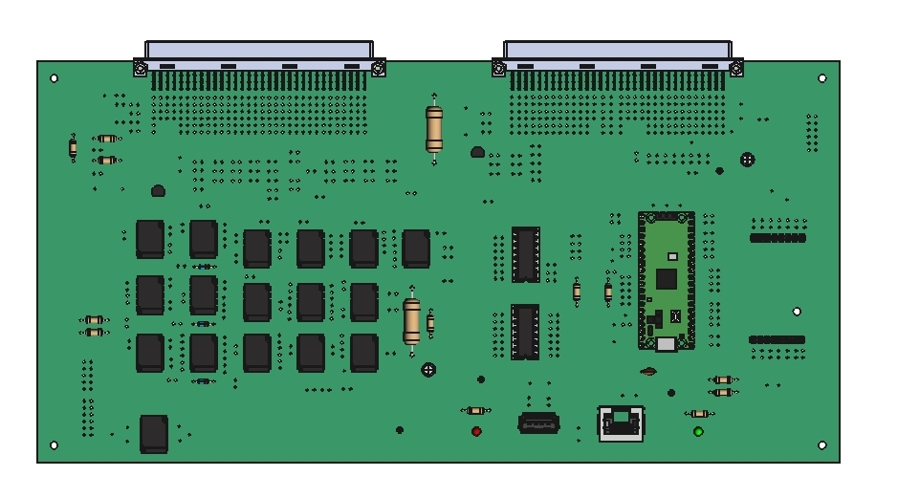
- Level 2 Test: Loopback Connectors Addition
Level 2 adds loopback connectors (see electrical diagram below) to the test, allowing the validation of the functionality of the CTRL_INST and JTAG connectors. For the JTAG connector, the test only verifies the wiring traces and does not follow the full JTAG protocol.

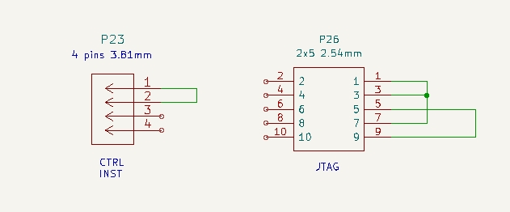
Materials:
- 4 pins 3.81mm female connector with wire between P23.1 and P23.2
- 10 pins (2x5 pins 2.54mm) female connector with wires between P26.1, P26.3 and P26.7. Add second wire between P26.5 and P26.7
  - Selftest Board 600-1010-xxx

When wiring completed, P23 and P26 will be connected to J23 and J26 on the back panel of the InterconnectIO box

- Level 3 Test: External Instrument Validation
Validate the test of the electronics wired to the external instruments. During normal usage of the First Station Test (FTS), the instruments are controlled by the OpenTap software, and the test is performed automatically without any intervention. However, during a built-in self-test, the instruments are manually controlled, and connections can be moved from one point to another to reduce the number of instruments required to complete the test.
Materials:
- Digital Multimeter with Volt Amp Ohm
- 2-channel Oscilloscopes
- Sinus and Triangle Signal generators
- Variable Power Supply (0-12V @ 500 mA)
- Formatted USB Flash Drive
- Ethernet Network

- Serial Interface
The communication with the InterconnectIO_Box uses a standard serial port without handshaking. A computer running Windows or Linux can be used.
Materials:
  - Serial cable with DB9 Female or USB to Serial adapter
  - Free Serial Terminal application (Putty on PC or CuteCom on Linux)
  - USB Type-A to Micro-USB cable to use with the serial console
The serial protocol used is N81 (No parity, 8 bits, and 1 stop bit), with a default Baudrate of 115200. Each Raspberry Pi Pico controller located on the InterconnectIO_Box is programmed to use the USB connector for serial communication using the N81 protocol and a Baudrate of 115200. The usage of this interface is similar to a serial console and can be used to monitor commands received by each Pico.

VALIDATION
This section provides the procedure to follow to perform the built-in self-test. The procedure assumes that the initial test of the InterconnectIO_Box and the Selftest Board has been successfully completed.

Step 1: Serial Communication
- Connect the serial cable between the computer and the InterconnectIO_Box.
- Open a terminal application and configure it with the following settings:
  - Protocol: N81 (No parity, 8 data bits, 1 stop bit)
  - Baud rate: 115200
- Turn on the InterconnectIO Box.
- Verify in the terminal that the display shows:
FTS>

If message not displayed, open the cover of InterconnectIO_Box and connect USB cable to the Master Pico. Setup second terminal to N81 @ 115200 and turn ON the InterconnectIO_Box. Verify in the terminal that the display shows (could take 10 secs):
The actual baudrate used to serial communication is displayed. The Baudrate need to be rounded, in this case, he will be rounded to 115200.
Heartbeat Master,Baudrate: 115207, version 1.0

Step 2: Preliminary Check
- Type in Terminal the command *IDN?
- Verify in the terminal that the display shows:
FTS> *IDN?
FirstTestStation,InterconnectIO,2022A,1.0

if no answer received, verify on the master serial console if the message has been received (see image below).
FirstTestStation,InterconnectIO,2022A,1.0
SCPI Command: *IDN?

Step 3: Built-in Selftest Execution
- Type in Terminal the command SYST:TEST
- Verify in the terminal that the display shows:
SYST:TEST

Internal Test Sequences
1- Selftest using only selftest board, no check of Onewire
2- Selftest run only if selftest board is installed, Onewire validation
3- Selftest using selftest board and loopback connector
4- Selftest of instruments in manual mode using selftest board
5- Test of SCPI command,selftest board is required
0- Exit test sequence
Enter test number to execute and press enter:

- Type in Terminal the number 4 (Test of SCPI Command)
- Verify in the terminal that the display shows:
TEST COMMAND RESULTS:
NbTotal: 137, NbGood: 137, NbBad: 0, NbError: 0
TEST COMMAND COMPLETED

- Type in Terminal the number 1 (Selftest only)
- Verify in the terminal that the display shows:
SELFTEST RESULTS:
NbTotal: 211, NbGood: 211, NbBad: 0, NbError: 0
SELFTEST COMPLETED

- Type in Terminal the number 3 (Selftest + Loopback)
- Verify in the terminal that the display shows:
- Type in Terminal the number 4 (Selftest of Instruments)
SELF TEST RESULTS:
NbTotal: 231, NbGood: 231, NbBad: 0, NbError: 0
SELFTEST COMPLETED
- Follow step by step instructions on terminal to complete the test.
- Verify in the terminal that the display shows:

- Type in Terminal the number 0 (Exit Built-in Selftest)
Manual Instruments Test
Connect DMM to Sense pins (+:J20-5 & -:J20-6)
Set DMM to be able to read 10 ohms resistors

Debugging Steps for Selftest Failure:

- Repeat the Test:
  - Run the selftest again to ensure that the failure is not intermittent or caused by a temporary issue. This helps confirm whether the issue is consistent or was a one-time error.
- Verify Fail Test Functionality:
  - Check the Validation Table Document to confirm the expected behavior for each test function. Ensure that all test criteria are properly defined and that the failure aligns with the documented conditions.

- Analyze Results on the Serial Console:
  - Carefully examine the output on the serial console. Look for any error codes, messages, or patterns that might indicate the root cause of the failure. These could point to specific parts of the system, such as communication errors or hardware issues.

- Send Commands Manually:
  - To further isolate the problem, send the relevant commands manually from the terminal to reproduce the failure. This will allow you to directly observe the system's behavior in response to the commands and check if the failure can be replicated.

- Perform Correction and Repeat the Test:
  - Once the issue has been identified, apply the necessary corrections (e.g., fix wiring, adjust configuration, replace faulty components). After the correction, rerun the selftest to ensure that the problem is resolved and the system is functioning as expected.

