

Envy Asset User Manual

**1. Product Management**

Description: Allows user to create/update and delete products.

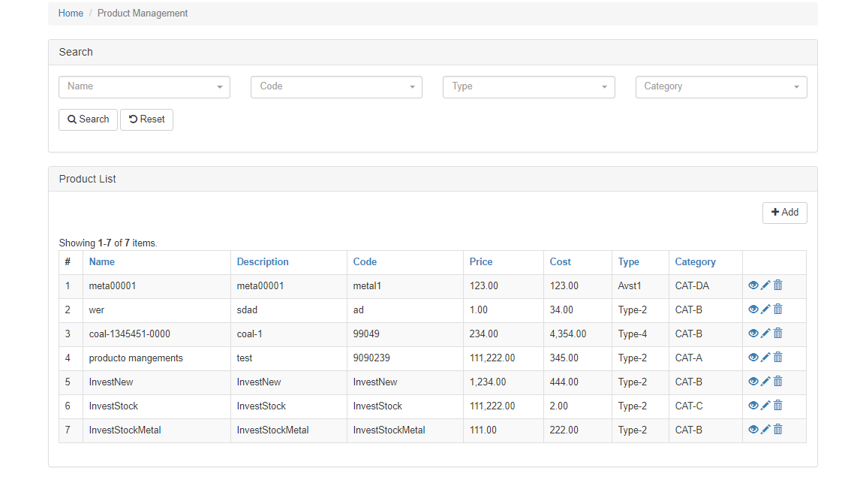

Search Box:

1. Name – the product name

2. Code - the product code.

3. Type – the product type

4. Category – the product category

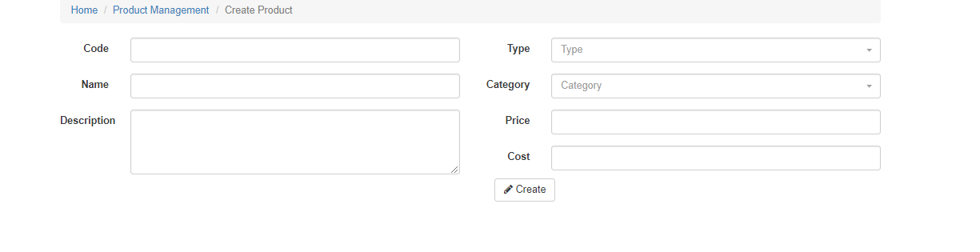

The Product Management Form.

1. Code – the product code entered by user.

2. Name – the product name, entered by user

3. Description – the product description, entered by user.

4. Type – Product type, a list of selected items from the Product type module. (shares/nickel/paper trade/ELN/short term/long term/medium term)

5 Category – Product Category, a list of selected items from the Product Category Module (Future metals trade/physical metal trade/securities/bonds;)

6. Price – Product Price

7. Cost – Product Cost

2. Investor Management

Description: Allows user to create/update and delete investors. Created Investors can login the site which directs them to their respective profile. They can view their transactions there.

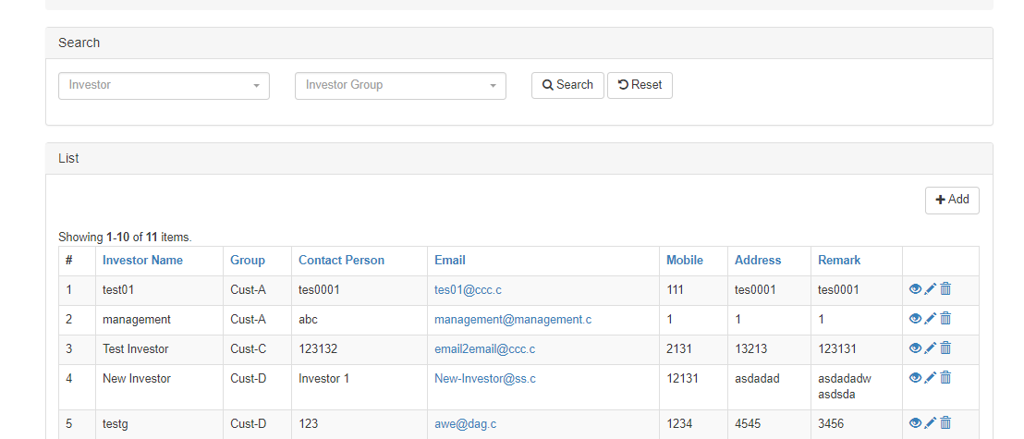

Search Box:

1. Investor – Dropdown List of available Investors.

2. Investor Group – Dropdown List of Investors Groups.

Investor Management Form

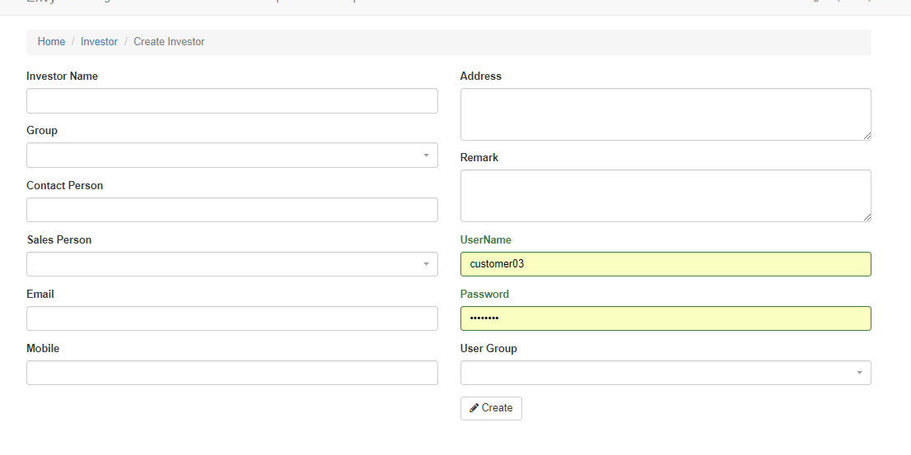

1. Investor Name - Investor’s name.

2. Investor Group – The investor’s group where it belongs

3. Contact Person – Investor’s contact person.

4. Sales Person – Sales person assigned to that investor.

5. Email – Email provided by investor.

6. Mobile – Mobile number provided by investor.

7. Address – Current Address of investors.

8. Remark – Additional information regarding the said investor.

9. User Name – The login id of the investor in the site.

10. Password – Investor’s password.

11. User Group – Access rights of the Investor. Select ‘Investor’ as its access rights.

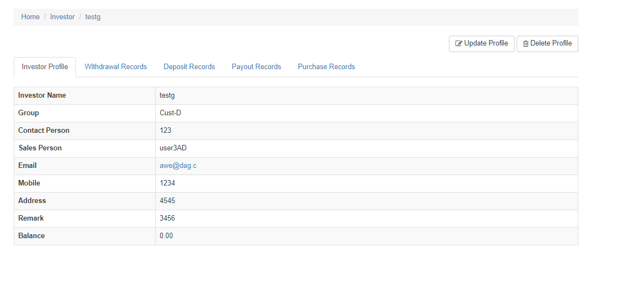

Investor View Page.

In this page, users/staff can view and update the records of the investors – Withdraw, Deposit, Payout and Purchases. Investors who logged will automatically be redirected to their profile.

Tabs:

1. Withdrawal Records – List of Withdraw Records of that investor.

2. Deposit Records – List of Deposit Records of that investor.

3. Payout Records – N/A.

4. Purchase Record - List of Purchase Records of that investor.

Qn: currently we have about 200 investors, is there a way I can input the investors’ data all at once instead of key in one by one?

3. Staff Management.

Description: Create, update and delete Staff/Employees.

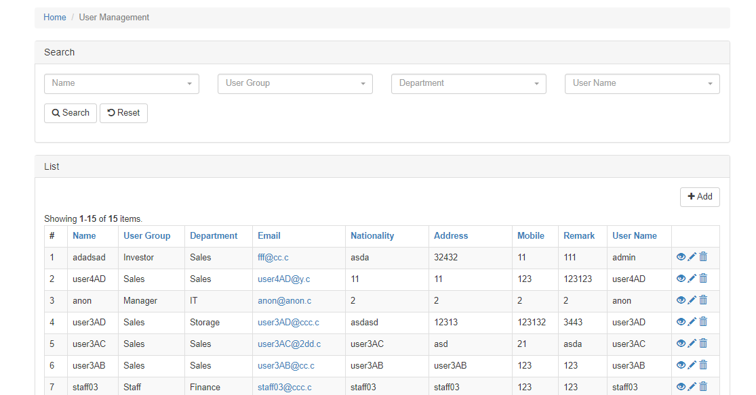

Search Box.

1. Name – Employee’s name.

2. User group – Employee’s assigned user group.

3. Department – Employee’s assigned department.

4. User name – Employe’s login ID.

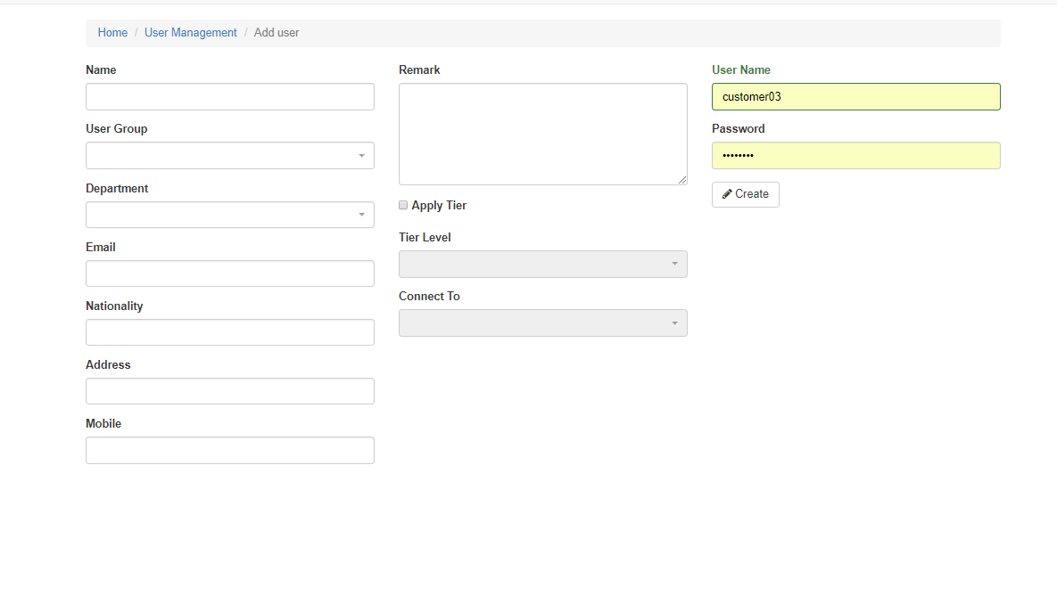

Staff Management Form

1. Name – Employee’s name.

2. User Group – Employee’s user group. (Executive Director/ Director/manager/staff)

3. Department – Employee’s department. (Finance/sales/traders/general admin)

4. Email – Employee’s email address.

5. Nationality - Employee’s nationality.

6. Address – Employee’s address.

7. Mobile - Employee’s mobile number.

8. Remark – Additional information about the employee.

9. Apply Tier- Checkbox. Check if this certain employee with will be a salesperson that will be assigned to an Investor.

10. Tier Level – The tier level of that employee. Based on the pyramid scheme, user can select where this employee belongs too. (one being the highest or 6?)

11. Connect to – Auto-generate a list of employee. If the Tier level selected is ‘three’, it will produce a list of level ‘two’ employees where one can connect them together. (further explanation needed)

12. User Name - Employee’s login ID.

13. Password - Employee’s login password.

4. Metal Investment.

Description: List of all metal transaction, usually uploaded with an excel file. (tried, not working)

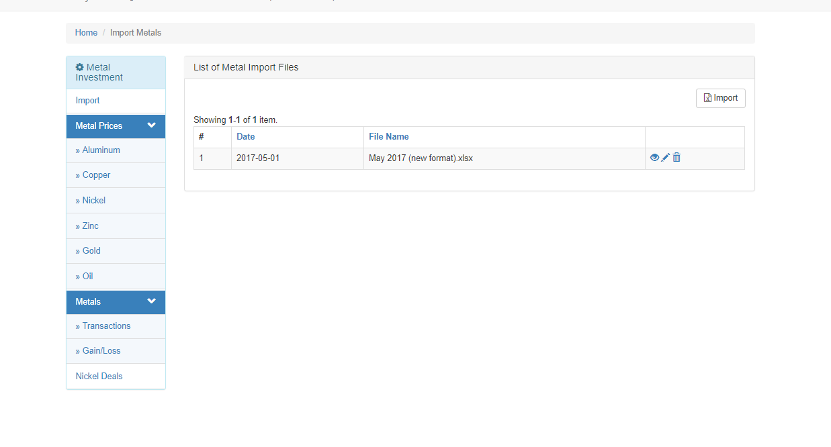

Sidebar Navigation

1. Import – A page where user can import the required excel file to the web. Application will process the data which can be viewed on the web. (need the standard template from you, as our current one does not work)

2. Metal Prices – Metal daily prices, which is in the excel file. Users can update the information here if that is needed. (how to update?)

3. Metals – Divided into two. The transaction deals with all the unrealized metals in the excel file. The gain/loss is the summary/overall of the report. (how to update?)

4. Nickel Deal – Extract the last record on the excel file. Nickel deal will be extracted. If today is Sept 2017 but the excel file – nickel deal has only Aug2017, it will extract Aug 2017. (how to update?)

Import Metal Form

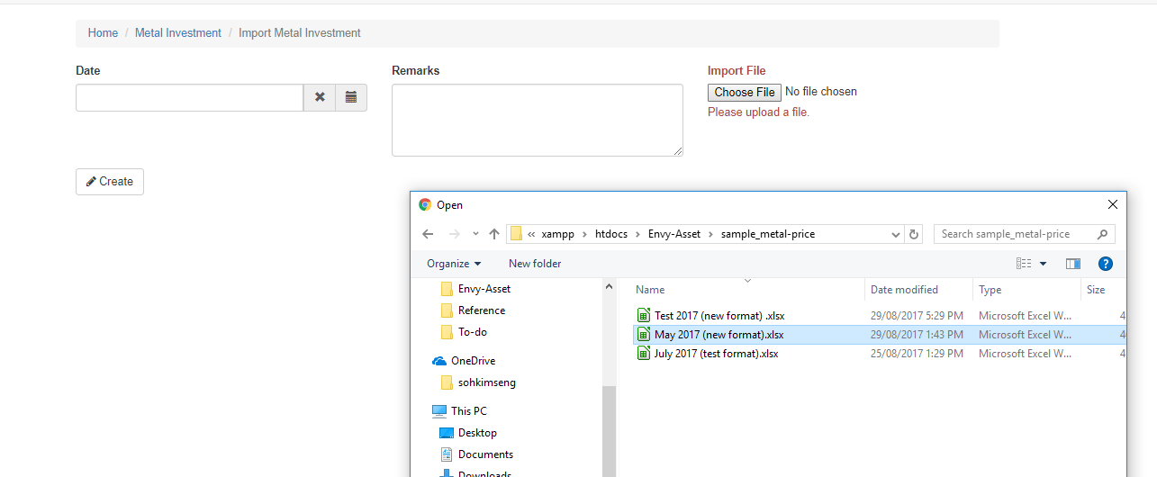

1. Date – DatePicker. The date when the file was uploded.

2. Remarks – Any description or additional information on that file.

3. Import file – upload the file.

Metal Prices

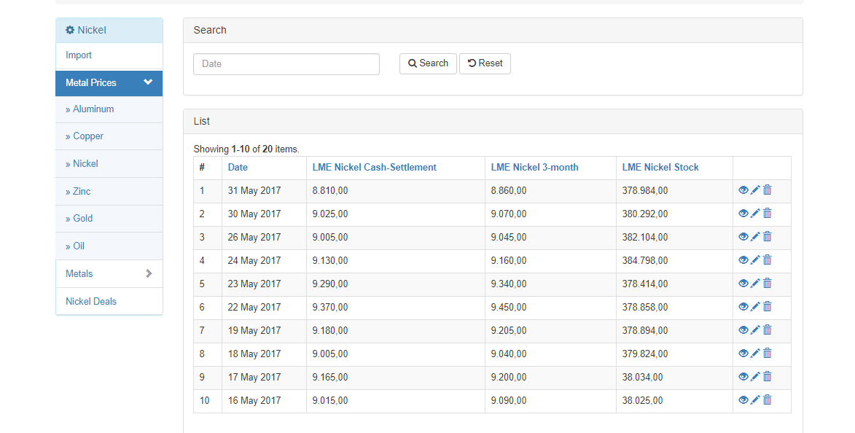

Notes: All metal prices can be updated if the users feel the need to. By clicking on the pencil icon, user can modify the related information. There is a data range filter where user can filter it by month.

Metals

Metal Transaction:

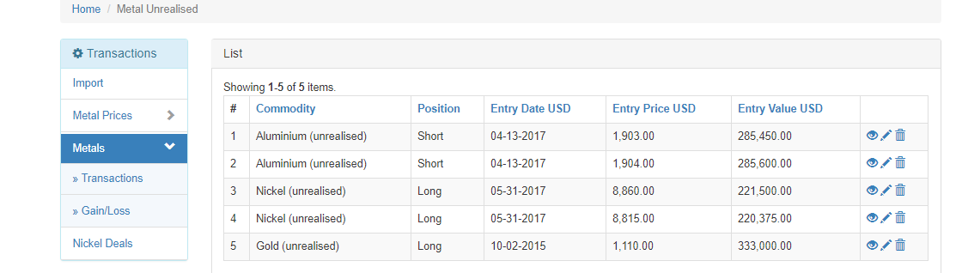

Extracts all metal (unrealised). Users can update the record if there are changes.

Gain/Loss:

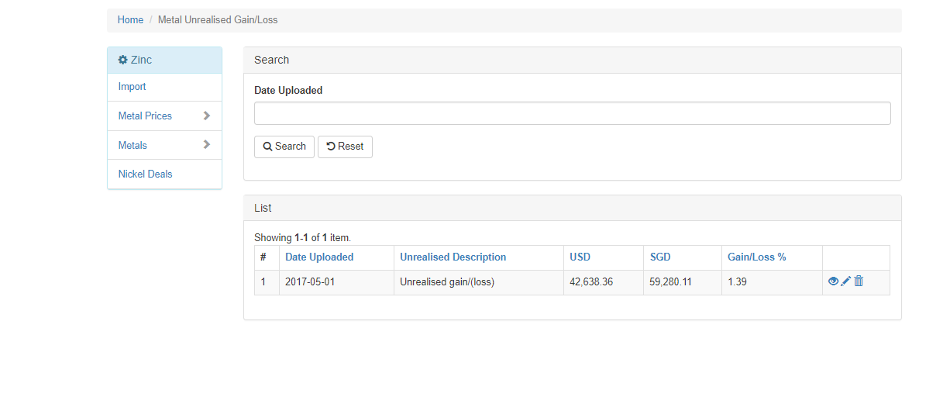

The overall result of the Metal. List the gain/loss and its USD/SGD equivalent. Can be updated if required.

Nickel Deals:

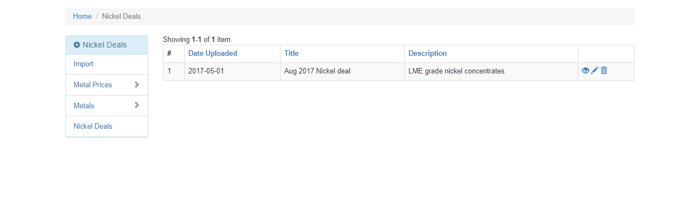

Extract the nickel deal record in the excel file.

5. Stock Investment

Description: Add/update and delete stocks.

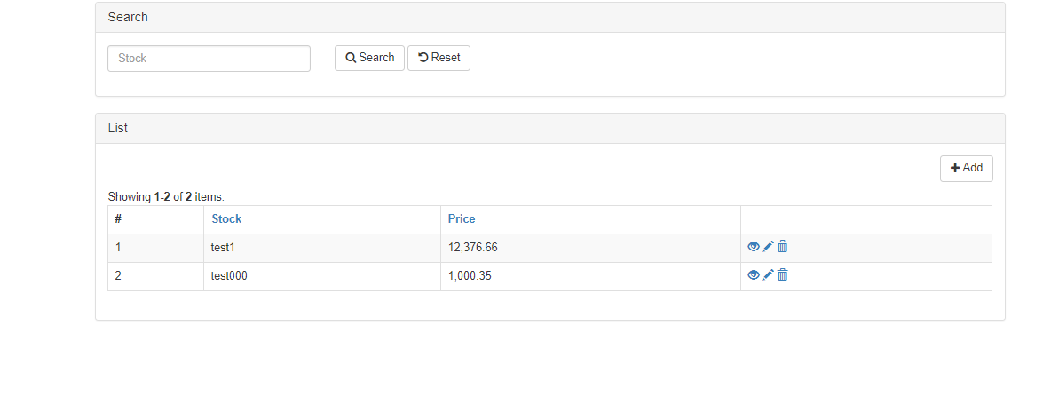

Search Box

1. Stock – The stock name.

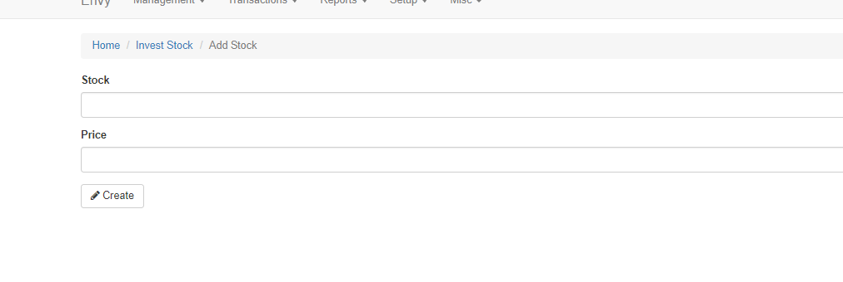

Stock Form.

1. Stock – Stock Name.

2. Price – Stock Price.

We need to add in, buy in price, current market price as at end of the month, unrealized gain/loss

6. Withdraw

Description – Create/Update and delete withdrawal records of Investors.

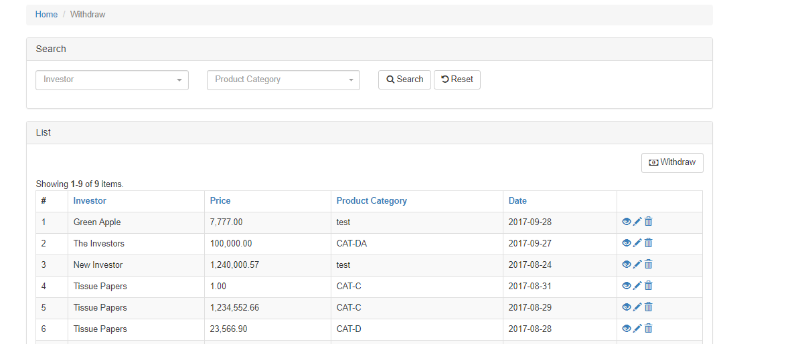

Search Box:

1. Investor- Investor’s name.

2. Product Category – The product’s category where the investor withdrew.

Withdraw Form

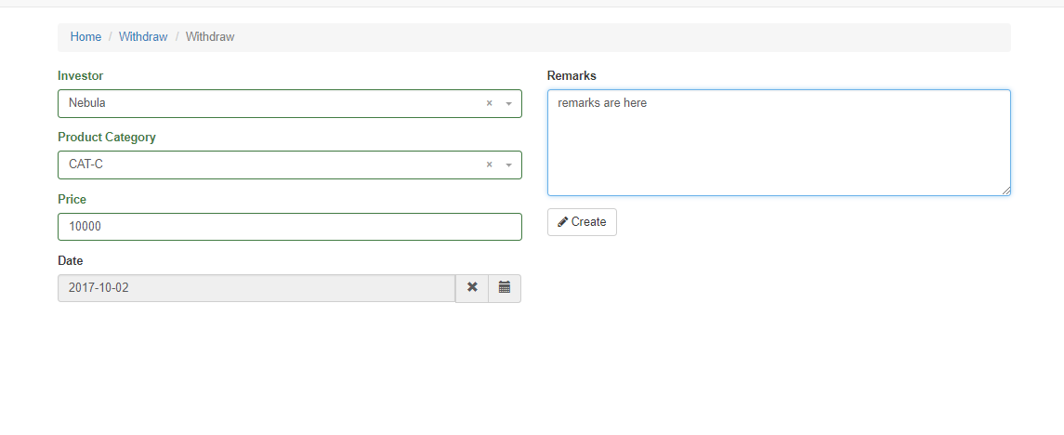

1. Investor – Investor’s Name. A dropdown list of all Investors. Users can select which investor to add.

2. Product Category – Product Category.

3. Price – The withdrawal price. (withdrawal amount)

4. Date – Date where the transaction occurred.

5. Remarks – Additional information.

7. Deposit

Description – Create/Update and delete deposit records of Investors.

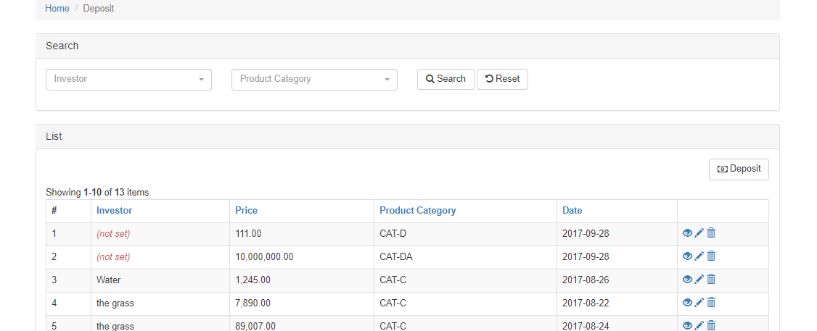

Search Box:

1. Investor- Investor’s name.

2. Product Category – The product’s category where the investor withdrew.

Withdraw Form

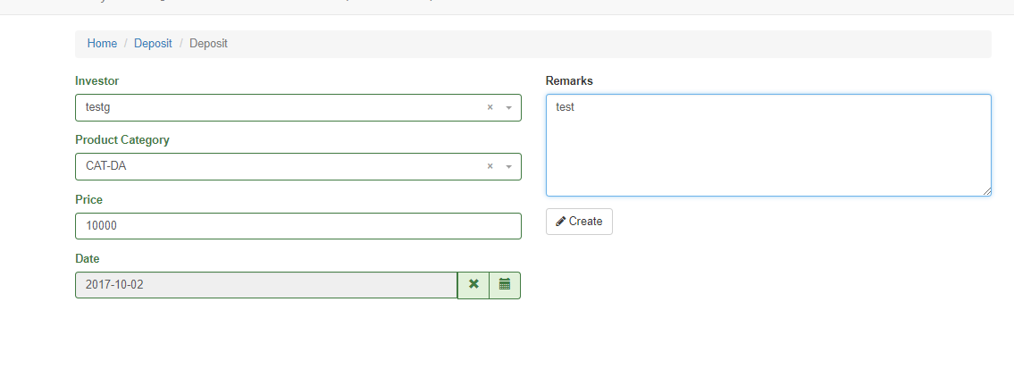

1.Investor – Investor’s Name. A dropdown list of all Investors. Users can select which investor to add.

2. Product Category – Product Category.

3. Price – The deposit price. (deposit amount)

4. Date – Date when the transaction occurred.

5. Remarks – Additional information.

8. Purchase

Description – Add/update and delete investor’s purchases. Successful purchases created will reflect on the salesperson’s commission based on its tier-level. (assuming this is applied to new investment/investor, how about the existing investors/investments, how does existing investors’ portfolio linked to sales person’ commission?)

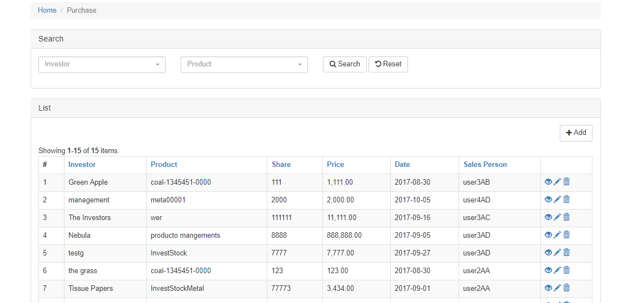

Search Box:

1. Investor – The Investor’s name.

2. Product – Product name where the investor purchases it.

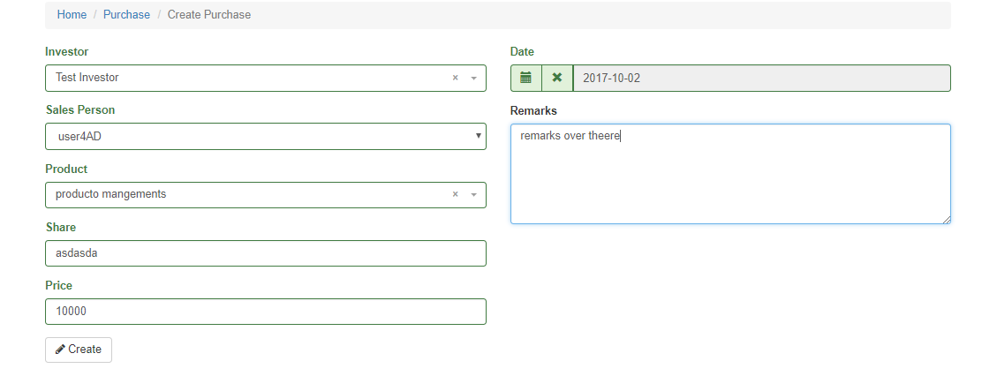

Purchase Form:

1. Investor – A dropdown list where users can select the investor.

2. Sales Person – Auto generated when an Investor is selected. This is the assigned salesperson in the Investor Module.

3. Product – A dropdown list of products available to be purchased.

4. Share – The purchase share. (??)

5. Price – The purchase price. Price will be commissioned to the salesperson and its related tiers. (do you mean capital input?)

6. Date – Purchase Date.

7. Remarks – Additional information regarding the purchase.

Investment overview is Error

9. Commission Report

Description: Generate the commission report. Users can view all the commissions done by the salesperson on the purchase module. Note that users can only edit, view and delete records.

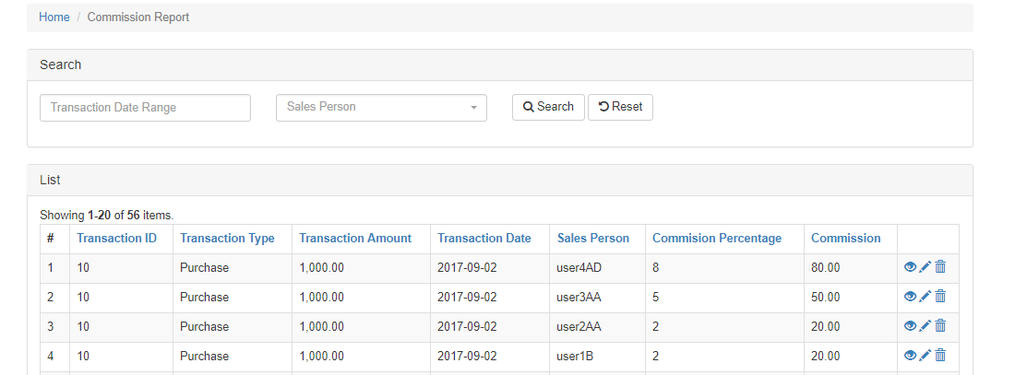

Search Box:

1. Transaction Date Range – Filter the report based on the data.

2. Sales Person – Filter the report based on the selected salesperson.

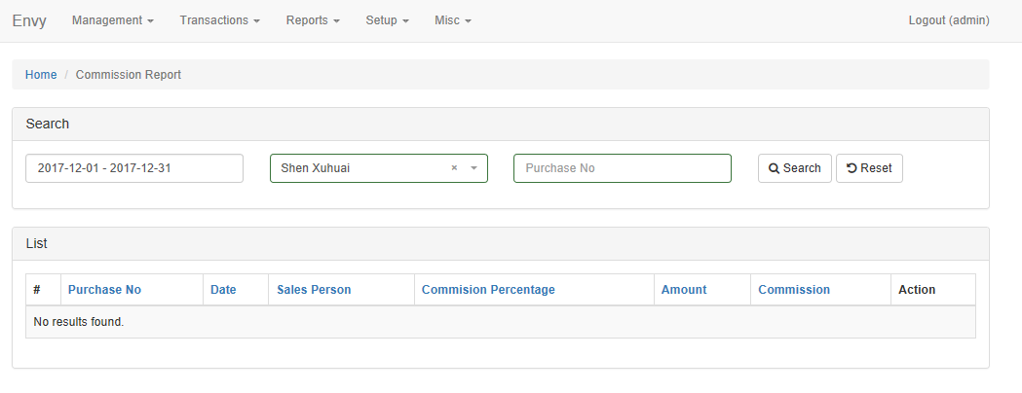

I can’t view/amend anything

List Box:

1. Transaction ID - the ID of the purchase record. Can be used to connect the commission to that purchase record.

2. Transaction Type – The type. Default to purchase.

3. Transaction Amount – the purchase price.

4. Transaction Date – the purchase selected date.

5. Sales Person - The sales persons. Using the pyramid scheme, it will get all the salesperson associated to it to provide their commission.

6. Commission percentage – the percentage that each salesperson get. Can be changed at the tier management module.

7. Commission - The money obtained by the salesperson. Transaction amount * commission percentage

10. Customer Report

Description. Produces the customer report based on the purchase module. It is required to select a date range to produce the list of investors.

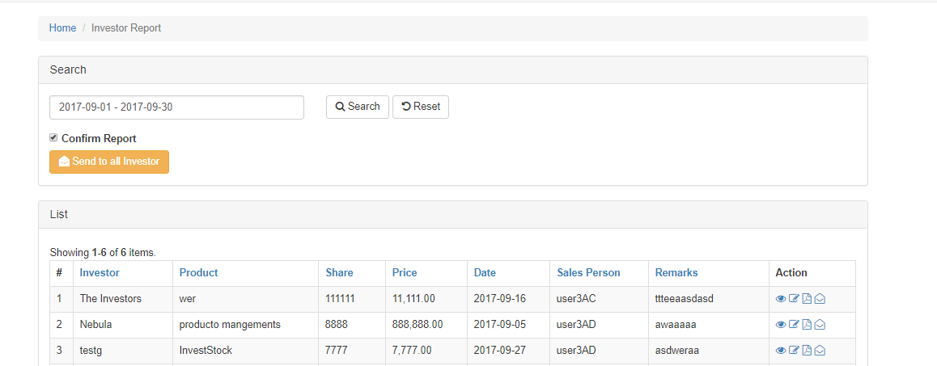

I cant view/edit anything either

Search Box:

1. Date Range – Filter the record based on the date range selected by user.

2. Confirm Report – A checkbox. It shows/hide the button “send to all investor”.

3. Send to investors – A button. Clicking on it will send an email to all investors produce on the table. Attach to it is a pdf file which contains the investment overview report.

List Box:

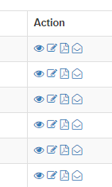

Actions:

1. Eye – Opens the view prompt box. User can view the purchase record of the investor.

2. Pencil – Opens the update prompt box. User can update the record.

3. Pdf file – Download the investment overview to the user’s computer.

4. Envelope – Sends an email to that particular investor. Attach to it is the investment overview report

11. User Rights

Description: Also known as permission setting. Admin can set limitations to usergroup as to what they can do and can’t do to the module. Example. Admin can prevent Staff usergroup from accessing the staff management but they can access the commission report.

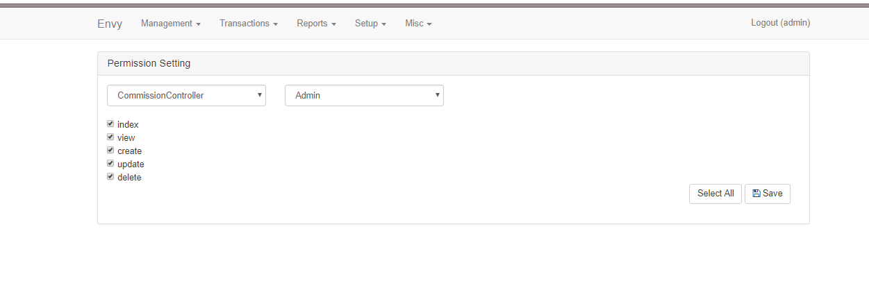

User Right Form (where can I find this user right form?)

1. Modules – List of all modules of the website.

2. Usergroup – List of all usergroups. Usergroups can be created on the usergroup module.

3. Actions – The checkboxes are all actions of that module. Checking one and saving it means that group has access to that action. If usergroup ‘staff’ checked ‘create’ of the commission module, ‘staff’ can create records for the commission module.

12. Investor Group.

Description: Create/update and delete investor group. In the investor module, there is a dropdownlist of investor group. This is the module that handle investor group.

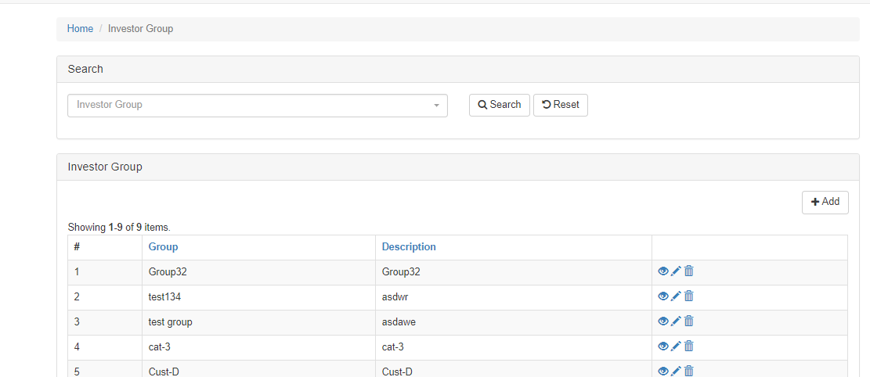

Search Box:

1. Investor Group – The name of the investor group.

List Box:

1. Group -Investor’s Group name.

2. Description – Description of the group.

13. Tier Management

Description: Handles all form/calculation regarding the salesperson’s commission.

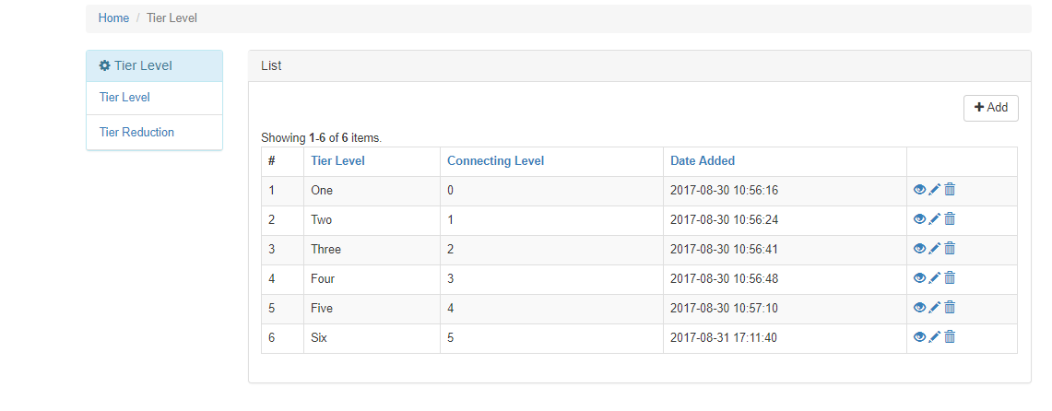

Sidebar Navigation:

1. Tier Level – The tier level. Heavily based on the pyramid scheme. At the staff creation module, there is the tier level, where user can select what level the registered user will be.

2. Tier Reduction – The commission percentage reduction. For every jump from one tier level to another there will be a reduce on the commission percentage that person will received.

Tier Level Form:

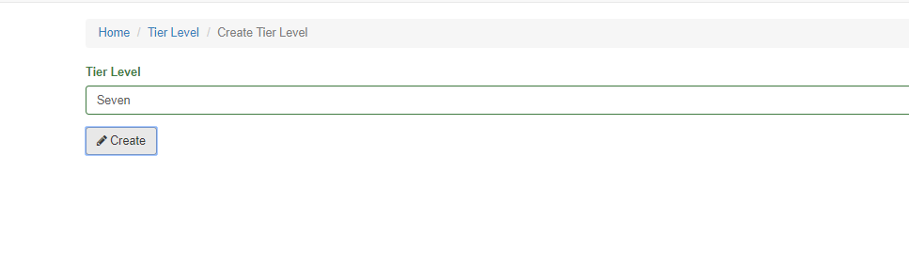

1. Tier Level – The tier level name. I just used the number to represent it.

Tier Reduction

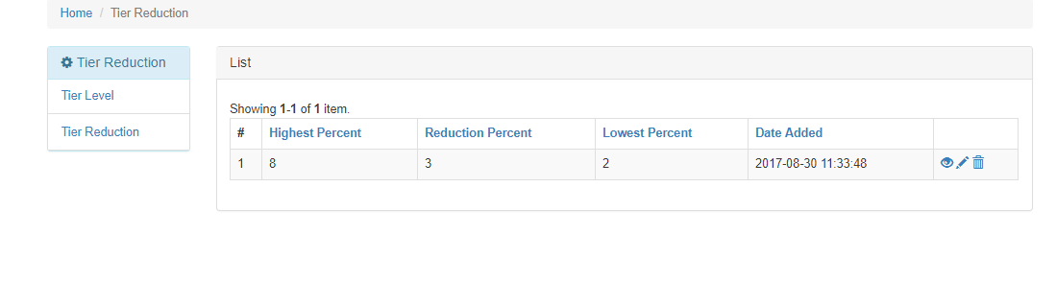

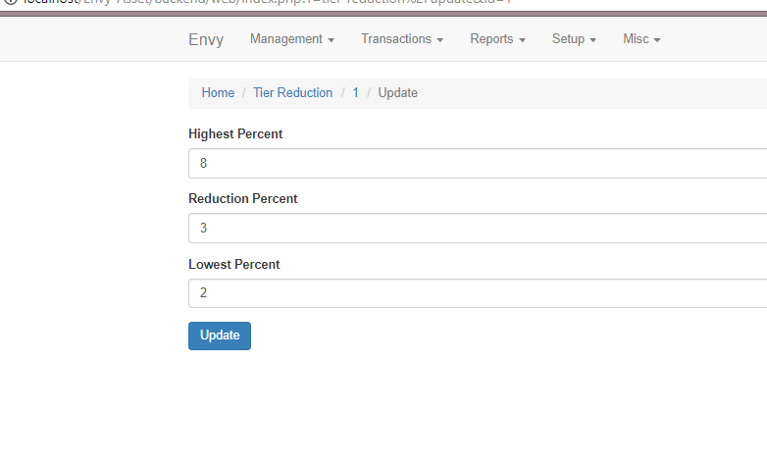Note: In Tier Reduction, you can only update the existing record.

1. Highest Percent – The highest commission percentage a salesperson can get.

2. Reduction Percent – The reduction percentage when the tier jumps (tier 4 to tier 3 then to tier 2).

3. Lowest Percent – The lowest commission percentage. It cannot be reduce to zero.

14. Announcement.

Description: Create announcements. It can view on the home page of the site.

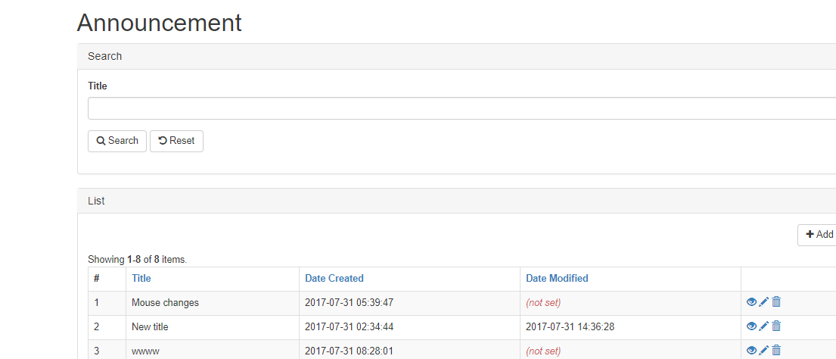

Search Box:

1. Title – Search the title of the announcement.

Announcement Form:

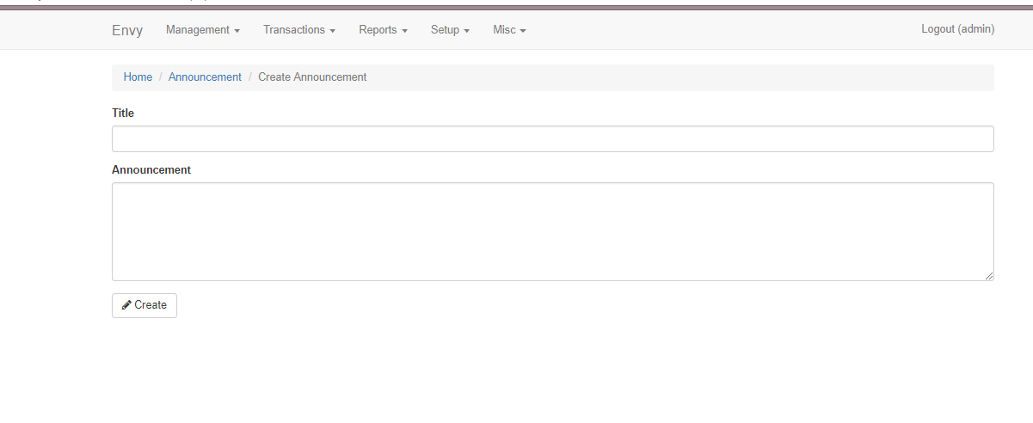

1. Title – Title of Announcement

2. Announcement – The content of the announcement

Output:

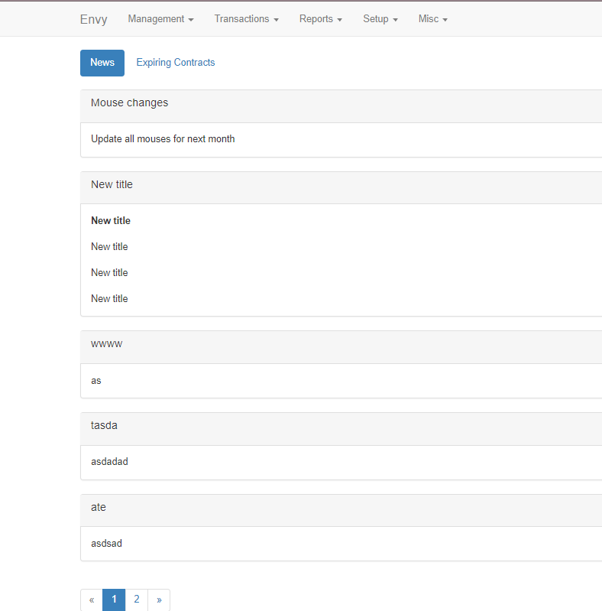

15. User Group

Description: Add/edit and delete usergroups. Usergroup is used on the staff management and user right management as a dropdownlist.

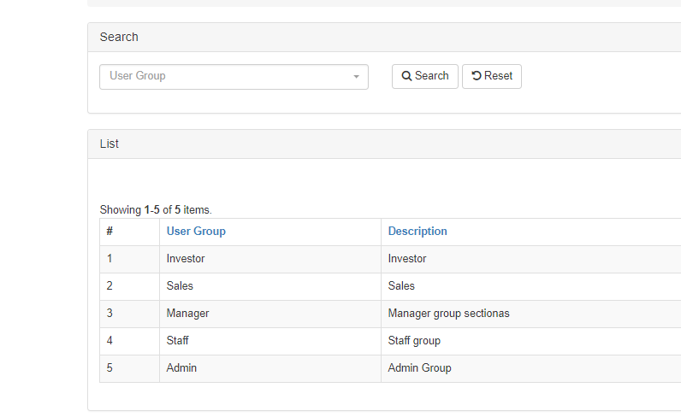

Search Box:

1. Usergroup – Filter the selected usergroup.

List Box:

1. User Group – Name of the user group.

2. Description – Usergroup description.

16. Department

Description: Create/edit and delete department. This is used on the staff management as a dropdownlist.

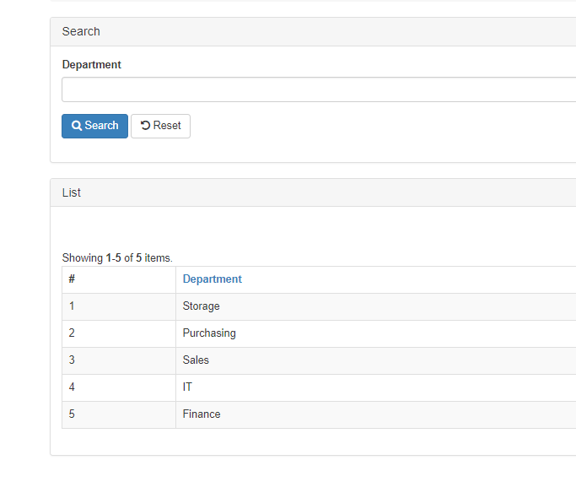

Search Box:

1. Department – Filter department

List:

1. Department – Name of Department.

17. Product Type

Description: Create/edit and delete product type. This is used on the product management as a dropdownlist.

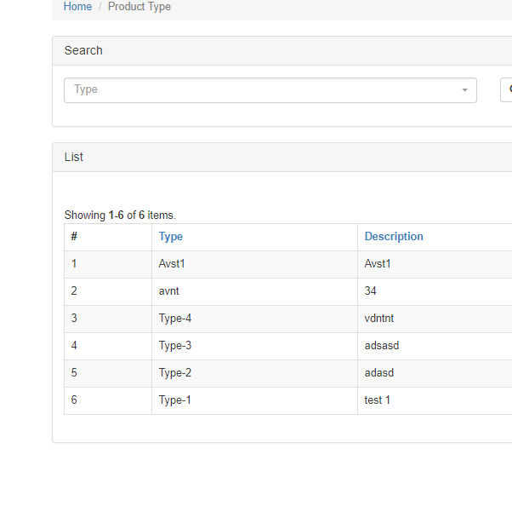

Search Box:

1. Product Type – Filter the product type.

List Box:

1. Type – The product type

2. Description – Product type description

18. Product Category

Description: Create/edit and delete product category. This is used on the product management, withdraw and deposit as a dropdownlist.

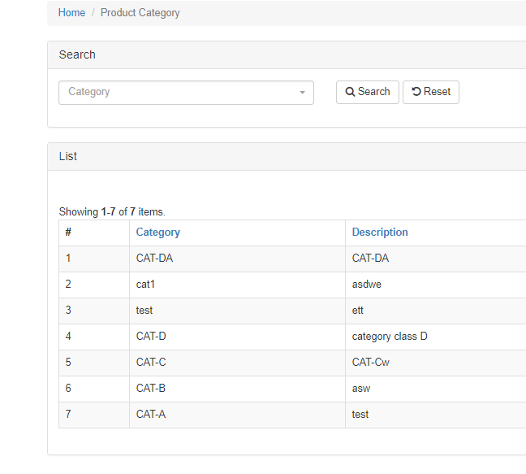

Search Box:

1. Category – Filters the product Category.

List Box:

1. Category – The product category name.

2. Description – Product category description.