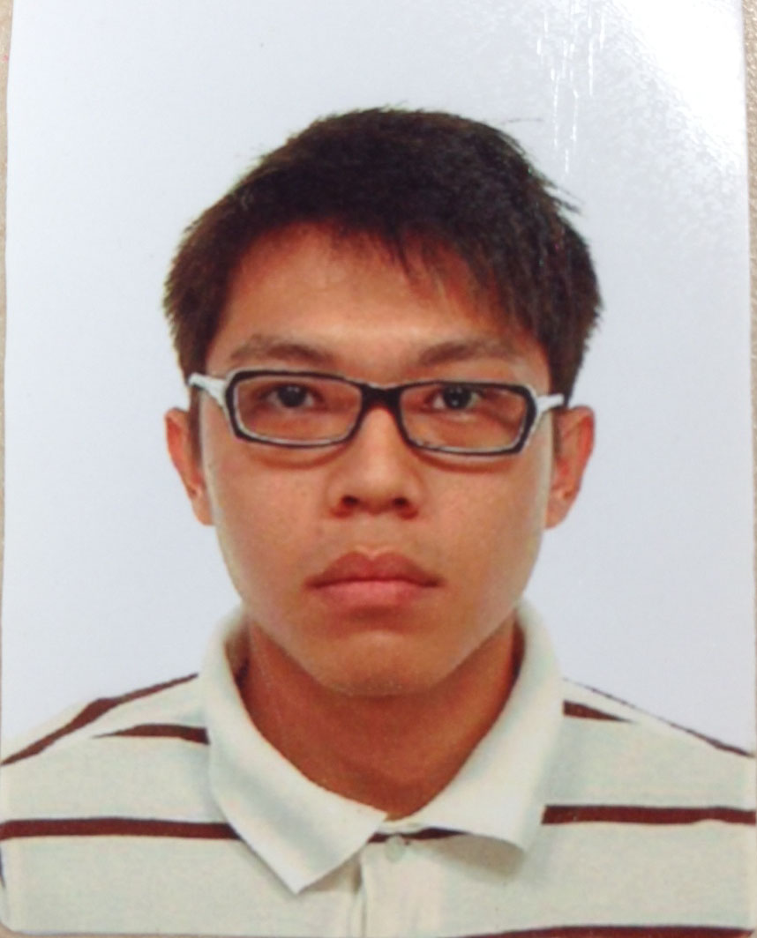**See Chern Shun**

Ang Mo Kio Ave 5 Block 604 #06-2707

Singapore: 560604

Mobile: 93840077

E-mail: [See_cs@hotmail.com](mailto:See_cs@hotmail.com)

**SUMMARY OF QUALIFICATIONS**

• Proven ability to excel in stressful environments and is an outstanding team player.

• Self-motivated and confident in making independent decisions and forward thinking.

• Fluent in both English and Chinese, spoken and written,

**Experience**

**Leadership:** Awarded Best Unit Cadet in NPCC.

Served with 1st Commando Battalion during NS, also awarded Best Signaller and Letter of Commendation. Appointed as Team Lead for Yeap Transport.

**Teamwork Abilities:** Managed a detachment and coordinated missions in NS.

Maintain team morale and motivation as Team Lead.

**Programming**: Represented NYP in Microsoft Imagine Cup (2012) and Code::XtremeApps (2011). FYP Grade of A for Android Application. Coded GPS/NFC, overhauled the system for Gabkotech Innovations and Yeap Transport. Coded in ASP.NET, Android at Gabkotech. Create CRM/Ticketing System using N Tier architecture and AGILE methodology for Yeap Transport.

**Management Skills:**  Promoted to CFC during NS. Delegated tasks assigned by PM to meet milestones and timelines as Team Lead.

**Software Skills:** Apple XCode

Eclipse/Android Studio

Visual Studio/ TFS

GitLab

**Software Language:** ASP.NET C#, C# MVC4, C# MVC 5

AJAX

HTML 5/ Bootstrap / JQuery

Web APIs

Objective C

SQL Server/MySQL

**Language Skills:** Bilingual in both spoken and written, English and Chinese

**Education**

**Nanyang Polytechnic** (2010-2013)

-Diploma in Multimedia Infocomm and Technology

**Employment History:**

**Singapore Armed Forces** (1 CDO BN)

* Completed National Service as Corporal First Class (2008-2010) 4th Company
* Performance: Outstanding
* Conduct: Outstanding

**Gabkotech Innovations Pte Ltd** (2013 to 2014)

* Appointed as Associate Software Engineer.
* Promoted to Software Engineer after 4 months.
* Upgraded and improve the algorithm of Location Based Services
* Implementation of Google Cloud Messaging and Offline mode for mobile
* Worked on Government Projects (NLB, CBM)

**Yeap Transport Pte Ltd** (2014 to Current)

* Appointed as Software Engineer.
* Appointed as Team Lead. Convert requirements to technical specifications.
* Worked with Web APIs for projects
* Picked up ASP.NET C# MVC
* Created CRM software for management of clients
* Implemented Ticketing Software for support issues
* Worked with Team on Mobile Tracking System and NFC

**Special Awards:**

NPCC

* Best Unit Cadet Award

1st Commando Battalion

* Letter of Commendation (2009)
* Promoted to Corporal First Class (2010)
* Best Signaller in Battalion (2010)

**Personal Data**

Birth Date: 20 July 1988

Marital Status: Single

Nationality: Singaporean

Race: Chinese

Expected Salary: $4500

**References**

Timothy Yeung

Business Development Manager, PA to the CEO

Tel: 9366 0346