***Task 1:***

***Create a new Laravel project named "MigrationAssignment" using the Laravel command-line interface.***

***Solution:***

Command:composer create-project laravel/laravel MigrationAssignment

***Task 2:***

***Within the project, create a new migration file named "create_products_table" that will be responsible for creating a table called "products" in the database. The "products" table should have the following columns:***

***Solution:***

Command:

php artisan make:migration create_products_table

**Products table migration File:**

***Task 3:***

***After creating the migration file, run the migration to create the "products" table in the database.***

***Solution:***

Command:php artisan migrate

***Task 4:***

***Modify the existing migration file "create_products_table" to add a new column called "quantity" to the "products" table. The "quantity" column should be an integer column and allow null values.***

***Solution:***

Command:php artisan make:migration add_quantity_to_products

**add_quantity_to_products migration file:**

***Task 5:***

***Create a new migration file named "add_category_to_products_table" that will be responsible for adding a new column called "category" to the "products" table. The "category" column should be a string column with a maximum length of 50 characters.***

***Solution:***

Command:php artisan make:migration add_category_to_products

**add_category_to_products migration file:**

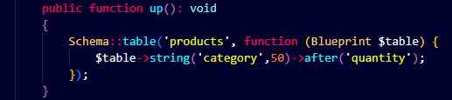

***Task 6:***

***After creating the new migration file, run the migration to add the "category" column to the "products" table.***

***Solution:***

*Command****:*** php artisan migrate

***Task 7:***

***Create a new migration file named "create_orders_table" that will be responsible for creating a table called "orders" in the database. The "orders" table should have the following columns:***

***id: an auto-incrementing integer and primary key.***

***product_id: an unsigned integer column to establish a foreign key relationship with the "id" column of the "products" table.***

***quantity: an integer column to store the quantity of products ordered.***

***created_at: a timestamp column to store the creation date and time.***

***updated_at: a timestamp column to store the last update date and time.***

***Solution:***

Command:php artisan make:migration create_orders_table

**create_orders_table migration file:**

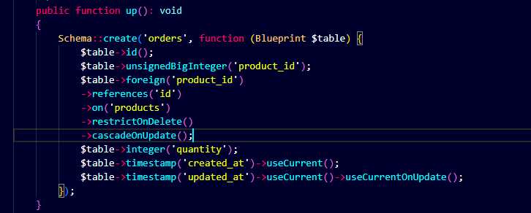

***Task 8:***

***After creating the migration file for the "orders" table, run the migration to create the "orders" table in the database.***

Solution:

Command:php artisan migrate