Au Transport and Precipitation During Cu-Fe-S Hydrothermal Reaction Paths
Methods, results, and modelling-focused discussion

3 Methods

3.1 Numerical and geochemical modeling
The primary modelling question is not only whether hematite-involved reactions in a Cu-Fe-S-Au-Cl-bearing hydrothermal fluid can generate a coherent pyrite-chalcopyrite-bornite assemblage, but also how Au-bearing aqueous species and Au-related solid phases evolve during this reaction path. Specifically, the model evaluates how Au is transported, released, precipitated, and spatially redistributed during surface-product dissolution-reprecipitation and infiltration-controlled shell-core alteration. The simulations were implemented with PhreeqPyne as a reproducible Python wrapper for PHREEQC/IPhreeqc input generation and selected-output parsing.

3.1.1 Modeling rationale and conceptual framework
The model was designed to test whether a redox- and sulfur-buffered hydrothermal reaction path can reproduce coupled Cu-Fe sulfide evolution and Au transfer under geologically plausible conditions. Two complementary conceptual systems were used. The titration model represents a batch reaction path in which phase and solution additions drive progressive dissolution-reprecipitation. The transport model represents a semi-open one-dimensional infiltration system in which an external boundary fluid modifies an initially zoned shell-core pore fluid by diffusion-only replacement.
The model focuses on phase transfer among hematite, pyrite, chalcopyrite, bornite, magnetite, and native Au, together with Au-bearing aqueous complexes such as Au(HS)2- and AuHS. It simplifies the natural system by excluding explicitly resolved fracture networks, variable permeability, episodic boiling, mechanical remobilization of native Au, and independently changing temperature-pressure histories. These simplifications are acceptable here because the purpose is to delimit feasible reaction windows rather than to reconstruct a unique natural pathway.

3.1.2 Input constraints and initial conditions
The calculations use the project configuration files as the current input constraints. Both model families are set at 240 degrees C and 27 bar with an initial pH of 8.0. The transport boundary fluid contains Na, Cl, K, P(V), Cu(I), Fe(III), S(-II), and Au(III); Cu(I) decreases from 6.5e-4 to 4.1e-4 mol/kgw, Fe(III) increases from 3.0e-4 to 5.0e-4 mol/kgw, S(-II) decreases from 2.4e-2 to 2.0e-2 mol/kgw, and Au(III) is held at 1.0e-4 mol/kgw across the staged boundary fluids.
The initial transport pore fluid is lower in salinity and metal content than the boundary fluid and is assigned a shell-core gradient for Na, Cl, K, P, Cu, Fe, S, and Au. In the titration workflow, the starting solution is reacted through 100 steps with scheduled additions of hematite, chalcopyrite, H2S(g), Cu(I), and Au(III). These settings represent the present modelling scenario and are treated as working constraints for evaluating Au transport and precipitation behavior.

3.1.3 Governing reactions/equations and thermodynamic database
The simulations use IPhreeqcCOM 3.8.6-17100 with the PHREEQC_ThermoddemV1.10_15Dec2020.dat thermodynamic database. The transport calculation follows a one-dimensional diffusion-reaction form, in which aqueous components are redistributed by diffusion while mineral equilibrium and kinetic reactions provide source and sink terms. Hematite dissolution is represented by a kinetic rate law that proceeds only when SI(Hematite) is negative and remaining kinetic reactant is available.
The key geochemical pathways represented by the model are hematite involvement, sulfide precipitation, Au complex transport, native-Au precipitation, and secondary redistribution during shell-core alteration. Au behavior is tracked through total Au, Au(I)/Au(III), Au(HS)2-, AuHS, Au-Cl species, Au hydroxide species, Au(element), and the saturation index of Au(element).

3.1.4 Boundary conditions and reaction/transport setup
The transport model consists of 10 cells and 8 reaction stages with stage shifts of 2, 3, 4, 10, 15, 16, 19, and 20. The boundary composition represents an infiltrating external hydrothermal fluid, whereas the initial cell solutions represent a shell-core pore-fluid gradient. The transport setup uses diffusion_only flow, constant closed boundary conditions, a 10000 s time step, 0.001 m cell length, 1e-6 m dispersivity, and a diffusion coefficient of 1e-9 m2/s.
The titration model is run as a stepwise phase-plus-solution reaction path. Each reaction step saves the evolving solution and equilibrium-phase assemblage for reuse in the next step, allowing progressive release and sequestration of Au to be evaluated along the same reaction path that produces the Cu-Fe sulfide assemblage.

3.1.5 Parameter selection and sensitivity tests
The current model explores parameter effects through staged boundary-fluid interpolation, shell-core initial gradients, and scheduled titration additions. The most important varied quantities are reaction progress, Cu(I) input, S(-II)/H2S input, Au(III) input, hematite addition, chalcopyrite addition, and the transport stage. These tests evaluate whether Au remains mobile as aqueous complexes, is released during surface-product turnover, or is trapped as native Au during sulfide precipitation.

3.1.6 Criteria for evaluating model consistency
A scenario is considered consistent with the modelling target only if it reproduces a coherent pyrite-chalcopyrite-bornite evolution while also producing interpretable Au behavior. Specifically, the output must show (1) Au-bearing aqueous complexes during transport or reaction, (2) precipitation or persistence of Au(element) without excessive unrelated native Cu or chalcocite dominance, (3) a stable weakly alkaline hydrothermal pH range, and (4) spatial or temporal Au redistribution that can be related to infiltration-controlled shell-core alteration.

4 Results

4.1 Baseline model evolution
In the titration model, the pyrite-chalcopyrite-bornite sequence develops together with systematic Au redistribution. Native Au remains present throughout the reaction path and increases from 3.93% at step 1 to 5.77% at step 100. The dominant Au-bearing aqueous species remain Au-sulfur complexes: log aAu(HS)2- varies from -5.211--4.894, whereas log aAuHS varies from -7.659--7.34. This indicates that Au is not simply removed at the first sulfide saturation step; it remains coupled to the evolving sulfur-bearing fluid before being progressively partitioned into Au(element).
The Cu-Fe sulfide assemblage evolves from early pyrite dominance to chalcopyrite dominance and then toward chalcopyrite-bornite coexistence. Pyrite decreases from 70.16% at step 1 to nearly zero by step 24, chalcopyrite reaches 96.06% near step 23, and bornite rises to 48.47% by step 100. The Au response is therefore synchronous with the surface-product dissolution-reprecipitation sequence rather than independent of the sulfide reaction path.
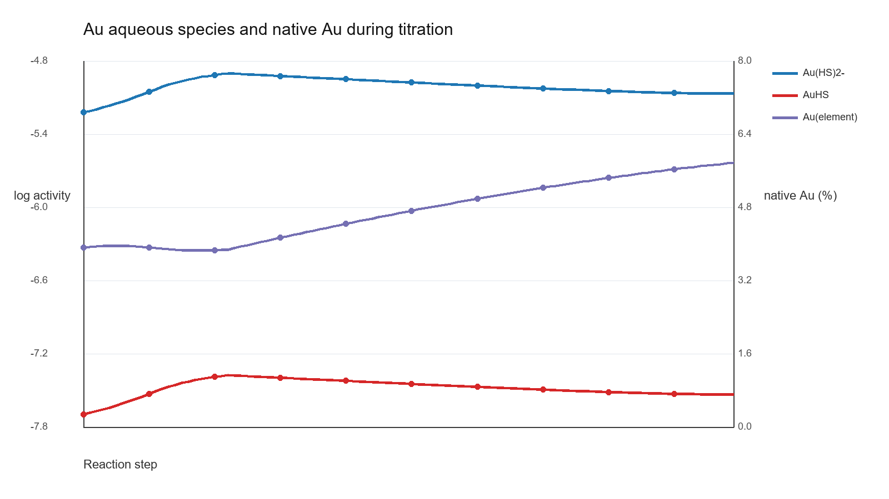
Figure 1. Evolution of Au-bearing aqueous species and native Au during the titration reaction path.
In the transport model, Au(element) is spatially redistributed during staged infiltration. The maximum native-Au percentage at stage ends is highest during stages 2-3, reaching 24.04% and 23.82%, then gradually decreases to 19.64% by stage 8. This trend indicates that Au precipitation is favored during early to intermediate infiltration-controlled alteration, whereas later stages increasingly stabilize chalcopyrite and magnetite at the expense of the highest native-Au accumulation.
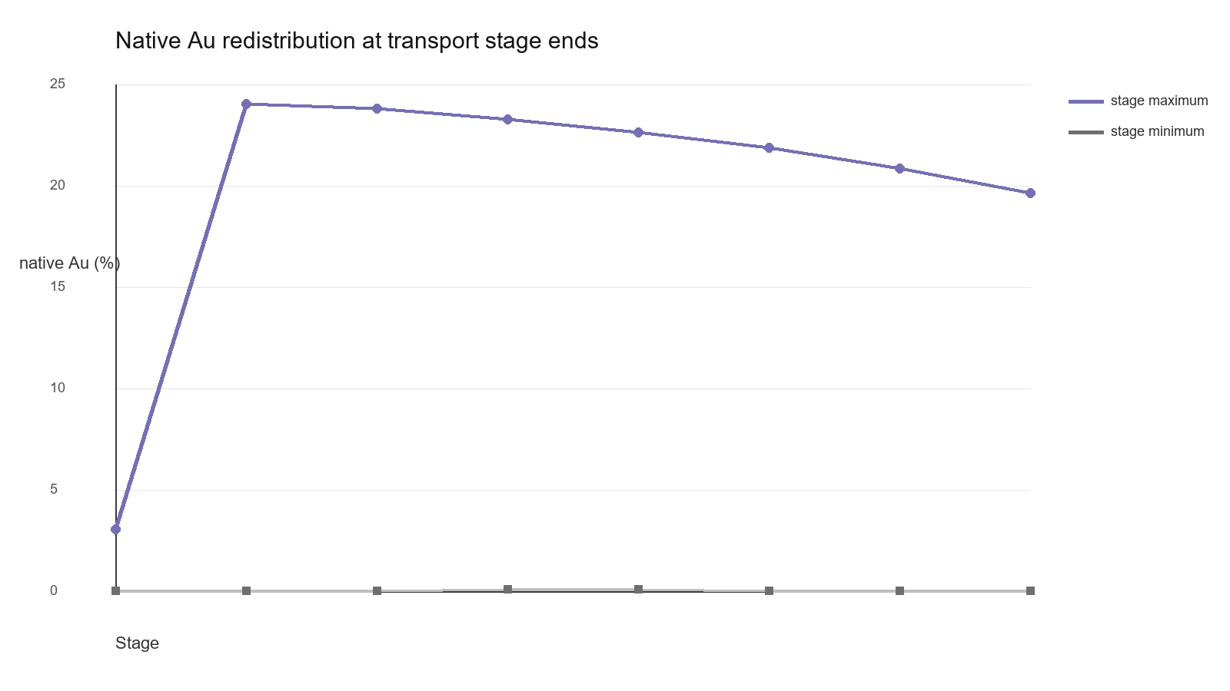
Figure 2. Stage-end native-Au redistribution in the one-dimensional transport model.

4.2 Effects of key parameters
Increasing reaction progress promotes transfer from pyrite to chalcopyrite and then to bornite, while native Au increases more gradually. Higher sulfur availability supports Au-sulfur complexes and allows Au to remain mobile along the reaction path before precipitation. In contrast, the transport stages show that Au accumulation is not monotonic; it depends on where infiltrating fluid, local sulfide precipitation, and evolving Fe-bearing phases intersect within the shell-core gradient.
The Au-bearing aqueous species respond more sensitively to sulfur-complexing conditions than to total Au alone. Au(HS)2- remains the higher-activity tracked Au complex relative to AuHS during the titration path, consistent with Au transport in reduced sulfur-bearing hydrothermal fluid. Native Au increases only after the sulfide assemblage has begun reorganizing, suggesting that Au precipitation is tied to reaction-front evolution and local changes in ligand availability.

4.3 Sensitivity analysis and permissible condition window
The current model constrains a working permissible window at 240 degrees C, 27 bar, weakly alkaline pH, reduced sulfur-bearing conditions, and coupled Cu-Au input. Within this window, Au can be transported as sulfur complexes, released during reaction-front advancement, and precipitated as Au(element) together with a coherent Cu-Fe sulfide assemblage. Outside this window, the expected failure modes would include lack of Au precipitation, sulfide assemblages dominated by only pyrite or only chalcopyrite, or Au redistribution that is decoupled from shell-core alteration.
Output constraint | Titration result | Transport result | Modelling interpretation
Au aqueous species | log aAu(HS)2- = -5.211--4.894; log aAuHS = -7.659--7.34 | Au complexes tracked with staged infiltration | Au remains mobile as reduced sulfur complexes
Native Au | 3.85-5.77% | 0-24.04% | Au precipitation is progressive and spatially variable
Sulfide assemblage | pyrite -> chalcopyrite -> bornite | chalcopyrite-rich with local bornite | Au evolution is coupled to Cu-Fe sulfide turnover
pH range | 8.151-8.292 | 7.962-8.089 | weakly alkaline conditions remain stable

4.4 Inconsistent scenarios and excluded conditions
The current tested path excludes interpretations in which Au behavior is independent of sulfide reaction progress. Early titration steps with high pyrite but low bornite do not represent the full Au-bearing assemblage, whereas later transport stages with decreasing native-Au maxima indicate that infiltration alone does not monotonically concentrate Au. These internally inconsistent intervals help delimit the conditions under which Au precipitation is linked to reaction-front chemistry rather than arbitrary Au input.

5 Discussion

5.1 Model-data comparison
The model provides a process-based explanation for Au redistribution during Cu-Fe sulfide replacement. A natural assemblage showing pyrite replaced by chalcopyrite-bornite, with native Au associated with sulfide reaction fronts, would be consistent with the modeled sequence. The coexistence of Au-sulfur complexes and Au(element) in the output supports a pathway in which Au is transported in reduced sulfur-bearing fluid and precipitated during local ligand, redox, or mineral-buffer changes.

5.2 Main controlling factors
The simulations indicate that sulfur-complexing capacity and reaction progress are primary controls on Au mobility, whereas Cu-Fe sulfide saturation controls the timing and location of Au precipitation. In the transport model, infiltration stage and shell-core gradients modulate where Au accumulates. Thus the dominant control shifts from Au transport as aqueous sulfur complexes to Au trapping during dissolution-reprecipitation at the reaction front.

5.3 Implications for geological process
The modeled conditions suggest that Au enrichment can occur locally during surface-product dissolution-reprecipitation rather than requiring a separate Au-only event. Au transport, release, and precipitation are best interpreted as part of the same hydrothermal alteration system that reorganizes pyrite, chalcopyrite, and bornite. The results apply most directly to local reaction fronts and shell-core alteration domains rather than to regional metal budgets.

5.4 Comparison with alternative models
Models invoking simple Au saturation from a homogeneous fluid are partly consistent with the presence of native Au, but they do not by themselves explain the coupled evolution of Au complexes, native Au, and Cu-Fe sulfide replacement. The present model further requires reduced sulfur-complexing conditions and an infiltration or reaction-front geometry. A purely mechanical redistribution model for native Au may still operate locally, but it is not required to explain the simulated Au-solid response.

5.5 Model limitations and uncertainty
The model identifies plausible process windows rather than a unique natural pathway. Key uncertainties include thermodynamic data for high-temperature Au-Cl-S complexes, kinetic parameters for hematite involvement, non-unique initial fluids, and the simplified representation of natural permeability and reaction surfaces. The inferred conditions should therefore be treated as permissible ranges for Au transport and precipitation during Cu-Fe sulfide alteration.

