# 0x0E. SQL - More queries

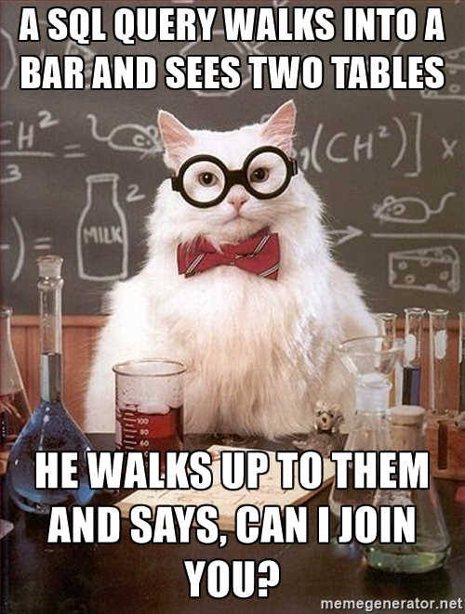

## **Resources**

**Read or watch**:

* [How To Create a New User and Grant Permissions in MySQL](https://intranet.alxswe.com/rltoken/RniBKj48bnIN8xpXhGl1yA)
* [How To Use MySQL GRANT Statement To Grant Privileges To a User](https://intranet.alxswe.com/rltoken/FIiEIvA6IN_hSKM5TvgyxQ)
* [MySQL constraints](https://intranet.alxswe.com/rltoken/LrovGa6N-OE2ID_tpWZRaQ)
* [SQL technique: subqueries](https://intranet.alxswe.com/rltoken/kR71h5zjkPtx4kBoVf7q0g)
* [Basic query operation: the join](https://intranet.alxswe.com/rltoken/rNMJeQ1jbNTCljbvCSjf6w)
* [SQL technique: multiple joins and the distinct keyword](https://intranet.alxswe.com/rltoken/HhZ6TJ1q5S0aR4lhfpKdOQ)
* [SQL technique: join types](https://intranet.alxswe.com/rltoken/T6FZUQdsMzr8hgNInBzudA)
* [SQL technique: union and minus](https://intranet.alxswe.com/rltoken/Nd-sdM8QUpf0YKIlXzVv4w)
* [MySQL Cheat Sheet](https://intranet.alxswe.com/rltoken/iSNyinU6SPWTGDUWMmcRkg)
* [The Seven Types of SQL Joins](https://intranet.alxswe.com/rltoken/-plhBsra0N7BOuFoEg--zg)
* [MySQL Tutorial](https://intranet.alxswe.com/rltoken/I4Lws_eQrIrNTbkZvvk-oQ)
* [SQL Style Guide](https://intranet.alxswe.com/rltoken/051eAEP_rePBU7jeh879GA)
* [MySQL 8.0 SQL Statement Syntax](https://intranet.alxswe.com/rltoken/YavbYiraYFr8oTukT_N6eQ)

Extra resources around relational database model design:

* [Design](https://intranet.alxswe.com/rltoken/EWLRPeqr5sQ9AqfoG_KXxw)
* [Normalization](https://intranet.alxswe.com/rltoken/mqBhYoSYbhH5ZZrhDcY0kA)
* [ER Modeling](https://intranet.alxswe.com/rltoken/R0exkJmf-2ddKjGfa8D0dA)

## **Learning Objectives**

At the end of this project, you are expected to be able to [explain to anyone](https://intranet.alxswe.com/rltoken/0qci3VdIVdKJXldEZ6zAjA), **without the help of Google**:

### **General**

* How to create a new MySQL user
* How to manage privileges for a user to a database or table
* What’s a PRIMARY KEY
* What’s a FOREIGN KEY
* How to use NOT NULL and UNIQUE constraints
* How to retrieve datas from multiple tables in one request
* What are subqueries
* What are JOIN and UNION

### **Copyright - Plagiarism**

* You are tasked to come up with solutions for the tasks below yourself to meet with the above learning objectives.
* You will not be able to meet the objectives of this or any following project by copying and pasting someone else’s work.
* You are not allowed to publish any content of this project.
* Any form of plagiarism is strictly forbidden and will result in removal from the program.

## **Requirements**

### **General**

* Allowed editors: vi, vim, emacs
* All your files will be executed on Ubuntu 20.04 LTS using MySQL 8.0 (version 8.0.25)
* All your files should end with a new line
* All your SQL queries should have a comment just before (i.e. syntax above)
* All your files should start by a comment describing the task
* All SQL keywords should be in uppercase (SELECT, WHERE…)
* A README.md file, at the root of the folder of the project, is mandatory
* The length of your files will be tested using wc