Brennan’s Bookstore

Application overview:

I will be making a database representing an online bookstore used by students. With books costing more than ever and many being unable to afford them, students should be able to sell their old books to the next wave of students taking their class at heavily discounted prices. This way, students get more money than they would from the school (40 dollars instead of 5) and students can purchase books for much less (40 dollars instead of 250). Students will use the website to peruse the book options available or search for a book based on its genre, and add it to their cart. When they purchase a book it removes it from the database. Students who are trying to sell their book will put up a listing until someone chooses their book.

Database Overview:

Book – This entity represents any given book that will be stored in the system and is considered “for sale by owner”. It has the following attributes –

* Id: This value is automatically assigned to each book when recorded into the database. It is a primary key and auto increments with each submission.
* Title: This value is a string which is a max of 200 characters. It cannot be blank and must be filled out in order to submit the book into the database. It represents the title of the book.
* Topic: This value is a string which is a max of 100 characters. It cannot be blank and must be filled out in order to submit the book into the database. It represents the topic of the book or what field of study it relates to, such as “Math”, “Biology” or “Computer Science”.
* Seller: this value is a string which is a max of 200 characters. It cannot be blank and is automatically filled out when the user submits a book to the site. **This is a foreign key to username from “User”.**
* sellLocation: this value is a string which is a max of 300 characters. It is automatically filled based on the seller’s location and **is a foreign key to LocationID in the Place entity**
* Price: Int value that represents the price of the book.

Author – This entity represents book authors so that students may learn more about their work.

* Id: This value is automatically assigned to each book when recorded into the database. It is a primary key and auto increments with each submission.
* Name: This value is a string which is a max of 100 characters. It cannot be blank and must be filled out in order to submit the author into the database.
* Info: This value is a string which is a max of 600 characters. It may be blank. It describes information about the author.

BookAuth – This is simply a handler for the many to many relationship between author and book.

* bookId – The book ID, **foreign key to ID in Book.**
* AuthorID – The author ID, **foreign key to id in Author**

User – this entity represents the user currently logged in.

* userName: This value is a string which is a max of 100 characters. It cannot be blank and must be filled out in order to access the site. This is the primary key.
* Password: This value is a string which is a max of 100 characters. It cannot be blank and must be filled out in order to access the site.
* Location: This value is a string which is a max of 200 characters. It cannot be blank and must be filled out in order to access the site. It should be chosen from a drop down menu on site. It represents the location that the user lives so that students can see if the books that a user offers are local or need to be shipped a distance. **Foreign key to locationID in the place entity.**

Place – this entity represents a hub of users so that users can prioritize trading books locally instead of having to pay shipping fees.

* LocationID: This value is automatically assigned to each location when recorded into the database. It is a primary key and auto increments with each submission. Locations are added by admins.
* Location: this value is a string which is a max of 300 characters. It identifies the location that any book trading hub is based upon.

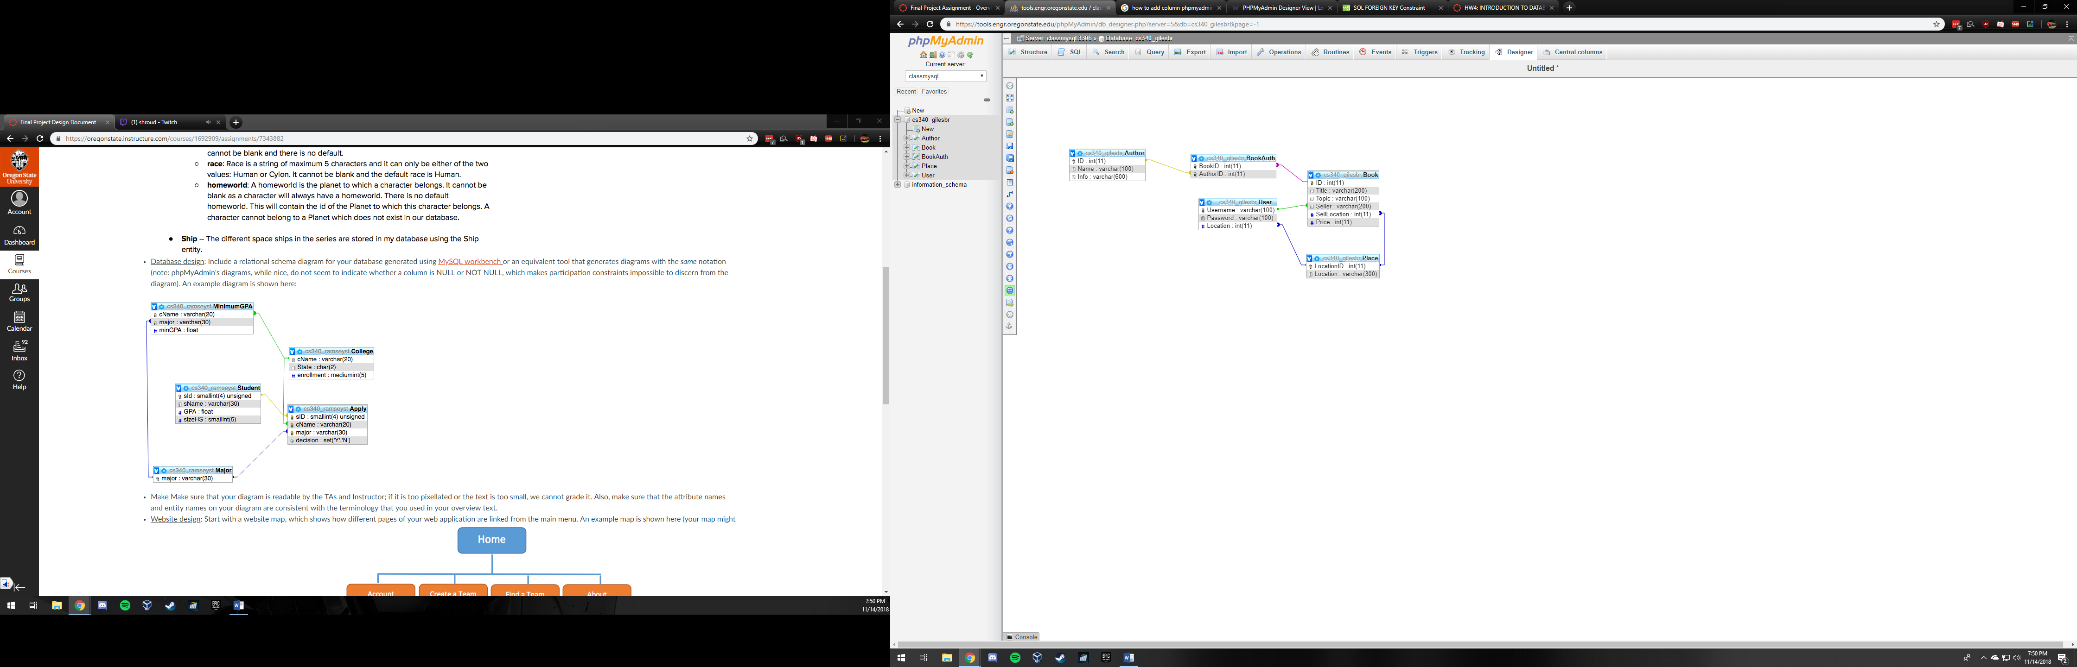

Welcome screen / Login

User page (lists all user’s listings)

Browse listings

Create listing

Edit Account

Inspect book

Page specific site designs are shown in reverse order – scroll to bottom to see login page and work your way up if you get confused.

Inspect book

Listing ID

Price

Title

Author

Topic

Location

About the author

Return to listings

Purchase

Edit Account

Username

New Password:

New Location:

SUBMIT

Create Listing

Title

Author

Topic

Price

SUBMIT

Browse Listings

Location

Topic

Author

Title

Listing ID

Inspect

Inspect

Inspect

Inspect

Inspect

Inspect

Inspect

SORT BY

Listing ID

Location

Topic

Author

Title

Return

User page

My Listings

Edit Account

Create Listing

Browse Listings

Welcome Screen

Username

Password

I leave near:

CREATE

Don’t have an account yet? Create one here!

LOGIN

Password

Username

Welcome To Brennan’s Books, a place where you can sell your textbooks for more and buy them for less! Take the greedy middlemen out of the equation and save some money for the weekends by signing up below.