

***ViBox***

**Fischer Liu, 2014.07**

Contents

Product Concept 3

Use Case 3

Functional Requirements 4

Non-Functional Requirements 5

Wireframe & Mockup 6

Future Road Map 7

Appendix 9

# Product Concept

Enjoy your favorite drama online any time at your wish. With the advent of the fast Internet network, people now can access the rich contents in a snap. From books, to pictures, to music albums, the Internet has not only provided people a quick way to those wonderful contents, but also broken the restrictions of time and space in the old days. Imagine that one day we no longer have to wait in front of TV for one hilarious drama or write a note to remind ourselves that in the next Friday the channel 32 will broadcast the drama we love so much. Just open the ViBox in your PC or in your smart phone and find yourself a comfortable seat. That’s all. You are now ready to enjoy your drama. You, of course, can pause the drama when leaving for a while and go on later. This is what the ViBox is made for. People can discover endless fantastic stories and joy from this little box any time.

# Use Case

* Nicole is 26 and works as a sales in a trade company. One of her favorite recreations is to watch Japanese or Korean drama. Because of work, however, Nicole often misses the TV schedule of these dramas.
* Nicole does not like searching or downloading the unknown free sources since it is too complicated and may cause damage to her computer and the video quality is not stable. To rent DVDs is not a good option for Nicole either because it is bothersome that she has to go to DVD store to rent or return DVDs. As a result, Nicole is willing to pay for watching good quality dramas from the paid online service.
* Nicole recently bought one new 4G smart phone. She likes to watch drama when commuting between her home and the company with the new smart phone.

# Functional Requirements

* Video playing
  + Supported video format:
    - MPEG-4 (For the platform which doesn’t support MPEG-4 natively, take advantage of the Flash Player)
  + Supported video resolutions:
    - Mid quality: 854 x 480 px
    - High quality: 1280 x 720 px
    - Best quality: 1920 x 1080 px
  + Controls:
    - Play
    - Pause
    - Progress bar
    - Switch resolution
      * Web(PC): Mid / High / Best quality
      * Mobile: Mid / High quality
    - Volume control: up / down / mute
      * Mobile: Not required for the UI control. Leave this function to the side button of smart phone
    - Resize player screen:
      * Web(PC): 854 x 480 px between the full screen
      * Mobile: The full screen only
* Content grouping
  + Popular: the recent popular contents (could be from different countries).
  + Japan / Korea / Taiwan / China / USA: the contents from the corresponding country
* Content search
  + Search drama based on the title of drama or the name of main actor/actress
* Membership management
  + The membership classes:
    - The paid member, able to watch drama online.
    - The trial member, only able to watch drama in the first 72 hours after registering.
  + The required data of member:
    - e-mail(for log-in) / password / birthday / gender / name

# Non-Functional Requirements

* Support the platforms: Web(PC) / iOS / Android
  + The supported versions of platform have to cover at least 80% of the market share in that particular platform
  + The supported versions:
    - Web(PC): Chrome 31.0+ / FireFox 25.0+ / IE 8.0+ / Safari 6.0+ (Please refer to the Appendix: Figure I and Table I)
    - iOS: iOS 7+ (Please refer to the Appendix: Figure II)
    - Android: Android 4.0.3+ (Please refer to the Appendix: Figure III)
* Preserve the design flexibility for the new features
  + Please refer to the Future Road Map section for the potential new features
* Good user experiences
  + Simple and intuitive user interface design
  + Stable video playing
  + Robust exception handling

# Wireframe & Mockup

In this section, there are some wireframe and mockup demo. Those materials will provide the quick and simple visual and functional demonstration of the ViBox.

* Wireframe
  + Web(PC): please see the web_app_wireframe.jpg attachment
  + Mobile: please see the mobile_app_wireframe.jpg attachment.
* Mockup

Please visit: http://viboxdemo.fischerliu.net63.net/

This site contains both the web app mockup and the mobile app mockup of the ViBox. These mockups will give some live demo to help you to build up the picture of the ViBox quickly.

# Future Road Map

Many functions could be implemented in the future based on the feedbacks and the behaviors from users. These possible functions could include building playlists, bookmarking contents, saving playing records or syncing up playing records between devices. Besides these functions, there are 4 potential directions to which the ViBox could evolve:

* New content

Besides drama, the ViBox could include other types of video content, like movie, animation and entertainment show etc. To provide more types of video content could bring more types of charging level so that more types of membership could be needed. For example, the premium paid member can watch both movie and drama while the paid member only can watch drama.

* Platform

The ViBox could open the uploading mechanism to public so the mid/small studios could also put their own episodes in the ViBox. The ViBox would become a video distribution platform. To let others upload contents means that the content approval process and the uploading control panel are required.

* Social

After watching drama, people tend toward commenting on the plot or discussing the drama with others. The people who watch or like the same drama over the Internet form a group implicitly. The ViBox could provide some social tools to make the people in the group connect to or interact with each other. The ViBox could enable the function of letting user post the comments of drama to the ViBox. User could subscribe the comments of one particular drama in which s/he is interested. The comments pushed to the subscribers could be geo-relevant, which means that user would be able to receive the comments from others living in the same city. Or user could subscribe comments from one particular user for one particular drama. This subscribing mechanism implies that the comment-posting feature, the subscription function or even the geo handling are required for implementation.

* Advertisement

The ViBox could sell ads to content providers, using some appropriate method and visual presentation to promote contents from sponsored providers. Besides content promotion ads, the Vibox could deliver content-related and user-interested ads in a proper amount. For example, user might be interested in the product or the place showed in the drama. Or maybe user might like the product endorsed by the actor/actress s/he likes. To show ads means that the UI layout would be changed to accommodate ads. The content-related and user-interested ads might require additional filtering mechanism to pick up these special ads.

# Appendix

**Figure I :** Global top PC browsers market share (2013/12 ~ 2014/5)

**Source :** http://gs.statcounter.com/

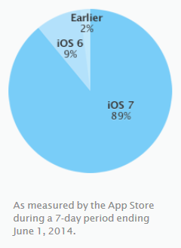

**Figure II :** iOS version distribution share

**Source :** https://developer.apple.com/support/appstore/

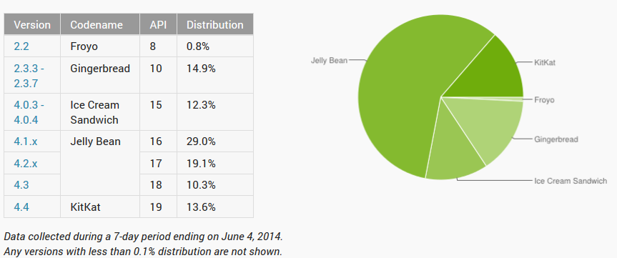

**Figure III :** Android version distribution share

**Source :** https://developer.android.com/about/dashboards/index.html

|  |  |  |  |
| --- | --- | --- | --- |
| Browser Version | Market Share (%) | Cumulative Market Share (%) | Cumulative Market Share Increasing Rate (%) |
| Chrome 36.0 | 0.05 | 0.05 |  |
| Chrome 35.0 | 1.66 | 1.71 | 3320.00 |
| Chrome 34.0 | 9.42 | 11.13 | 550.88 |
| Chrome 33.0 | 10.48 | 21.61 | 94.16 |
| Chrome 32.0 | 9.28 | 30.89 | 42.94 |
| Chrome 31.0 | 11.27 | 42.16 | 36.48 |
| Chrome 30.0 | 0.46 | 42.62 | 1.09 |
| Chrome 29.0 | 0.6 | 43.22 | 1.41 |
| Chrome 28.0 | 0.3 | 43.52 | 0.69 |
| Chrome 27.0 | 0.51 | 44.03 | 1.17 |
|  |  |  |  |
| Firefox 30.0 | 0.09 | 0.09 |  |
| Firefox 29.0 | 2.03 | 2.12 | 2255.56 |
| Firefox 28.0 | 3.72 | 5.84 | 175.47 |
| Firefox 27.0 | 4.12 | 9.96 | 70.55 |
| Firefox 26.0 | 5.23 | 15.19 | 52.51 |
| Firefox 25.0 | 1.93 | 17.12 | 12.71 |
| Firefox 24.0 | 0.35 | 17.47 | 2.04 |
| Firefox 23.0 | 0.18 | 17.65 | 1.03 |
| Firefox 22.0 | 0.17 | 17.82 | 0.96 |
| Firefox 21.0 | 0.25 | 18.07 | 1.40 |
|  |  |  |  |
| IE 11.0 | 8.44 | 8.44 |  |
| IE 10.0 | 4.46 | 12.9 | 52.84 |
| IE 9.0 | 3.84 | 16.74 | 29.77 |
| IE 8.0 | 6.65 | 23.39 | 39.73 |
| IE 7.0 | 0.25 | 23.64 | 1.07 |
| IE 6.0 | 0.39 | 24.03 | 1.65 |
|  |  |  |  |
| Safari 7.0 | 1.74 | 1.74 |  |
| Safari 6.1 | 0.97 | 2.71 | 55.75 |
| Safari 6.0 | 0.67 | 3.38 | 24.72 |
| Safari 5.1 | 1.14 | 4.52 | 33.73 |
| Safari 5.0 | 0.33 | 4.85 | 7.30 |
| Safari 4.1 | 0.05 | 4.9 | 1.03 |
| Safari 4.0 | 0.1 | 5 | 2.04 |

**Table I :** Global top PC browsers market share by versions (2013/12 ~ 2014/5)

**Source :** http://gs.statcounter.com/