ECE 291A Statistical Learning

Jinyu Zhao

A53324435

a)

Prior probability of Cheetah is: 0.1918649270913277

Prior probability of grass is: 0.8081350729086723

b)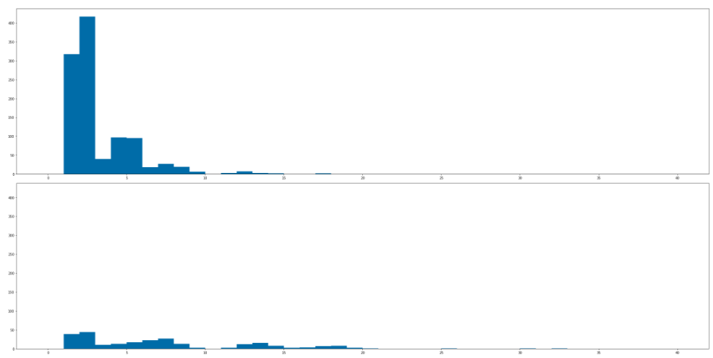

c)

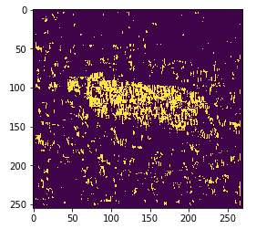

d) The error probability is 0.23453885257806825