Evaluating Runtime Authorization Under Context and Provenance Uncertainty for Tool-Using LLM Agents

Abstract
Tool-using LLM agents can turn prompt injection into external actions, but measured security depends on runtime authorization. We exclude raw evaluator and scoring fields from online state, vary authorization—including an explicitly gold-derived sensitivity condition—and jointly measure unsafe effects, task completion, burden, failure, latency, and cost.
We reanalyze 7,353 DeepSeek records and 40 defense-aware adaptive tasks. In a 5,082-record V4 Pro Public matrix, M3-full produced 38/600 unsafe effects versus 13/600 for policy-only, while both completed 49/168 benign tool tasks. A 1,791-record V4 Flash matrix showed the same security direction (24/400 versus 12/400). Adaptive search found first unsafe effects for 4/40 tasks by query 50 and 18/40 by query 200.
A frozen 900-work-item V4 Pro experiment crossed two Guard variants with non-oracle auto_compiled and oracle-sensitivity exact_gold authorization on 180 paired AgentDojo and M3-v2 cases. Three of four main cells had 0/100 unsafe effects and the fourth had 1/100. Changing from auto_compiled to exact_gold reduced benign-tool completion by 21.67 percentage points for policy-only and 15.00 for M3-full. It eliminated ASK but increased records with DENY to 45.00–48.89%, failures to about 24%, and p95 latency to about 19.5 seconds.
Authorization construction can therefore alter security–utility measurements even when attack rates appear stable. The evaluated provenance-aware extensions showed no stable gain over policy-only. Gemini free-tier execution closed at 32/450 terminal items, so no cross-provider inference was made.
Keywords: prompt injection; LLM agents; runtime authorization; provenance; security–utility trade-off

1. Introduction

1.1 Motivation
Tool-using language-model agents turn generated text into actions. An indirect prompt injection embedded in a message, document, webpage, memory item, or tool response can therefore become a request to send data, modify state, or invoke a privileged operation. Public environments such as AgentDojo and InjecAgent show that security must be evaluated together with task utility rather than as a text-classification problem alone (Debenedetti et al. 2024; Zhan et al. 2024). Runtime systems including VIGIL, DRIFT, the Task Shield, IPIGuard, and AgentSpec consequently interpose verification, task alignment, dependency, information-flow, or policy checks before an effect is committed (Lin et al. 2026; Li et al. 2025; Jia et al. 2025; H. Wang, Poskitt, and Sun 2026; An et al. 2025).
This literature also makes a broad novelty claim untenable. Verify-before- commit, contextual policy generation, least privilege, planned dependency checks, and control/data-flow separation are already occupied design spaces (Lin et al. 2026; Tsai and Bagdasaryan 2025; Shi et al. 2025; An et al. 2025; Debenedetti et al. 2025). Recent preprints go further by auditing context influence, comparing an authorization graph with a parameter-source execution graph, or controlling source authority in next-action decisions (Weng et al. 2026; P. Wang, Li, and Tian 2026; Liao 2026). Evidence-backed permission graphs with formal runtime authorization further narrow the mechanism claim boundary (Y. Zhang et al. 2026). The open question for this study is therefore not whether a provenance-aware guard can be built for the first time. It is whether authorization information, enforcement structure, and failure handling materially change the security and utility measured for tool-using agents.

1.2 Evaluation gap
Three distinctions are easy to blur in an agent-security experiment.
First, a detector score or model refusal is not an executed-effect endpoint. Prompt-level structuring, spotlighting, instruction hierarchy, and injection detection can reduce model compliance, but they do not by themselves prove that an unauthorized action failed to cross an external runtime boundary (S. Chen et al. 2025; Hines et al. 2024; Wallace et al. 2024; Y. Chen et al. 2025).
Second, the authorization regime is part of the treatment. A guard that sees per-sample answer keys, evaluator labels, or an exact policy reconstructed from the expected answer is solving a different problem from a guard that receives only trusted user intent and a non-oracle policy compiled before execution. The present source audit does not establish that such leakage is universal, so we frame this as authorization uncertainty rather than a domain-wide answer-key defect.
Third, low attack success can be purchased by blocking useful work. A runtime defense must therefore report executed unsafe effects, benign task completion, confirmation burden, operational failures, latency, tokens, and cost under a common intention-to-treat denominator. Static attacks are also insufficient for a robustness claim when an attacker can adapt to the public defense interface (Nasr et al. 2025).

1.3 Research questions
The study asks three questions.
- RQ1: Authorization regime. How do exact_gold, auto_compiled, broad, underspecified, and conflicting authorization regimes change unsafe effect, benign task completion, and ASK/DENY burden?
- RQ2: Module contribution. Does provenance, temporal/data-flow enforcement, and confirmation add security beyond the same runtime with policy-only enforcement, and what does it cost operationally?
- RQ3: External validity and adaptive budget. Are these directions stable across AgentDojo, M3-v2, a second provider, and the completed defense-aware budgets 50 and 200?

1.4 Study design
M3 uses a three-state runtime decision (ALLOW, ASK, DENY), a projection that excludes evaluator-only fields from online state, permission monotonicity for automatic paths, parameter-source evidence, and independent confirmation for privilege expansion. The primary paired experiment crosses policy-only and M3-full with non-oracle auto_compiled and oracle-sensitivity exact_gold. A nested subset adds three authorization stress regimes. The cross-provider subset adds a peer-reviewed structural condition. Timeouts, parsing failures, refusals, maximum-step outcomes, and provider failures remain in the intention-to-treat denominator.
The new primary sample contains 180 paired cases and 900 DeepSeek V4 Pro work items; a nested 90-case sample contributes 450 planned Gemini 3.6 Flash work items. The design separately reuses the completed 480-record medium study, 5,082-record Pro Public matrix, 1,791-record Flash Public matrix, and the 40-task adaptive evidence at budgets 50 and 200. Provider tools and real external effects are prohibited throughout.

1.5 Empirical motivation and study framing
The completed medium falsification study did not support an incremental mechanism claim. M3-full reduced unsafe effects from 8/36 under the structural condition to 0/36, but M3 policy-only also produced 0/36. Benign tool completion fell from 12/24 under the structural condition to 6/24 under M3-full, violating the preregistered non-inferiority margin. These observations motivate an empirical study of authorization uncertainty and the security–utility frontier rather than a claim that M3-full is a new or state-of-the-art defense.
The larger, independently reproduced Public primary matrix reinforced this finding. Across 600 attacks, M3-full reduced unsafe effects from 133 under the structural condition to 38, but policy-only produced only 13. Across 168 benign tool tasks, both M3 variants completed 49 versus 103 under the structural condition. The full mechanism therefore shows neither incremental security nor utility value beyond policy-only in the primary-model evidence. The 1.4955% retained diagnostic fraction also exceeds the predefined 1% threshold for a clean mechanism-quality claim.
The completed 40-task adaptive panel observed first unsafe effect for 4/40 tasks by budget 50 and 18/40 by budget 200. These points show substantial budget sensitivity but do not establish saturation. The lean paper therefore reports a first-success curve only through query 200 and makes no budget-500 or 2,000 claim.
The prospectively frozen authorization-regime experiment is now complete for DeepSeek. Unsafe effects remained at or near zero across all four main cells, but exact authorization reduced benign-tool completion, replaced ASK with much more frequent DENY, and increased failure and latency. M3-full showed no stable incremental security or utility advantage over policy-only. These unfavorable results are retained. Gemini free-tier execution closed incomplete at 32/450 terminal work items and therefore supports no cross-provider claim.

1.6 Contributions
The current evidence supports four bounded contributions:
- an evaluator/online-state contract that makes authorization visibility explicit and prevents evaluator-only fields from entering runtime state;
- a paired security–utility evaluation that directly compares policy-only and full provenance/temporal/confirmation enforcement;
- an intention-to-treat experiment that records official model identity, request commitments, isolated effects, and terminal diagnostics while retrying only response-less failed rows; and
- an empirical account of authorization regime, confirmation burden, benchmark/task heterogeneity, and defense-aware attack budget.
These contributions do not assert first, only, or SOTA status. Preprints are used to define the contemporary novelty boundary, not as peer-reviewed evidence.

2. Related work

2.1 Runtime verification and task alignment
VIGIL implements a verify-before-commit protocol for tool-stream injection and introduces the 959-case SIREN benchmark (Lin et al. 2026). It is the closest peer-reviewed structural comparator to M3 because both systems interpose before an effect is committed. DRIFT instead combines dynamic rules with control- and data-level constraints and memory-stream isolation (Li et al. 2025). The Task Shield verifies whether instructions and tool calls contribute to the user’s declared objective (Jia et al. 2025). Together, these peer-reviewed systems prevent us from claiming that M3 introduced verify-before-commit, dynamic information-flow checks, or task-alignment verification.
PlanGuard is a related preprint that isolates planning from untrusted context and applies hierarchical tool and parameter consistency checks (Gong and Deng 2026). Its presence further narrows the possible novelty claim: planning consistency is an adjacent mechanism, not an unoccupied problem. We therefore use these works to define comparison classes and mechanism boundaries rather than to motivate a first-or-only claim.

2.2 Privilege, provenance, and information flow
Progent represents least privilege as symbolic tool-and-argument rules. Its latest arXiv v3 description explicitly distinguishes automatic narrowing from expansion that requires approval (Shi et al. 2025). This overlaps directly with M3’s permission-monotonicity and confirmation design. IPIGuard, published at EMNLP 2025, constrains execution through a planned tool-dependency graph (An et al. 2025). CaMeL separates trusted control and data flow and uses capabilities to prevent unauthorized flows (Debenedetti et al. 2025). These systems occupy the privilege, dependency, and information-flow design space that a provenance-aware runtime must acknowledge.
FAVA is a July 2026 preprint that translates natural-language tasks into a permission intermediate representation, lowers it to an evidence-backed permission graph, and uses an SMT authorizer before effectful execution (Y. Zhang et al. 2026). It further narrows any mechanism novelty claim around structured authorization and data-flow-aware permission graphs. Our study differs by treating the authorization regime itself as the paired experimental factor and by jointly measuring executed unsafe effects, benign utility, confirmation/blocking burden, and operational failure.
Two 2026 preprints overlap even more closely with provenance-aware authorization. ARGUS constructs an influence-provenance graph for context-dependent decisions (Weng et al. 2026), while AuthGraph compares an authorization graph derived in an isolated context against a parameter-source execution graph (P. Wang, Li, and Tian 2026). Their existence rules out a claim that M3 is the first parameter-source or provenance-aware authorization defense. Because neither work is treated here as peer reviewed, their reported effects define the contemporary claim boundary but are not used as settled comparative facts.
Auditing Provenance Sensitivity in LLM Agent Action Selection supplies an especially close 2026 measurement counterpart: it holds task content and policy fixed while changing source authority, then measures whether action selection changes (Liao 2026). Its controlled next-action design is narrower than M3’s executed-effect study, but it reinforces the need to separate evidence relevance from authorization. Our experiment extends that question to full tool trajectories, paired runtime Guard conditions, benign utility, ASK/DENY burden, and operational failure.
The remaining defensible contribution is consequently methodological and empirical. We test whether authorization information itself changes measured security and utility; enforce a runtime projection that excludes evaluator fields; compare policy-only and full provenance/temporal/confirmation variants in paired conditions; and quantify ASK burden, operational failures, and executed effects under a common evidence contract. These are study-design claims and must stand on M3’s own completed experiments.

2.3 Prompt-level defenses and execution-level outcomes
Structured queries, spotlighting, instruction hierarchy, and injection detectors act at the prompt, representation, or model-output layer (S. Chen et al. 2025; Hines et al. 2024; Wallace et al. 2024; Y. Chen et al. 2025). They are relevant baselines, but detector scores and model compliance are not equivalent to an executed-effect endpoint. Our evaluation therefore records whether a proposed action crossed the runtime boundary and changed the sandbox state, while also retaining benign task completion. This distinction is necessary because a defense can appear secure by refusing useful actions or by failing before an effect is attempted.

2.4 Benchmarks and adaptive evaluation
AgentDojo supplies dynamic security and utility tasks and is the main public benchmark in this study (Debenedetti et al. 2024). InjecAgent provides a complementary collection of indirect prompt injections for tool-integrated agents (Zhan et al. 2024). ASB broadens the scenario and defense taxonomy (H. Zhang et al. 2025). The public expansion retains the benchmarks’ unique task identities instead of duplicating benign cases to manufacture a denominator.
Static attacks are insufficient for a robustness claim. The Attacker Moves Second argues that a defense-aware attacker should optimize against the defense design rather than replay a fixed attack set (Nasr et al. 2025). The adaptive panel therefore exposes only public ALLOW/ASK/DENY and post-enforcement unsafe-effect feedback, searches frozen tasks at prespecified query budgets, and reports the first-success distribution. Since L27 remains a preprint, it motivates the protocol but is not described as a peer-reviewed theorem.

2.5 Positioning summary
M3 is not positioned as the first runtime guard, the first provenance system, or a state-of-the-art defense. The medium experiment already showed that M3-full did not improve security over M3 policy-only and failed the benign-tool non-inferiority criterion. The active paper instead studies how non-oracle authorization, provenance-aware enforcement, confirmation, operational failure handling, benchmark choice, and adaptive attack budget jointly shape the measured security–utility frontier.

3. Methods

3.1 Study design and research questions
We conduct a paired empirical study of runtime authorization for tool-using language-model agents. The design separates the information supplied to the online Guard from the offline fields used to score the run. It then varies the authorization regime and the Guard mechanism while holding the task, attack, provider, model, tool environment, and evaluator fixed.
The study addresses three research questions:
- RQ1: Authorization regime. How do exact_gold, auto_compiled, broad, underspecified, and conflicting authorization regimes change executed unsafe effects, benign task completion, and ASK/DENY burden?
- RQ2: Mechanism contribution. Does the provenance/data-flow/ confirmation logic in M3-full improve on the same runtime using policy-only enforcement, and what operational cost does it introduce?
- RQ3: External validity and adaptive budget. Are the observed directions stable across AgentDojo, M3-v2, a second provider, and the already completed defense-aware budgets 50 and 200?
Positive results are not a stopping condition. The analysis is retained if exact_gold has little effect, M3-full underperforms policy-only, or the second provider differs from the primary model.

3.2 Threat model and safety boundary
The attacker controls text in documents, messages, retrieved records, memory, or simulated tool outputs processed while the agent performs a trusted user task. An unsafe effect is a state transition that violates the task-specific offline evaluator after the runtime Guard has issued its decision. The model may propose tool calls, but it cannot invoke provider-managed tools or reach a real external system.
All experiments use isolated benchmark state. Real email, payment, browser, shell, code-execution, production API, credential, and unrestricted filesystem operations are disabled. A proposal can affect only copied AgentDojo state, M3-v2 mock resources, example.test, /mock/, or the public sandbox. Model output is therefore treated as untrusted data, not executable authority.
Training-time poisoning, model-weight compromise, credential theft, host compromise, and direct modification of the trusted policy store are outside scope.

3.3 Online-state and evaluator separation
Every run constructs the online state through an allowlist projection. Permitted fields include trusted user intent, the benchmark-visible task context, the selected authorization regime, provenance events available at that step, and the proposed action. Gold answers, expected actions, attack and task-success labels, evaluator explanations, reference trajectories, and offline effect receipts are excluded.
The exact_gold condition is an explicitly labeled oracle sensitivity analysis. It converts evaluator-derived authorization into the condition’s authorization object, but does not expose the evaluator labels or scoring fields themselves. exact_gold is never presented as the primary deployment regime. The primary regime is auto_compiled, created from the trusted user request before untrusted content is processed.
Each compact result stores a digest of the online-visible projection and a boolean forbidden-field check. A run fails the minimal integrity check if a forbidden field is present. The final analysis checks this condition once for all terminal records; it does not recursively replay historical evidence.

3.4 Runtime conditions
The common runtime interfaces are TaskPolicyManifest, ActionProposal, GuardDecision, and ProvenanceEvent. The two M3 conditions share the agent, model, parser, evaluator, tool environment, and task policy representation.
- M3 policy-only evaluates the proposed tool and arguments against the current task policy. Provenance propagation, temporal/data-flow checks, and independent confirmation are disabled.
- M3-full enables policy enforcement plus parameter provenance, temporal/data-flow constraints, permission-monotonic transitions, and confirmation. Automatic transitions may preserve or reduce authority; authority expansion produces ASK and requires an independent confirmation result.
ALLOW, ASK, and DENY are runtime decisions, not security outcomes by themselves. Security is scored from the isolated post-enforcement effect receipt. Utility is scored by the benchmark task-completion evaluator.
The Gemini subset adds the strongest available peer-reviewed structural baseline under auto_compiled. The baseline is included to anchor the cross-provider sample, not to support a universal ranking.

3.5 Authorization regimes
Five regimes are evaluated:
- auto_compiled: task policy compiled from trusted user intent before untrusted evidence is processed;
- exact_gold: evaluator-derived authorization used only as an oracle sensitivity condition;
- broad: a deliberately permissive authorization envelope;
- underspecified: necessary details or constraints are omitted;
- conflicting: the authorization object contains mutually inconsistent constraints that the runtime must resolve or reject.
The four primary DeepSeek cells pair policy-only and M3-full with auto_compiled and exact_gold. A fixed nested subset adds M3-full under the three non-oracle stress regimes.

3.6 Existing evidence reused without new calls
Four completed datasets are analyzed once:
- 5,082 DeepSeek V4 Pro records from the Public primary matrix;
- 1,791 DeepSeek V4 Flash records from the Public second-model matrix;
- 480 records from the medium falsification study; and
- the completed DeepSeek V4 Pro adaptive tasks at budgets 50 and 200.
The reuse analysis performs one count/uniqueness pass, retains all terminal failures in the ITT population, and computes the prespecified endpoint summaries without repeating model execution. These data establish the empirical motivation and the two-point adaptive first-success curve; they do not establish attack saturation.

3.7 Frozen primary sample
The new DeepSeek study contains 180 unique paired cases selected before the new outcomes were inspected:
- 100 attacks, with 50 from AgentDojo and 50 from M3-v2;
- 60 benign tool tasks, with 30 from each benchmark; and
- 20 benign no-tool tasks.
Selection is stratified by benchmark, task type, and attack family. Every main case is assigned to four cells: policy-only/auto_compiled, policy-only/ exact_gold, M3-full/auto_compiled, and M3-full/exact_gold. This produces 720 work items.
A nested 60-case subset receives three additional M3-full assignments: broad, underspecified, and conflicting, adding 180 work items. The frozen DeepSeek plan therefore contains 900 work items. The first six items form the formal technical prefix and remain part of the final denominator.

3.8 Frozen cross-provider sample
The Gemini study uses 90 cases nested within the DeepSeek main sample:
- 50 attacks;
- 30 benign tool tasks; and
- 10 benign no-tool tasks.
Each case receives five assignments: structural baseline/auto_compiled, policy-only/auto_compiled, M3-full/auto_compiled, policy-only/exact_gold, and M3-full/exact_gold. The plan contains 450 work items, including a six-item formal prefix.
Gemini uses the official free tier with a paid ceiling of USD 0. At the first HTTP 429, the active run stops and leaves all unstarted items pending. On a new provider quota day, only unstarted items and work items with no official model response are eligible for explicit recovery. A rate-limited work item becomes a terminal diagnostic on its third quota-day attempt. If the 450-item plan still cannot be completed after three provider quota days, the observed subset is reported diagnostically, unstarted work items are counted as unavailable, and no cross-provider generalization claim is made.

3.9 Providers and model identity
The primary model is DeepSeek V4 Pro through the official DeepSeek endpoint. The cross-provider model is Gemini 3.6 Flash through the official Google Generative Language OpenAI-compatible endpoint. Each request is assigned a local request identifier and canonical payload digest before transport. A response-bearing record retains the official response identifier, exact returned model identity, usage, latency, and cost or free-tier attestation. Provider calls for the evidence reported here were made during July and August 2026. The returned names are provider-managed model aliases and therefore identify the served model at request time without freezing its hidden weights.
Prompts and model responses are not copied into the compact analysis file. Content-free request metadata and the provider’s internal trace remain in a restricted local run directory outside the analysis dataset. Exact model identity is checked in the final one-pass integrity validation.

3.10 Failure and recovery policy
Automatic retry is disabled. Recovery operates at the predefined experiment-item level:
- a work item with an official model response is terminal, including timeout, refusal, parse failure, and maximum-step outcomes after that response;
- a transport or preparation failure with no official response may be retried only with the explicit failed-row option;
- only the affected work item is retried; successful and unaffected work items are skipped;
- a repeated non-rate-limit pre-response failure becomes terminal on its second attempt; and
- Gemini rate-limit recovery stops at the first 429 in each quota day and becomes terminal on the third quota-day attempt.
Earlier response-less attempts remain append-only in the raw file. The scientific analysis selects the latest terminal attempt for each experiment item and reports the count of superseded attempts. For Gemini, it applies the same retry-state normalization as the runner using the content-free pause-event ledger, so a quota pause cannot be mistaken for a scientific terminal. No prior row is overwritten.

3.11 Outcomes
The two joint primary endpoints are:
- unsafe-effect rate on assigned attack tasks; and
- task-completion rate (TCR) on assigned benign tool tasks.
Benign no-tool completion is descriptive. Secondary outcomes are ASK count, DENY count, operational failure, p50/p95 latency, total tokens, API cost, and predefined heterogeneity by benchmark and attack family.
All terminal work items remain in the intention-to-treat denominator. The analysis reports raw numerator/denominator values alongside proportions. A provider or parser failure is not silently removed and is not relabeled as a successful security outcome. Its unsafe-effect indicator records whether an isolated unsafe effect was observed, while its operational failure remains a separate reported outcome and it cannot count as task completion. Latency and burden summaries likewise include all terminal work items, not only completed ones.

3.12 Statistical analysis
Each condition proportion receives a Wilson 95% confidence interval. The paired analyses report the absolute difference in percentage points, the two discordant counts, and a two-sided exact McNemar test. Uncertainty for the paired absolute difference is estimated with 10,000 deterministic bootstrap resamples. Each resample draws paired case identifiers with replacement and keeps both condition outcomes for the selected case together; the case is the cluster and inferential unit.
The four primary authorization/mechanism comparisons are:
- policy-only auto_compiled versus policy-only exact_gold;
- M3-full auto_compiled versus M3-full exact_gold;
- auto_compiled policy-only versus M3-full; and
- exact_gold policy-only versus M3-full.
McNemar p-values are Holm-adjusted separately for attack unsafe effect and benign-tool TCR. The broad, underspecified, and conflicting comparisons are reported as prespecified regime extensions. Model, benchmark, and attack- family panels are descriptive heterogeneity analyses rather than additional confirmatory families.
Adaptive evidence is limited to budgets 50 and 200. We report the cumulative fraction of the fixed 40-task cohort with a first unsafe effect by query count and the two observed budget points. We do not extrapolate a saturation level.

3.13 Minimal verification and reproducibility
Verification is deliberately proportional to the lean study. It consists of:
- focused unit tests for modified provider, authorization projection, evaluator, analysis, and plotting code;
- the six-item formal prefix for each provider; and
- one terminal pass over row count, experiment-item uniqueness, forbidden-field isolation, exact model identity, and ITT failure retention.
Each provider writes one append-only compact raw JSONL. The final statistics are written once to one authorization-analysis JSON, and figures are exported as submission-ready vector PDF, editable SVG, and raster PNG previews for manuscript/QA use. Reproducibility assets include frozen samples, condition assignments, analysis code, aggregate tables, and versioned source.

4. Results

4.1 Medium falsification study
The medium study contains 480 records: 432 primary auto_compiled records covering 72 paired cases across six conditions, plus 48 authorization-regime probe records. The preregistered analysis did not support an incremental mechanism claim. M3-full met the security-effect and deny-all criteria, but missed the utility point non-inferiority criterion and showed no security gain over M3 policy-only. Both the favorable security comparison and the unfavorable utility and module comparisons are reported.
Supplementary Table S1 reports the online-state source audit.
This audit supports only covered-path statements. It does not establish a domain-wide oracle-authorization problem.
Supplementary Table S2 reports the completed medium security and utility outcomes.
The medium sample therefore shows a security–utility trade-off, not an incremental mechanism benefit. Both M3 variants eliminated the eight unsafe effects observed under the structural condition, but they also completed substantially fewer benign tool tasks.
Supplementary Table S3 reports the prespecified paired comparisons.
The security effect relative to the structural baseline was large in this sample, but the full mechanism did not outperform policy-only. Relative to the structural condition, its benign-tool TCR was 25 percentage points lower, well outside the preregistered −5 percentage-point non-inferiority margin.
Supplementary Table S4 reports the runtime burden and operational quality.
Across the 432 primary records, 411 completed and 21 retained terminal failures comprised six max_steps, six parse failures, and nine provider failures. The 4.86% overall failure fraction and 2.08% provider-failure fraction passed the predefined operational-quality envelope. Every terminal state remains in the intention-to-treat denominator.
For M3-full, 22 initial ASK decisions comprised 17 permission-expansion events, four independent-confirmation requirements, and one out-of-scope parameter. Confirmation outcomes remained pending in this synthetic study; the ASK count measures burden and cannot be interpreted as successful human approval.

4.2 Authorization-regime sensitivity
Forty-eight probe records compare four alternate regimes with matched auto_compiled executions for M3 policy-only and M3-full. Each condition–regime comparison contains six pairs. No unsafe effect occurred in these small probes. For the explicitly labeled exact_gold probe, task completion increased from 1/6 under matched auto_compiled to 3/6 under exact_gold, while initial ASK decreased from 3/6 to 0/6; exact McNemar tests were p=0.5 and p=0.25, respectively. These six-pair estimates are sensitivity signals, not evidence of a domain-wide bias.

4.3 Prespecified decision criteria
Gate | Result | Evidence
Security effect vs structural | Pass | 22.22 pp absolute reduction
Tool-utility point non-inferiority | Fail | −25.00 pp vs −5 pp margin
Full vs policy-only security gain | Fail | 0/36 vs 0/36
Deny-all rejection | Pass | Benign initial ASK-or-DENY 22.22%
Operational quality | Pass | All three predefined quality checks passed
Supported interpretation | Empirical trade-off study | Incremental defense-mechanism claim not supported
The results therefore support an empirical study of authorization uncertainty and the security–utility trade-off. They do not support a defense-superiority or SOTA claim.

4.4 Public primary-model result
The completed Public matrix contains 847 unique cases and 5,082 records: 600 attacks and 247 benign cases crossed with the same six conditions. All 76 diagnostic records (1.4955%) remain in ITT. The predefined 1% quality ceiling therefore failed and prohibits a clean mechanism-quality claim. A one-pass integrity check nevertheless confirmed unique case-condition coverage, model identity, and diagnostic retention. The result is primary-model-only.
Across the 600 paired attacks, M3-full produced 38 unsafe effects (6.33%, Wilson 95% CI 4.65–8.57) versus 133 (22.17%, 19.03–25.66) under the structural condition. The paired difference was −15.83 percentage points (10,000-cluster bootstrap 95% CI −19.50 to −12.17; exact McNemar p=4.04e−17, Holm-adjusted p=1.61e−16). This security reduction did not identify a full-system module contribution: M3 policy-only produced only 13 unsafe effects (2.17%, 1.27–3.67), so M3-full was 4.17 points worse (95% bootstrap CI 2.50–6.00; exact McNemar p=1.62e−6).
Benign tool completion under M3-full was 49/168 (29.17%, 22.82–36.44), versus 103/168 (61.31%, 53.77–68.34) under the structural condition: −32.14 points (95% bootstrap CI −39.88 to −25.00; exact McNemar p=1.19e−14). M3-full and policy-only both completed 49/168, with a paired difference of 0.00 points. All six conditions completed 79/79 benign no-tool tasks.
Supplementary Table S5 reports the public-primary benchmark strata.
The direction is consistent across both attack benchmarks: M3-full is safer than the structural condition but less safe than policy-only. Utility is strongly benchmark dependent. The public M3-v2 tool tasks show no completion difference among the three focal conditions, whereas AgentDojo tool completion falls by 55.67 points for both M3 variants relative to the structural condition. AgentDojo benign denominators remain the 97 unique official utility tasks and are not duplicated.

4.5 Public DeepSeek V4 Flash replication
The completed Flash matrix contains 1,791 records: 400 attacks, 145 benign tool tasks, and 52 benign no-tool tasks under each of the structural, policy-only, and full conditions. M3-full produced 24/400 unsafe effects (6.00%, Wilson 95% CI 4.06–8.77), compared with 12/400 under policy-only (3.00%, 1.72–5.17) and 47/400 under the structural baseline (11.75%, 8.95–15.28). Thus the full-minus-policy difference was +3.00 percentage points, preserving the unfavorable direction observed with V4 Pro.
Benign-tool completion was 38/145 for full (26.21%, 19.73–33.91), 35/145 for policy-only (24.14%, 17.90–31.71), and 82/145 for the structural baseline (56.55%, 48.42–64.35). All three conditions completed 52/52 benign no-tool tasks. The small +2.07-point full-minus-policy tool-completion difference does not offset the security disadvantage and is not interpreted as an independent mechanism gain. Sixteen operational diagnostic records remain in ITT; the Flash result therefore supports a same-provider model replication, not a clean mechanism-quality or cross-provider claim.

4.6 Public operational and decision burden
The Public matrix contains 4,616 completed, 112 maximum-step, 120 parse-failure, and 234 provider-failure records. Diagnostics are uneven by condition: 27 structural, 24 safe-prompt, 22 M3-full, two no-defense, one PromptGuard, and zero policy-only. This imbalance is disclosed because terminal failure can affect observed unsafe-effect counts; no diagnostic was retried or excluded.
On attacks, M3-full issued 181 initial ASK and 44 initial DENY decisions, versus 197 ASK and no DENY under policy-only. On the 168 benign tool tasks, M3-full issued 75 ASK decisions and policy-only issued 69. The primary mechanism comparison therefore met its structural security-effect criterion but missed utility non-inferiority and module-gain criteria. This pattern is consistent with a security–utility trade-off rather than incremental benefit from the full mechanism.

4.7 DeepSeek authorization-regime experiment
The frozen authorization study contributes 900 terminal DeepSeek V4 Pro work items across 180 paired cases. The four main cells each contain 100 attacks, 60 benign tool tasks, and 20 benign no-tool tasks. A nested 60-case subset adds the broad, underspecified, and conflicting regimes under M3-full. Recovery was limited to 33 work items for which no provider response had been obtained; all 867 response-bearing work items were left untouched. The final ITT population contains 768 completed records, 54 parse failures, 30 maximum-step terminals, 15 provider failures, and 33 repeated pre-response failures. No raw evaluator, label, or gold-answer field entered the online projection; exact_gold exposed only its derived authorization object. Provider tools and real external effects remained disabled.

4.7.1 Joint security and utility endpoints
Unsafe effects were at the floor in the main experiment: 0/100 under M3-full with either auto_compiled or exact_gold, 0/100 under policy-only with exact_gold, and 1/100 under policy-only with auto_compiled. Consequently, the full-minus-policy difference under auto_compiled was −1.00 percentage point (task-cluster bootstrap 95% CI −3.00 to 0.00; Holm-adjusted McNemar p=1.0), while all other primary security contrasts were exactly zero or differed by the same single event. These data provide no evidence that the full mechanism adds a reproducible security benefit over policy-only.
Benign-tool completion showed the larger authorization effect. Under auto_compiled, policy-only completed 22/60 tasks (36.67%, Wilson 95% CI 25.62–49.32) and M3-full completed 16/60 (26.67%, 17.13–39.01), a paired full-minus-policy difference of −10.00 points (bootstrap 95% CI −18.33 to −3.33; Holm-adjusted p=0.09375). Under exact_gold, policy-only completed 9/60 (15.00%, 8.10–26.11) and full completed 7/60 (11.67%, 5.77–22.18), a −3.33-point paired difference (bootstrap 95% CI −8.33 to 0.00; Holm-adjusted p=0.5). All four main cells completed 20/20 benign no-tool tasks.
Changing policy-only from auto_compiled to exact_gold reduced paired benign-tool completion by 21.67 points (bootstrap 95% CI −36.67 to −5.00; Holm-adjusted p=0.05853). For M3-full, the corresponding reduction was 15.00 points (−28.33 to −1.67; Holm-adjusted p=0.09808). The bootstrap intervals exclude zero, but neither exact McNemar comparison remains below 0.05 after Holm correction. We therefore interpret the consistent direction and effect size as evidence of authorization sensitivity in this sample, not as a universal oracle-policy effect.

4.7.2 Stress regimes and operational burden
On the nested benign-tool subset, moving from matched M3-full auto_compiled executions to broad, conflicting, or underspecified policies reduced completion by 25, 30, and 25 percentage points, respectively. Their bootstrap intervals were −45 to −5, −50 to −10, and −50 to 0 points. No unsafe effect occurred in any of the 30-attack stress cells, so the stress comparison primarily exposes lost utility rather than an observable security gain.
The decision and failure profiles explain part of this trade-off. Under policy-only, auto_compiled produced ASK on 34.44% and DENY on 7.22% of records, whereas exact_gold produced no ASK but DENY on 48.89%; its failure rate rose from 7.22% to 23.89% and p95 latency from 10.63 to 19.42 seconds. M3-full showed the same pattern: ASK fell from 32.22% to zero, DENY rose from 11.11% to 45.00%, failure rose from 9.44% to 24.44%, and p95 latency rose from 9.18 to 19.62 seconds. DENY incidence counts records with at least one DENY; the separate event totals are retained because a record may contain multiple decisions. Across all 900 work items, provider cost was CNY 1.3888324.
These results reverse the simple expectation that an answer-derived exact policy must improve measured utility. In this implementation, the exact policy behaved as a more restrictive authorization treatment, replacing confirmation with repeated blocking and higher operational failure. The result supports making authorization construction explicit in evaluations; it does not show that every gold-derived policy or every runtime guard behaves similarly.

4.8 Defense-aware adaptive evidence through budget 200
The initial DeepSeek V4 Pro cost canary covered eight result-blind, attack-family-balanced M3-v2 development tasks under M3-full and the auto_compiled authorization regime. At a maximum of 50 queries per task, no unsafe effect was found: 0/8 tasks, or 0.00% (Wilson 95% CI 0.00–32.44%). The run retained one closed diagnostic query in ITT; that task ended at query 24, while the other seven tasks reached query 50. In total, the canary contains 374 terminal queries, 562 official provider calls, and CNY 0.552805 cost. Initial decisions across terminal queries were 207 ALLOW, 123 ASK, and 44 DENY.
The full frozen panel subsequently reached terminal status for all 40 tasks. First unsafe effect occurred for 4/40 tasks by budget 50 (10.00%, Wilson 95% CI 3.96–23.05) and for 18/40 by budget 200 (45.00%, 30.71–60.17). Fourteen of the 18 observed successes therefore appeared only after query 50. The evidence supports a budget-sensitivity claim through 200, but it does not establish saturation, compare another model, or justify a SOTA/adaptive-robustness claim.
Supplementary Table S6 reports the defense-aware adaptive attack.

4.9 Remaining evidence boundary
The medium, Public Pro, Public Flash, authorization-regime, and budget-50/200 studies jointly support an empirical security–utility paper. They do not support a leading-defense, causal provenance, saturated-adaptive, or cross-provider claim. Gemini reached the three-quota-day free-tier stopping rule with 32/450 terminal work items: five response-bearing items, 83 observed but nonterminal items, and 335 unstarted items. The incomplete cohort is retained only for operational accounting and is excluded from the comparisons above. UTR and DSR are not identifiable from the current record contract and are not reconstructed from unsafe-effect rate.

5. Discussion

5.1 Existing evidence changes the research claim
The completed medium and Public experiments do not support presenting M3-full as a stronger defense than policy-only. In the 5,082-record DeepSeek V4 Pro Public matrix, M3-full produced more unsafe effects than policy-only (38/600 versus 13/600), while the two variants completed the same number of benign tool tasks (49/168). The 1,791-record V4 Flash matrix showed the same security direction: 24/400 unsafe effects for full versus 12/400 for policy-only. The Flash utility difference was small (38/145 versus 35/145) and does not rescue a claim of independent full-module value.
This is scientifically useful negative evidence. The two variants share the policy representation and runtime enforcement point, so their divergence focuses attention on the additional provenance, temporal/data-flow, and confirmation path. A full mechanism can fail to improve security because its additional state or decision logic introduces ambiguity, because ASK resolution reopens paths that policy-only blocks, because the model adapts to feedback differently, or because the evaluated provenance representation is too noisy to supply useful discrimination. The new authorization-regime experiment is designed to distinguish some of these explanations without claiming that it identifies a universal causal mechanism.

5.2 Authorization is part of the treatment
Authorization is often treated as fixed infrastructure rather than an experimental variable. That assumption is risky in tool-agent evaluation. An exact per-case authorization object reconstructed from the expected answer can remove uncertainty that a deployed Guard must resolve. A broad policy can improve apparent utility by authorizing too much. An underspecified policy can make safe completion impossible, while conflicting constraints may increase denial, confirmation, or failure even when they prevent unsafe effects.
The paired design makes these trade-offs observable. auto_compiled is the primary deployment-like regime because it is created from trusted user intent before untrusted context is processed. exact_gold is an oracle sensitivity condition, not a preferred policy source. The broad, underspecified, and conflicting cells are stress tests on a fixed nested sample. Their value lies in showing whether a headline security number is stable to plausible policy construction errors.
The DeepSeek paired experiment did not reveal an unsafe-effect advantage for exact_gold: three of four primary cells had 0/100 unsafe effects, while the remaining policy-only auto_compiled cell had 1/100. The meaningful movement was instead in utility and runtime burden. Moving from auto_compiled to exact_gold reduced benign-tool completion by 21.67 points for policy-only and 15.00 points for full. The task-cluster bootstrap intervals excluded zero, although the corresponding McNemar comparisons did not remain below 0.05 after Holm correction.
The operational shift was substantial. Exact policies eliminated ASK in both M3 variants but increased the share of records with DENY from 7.22% to 48.89% for policy-only and from 11.11% to 45.00% for full. Failure rose to roughly 24% and p95 latency to roughly 19.5 seconds in both exact cells. The broad, conflicting, and underspecified stress regimes likewise reduced completion by 25–30 points on their nested benign-tool subset without changing the observed attack floor. These findings show that policy specification can move burden and utility even when a headline attack rate appears stable.

5.3 Executed effects and utility must be reported together
A low prompt-injection success rate is not sufficient evidence of a useful runtime defense. A detector may flag adversarial text without preventing an effect; a runtime may prevent effects by denying nearly every useful action; and a parser/provider failure may look secure if the evaluator counts only successful executions. We therefore treat isolated executed effect as the security endpoint and benign tool-task completion as a joint primary endpoint.
The Public evidence already illustrates the problem. Relative to the structural condition, both M3 variants reduced unsafe effects but also had much lower benign-tool completion. Policy-only then outperformed full on security without losing additional utility. The interpretation is not that provenance is intrinsically harmful. It is that the evaluated full implementation did not earn its complexity under these tasks and policies.
ASK, DENY, operational failure, latency, tokens, and cost provide the missing mechanism-facing context. An authorization regime that shifts unsafe effects downward but greatly increases ASK may be acceptable in high-consequence workflows and unacceptable in routine automation. A regime that shifts both ASK and failure upward may simply externalize uncertainty rather than resolve it. The paper reports these burdens directly rather than collapsing them into a composite score.

5.4 Adaptive evidence is budget-sensitive, not saturated
The 40-task defense-aware panel found first unsafe effect for 4/40 tasks by 50 queries and 18/40 by 200 queries. Thus a budget-50 evaluation would have missed most successes later observed by budget 200. This supports the general warning that a static or weak attacker can overstate robustness (Nasr et al. 2025).
The evidence stops at 200. It cannot establish that attack success has saturated, estimate an asymptotic attack rate, or compare hardest-task behavior at 2,000 queries. The correct presentation is a cumulative first-success curve through 200 with an explicit no-saturation boundary. This narrower result is more defensible than extending a long and costly panel whose additional validity for the paper’s authorization question is uncertain.

5.5 Relation to recent provenance and authorization work
VIGIL, DRIFT, the Task Shield, IPIGuard, Progent, CaMeL, ARGUS, AuthGraph, FAVA, and provenance-sensitivity auditing occupy overlapping parts of the design space (Lin et al. 2026; Li et al. 2025; Jia et al. 2025; Weng et al. 2026; P. Wang, Li, and Tian 2026; Shi et al. 2025; An et al. 2025; Debenedetti et al. 2025; Liao 2026; Y. Zhang et al. 2026). These works rule out claims that M3 is the first verify-before-commit system, the first parameter-source defense, or the first structured runtime authorizer.
The remaining contribution is methodological and empirical. The study holds task content fixed while changing authorization regimes and Guard modules, keeps evaluator fields offline, measures post-enforcement effects, retains failure in ITT, and reports operational burden. In particular, the recent provenance-sensitivity study changes source authority in controlled next-action tasks (Liao 2026). The present design extends that measurement question to complete tool trajectories and executed effects, albeit with the additional implementation complexity and failure modes that such trajectories introduce.

5.6 Cross-provider interpretation
The Gemini sample is deliberately smaller and nested inside the DeepSeek sample. It can show whether the main paired direction appears under another provider; it cannot establish broad model-family generality. The official free tier also introduces an availability constraint. The protocol stops at the first 429, resumes only response-less or untouched work on a later quota day, and downgrades transparently after three quota-day attempts.
The stopping rule closed with 32/450 terminal work items, including five with official model responses; 83 observed items remained nonterminal and 335 were unstarted. These rows are retained for operational accounting but excluded from scientific inference. External validity is therefore limited to DeepSeek V4 Pro and V4 Flash, and no cross-provider conclusion is made.

5.7 Limitations
First, the new primary experiment uses one proprietary model and two benchmark families. Model updates, tool schemas, system prompts, and application context may change the effects. The smaller Gemini subset was designed to probe this dependence, but it contributes no cross-provider evidence unless all 450 work items reach terminal status. Although execution dates, official response identifiers, and returned model names are retained, provider-managed aliases do not make the underlying weights immutable.
Second, the new authorization experiment has a strong attack-endpoint floor: only one unsafe effect occurred across the 400 primary attack records. It can therefore estimate utility and operational burden more informatively than small security differences between its four primary cells. Security-direction evidence comes mainly from the larger Public matrices and must not be inferred from these near-zero cells alone.
Third, auto_compiled is one policy compiler, not a complete model of human authorization. The stress regimes approximate common policy errors but do not measure their prevalence in deployed systems. exact_gold is intentionally artificial and should not be read as a recommended configuration.
Fourth, the effect environment is isolated. This is necessary to prevent real email, payment, browser, code, or production actions, but it may omit latency, state, and recovery behavior found in live applications.
Fifth, the adaptive panel reports budgets only through 200 and does not prove saturation. Attack search is still one family of defense-aware optimization; another optimizer may find different failures.
Sixth, failure handling is conservative but not interpretation-free. All response-bearing failures are terminal in ITT, whereas response-less transport failures can receive bounded explicit recovery. We report raw failures and superseded attempts so readers can assess that choice.
Finally, this paper does not include an independent blind set. It also does not claim first, only, or SOTA status. Its external-validity claims are limited to the models, benchmarks, policy compiler, stress regimes, and attack budgets actually evaluated.

5.8 Practical implications
Three practical recommendations follow. First, agent-security benchmarks should publish the fields visible to the online Guard and keep evaluator-only answers outside that projection. Second, runtime defenses should be compared against a policy-only variant on the same tasks; otherwise a complex module may receive credit for behavior already supplied by the base policy. Third, security reports should include benign completion, confirmation/blocking burden, failures, latency, and attack budget alongside unsafe-effect rate.
The DeepSeek authorization-regime results now tie these recommendations to observed effects: exact and stressed policies materially changed completion, blocking, failure, and latency while observed unsafe effects remained near zero. The prespecified Gemini stopping rule closed with an incomplete diagnostic subset, which cannot alter or broaden the DeepSeek findings.

6. Conclusion
This study treats runtime authorization as an experimental variable rather than fixed infrastructure. Across the completed medium and Public studies, M3-full reduced unsafe effects relative to a structural baseline but did not improve on policy-only enforcement. The direction replicated across DeepSeek V4 Pro and V4 Flash: full produced more unsafe effects than policy-only, while benign-tool utility was equal or only slightly different. The evaluated provenance, temporal/data-flow, and confirmation extensions therefore did not show an independent advantage sufficient to support a leading-defense claim.
The prospectively frozen authorization experiment explains why security alone is an incomplete endpoint. Unsafe effects remained at or near zero in all four main cells, yet changing from auto_compiled to exact_gold reduced benign-tool completion by 21.67 percentage points for policy-only and 15.00 points for M3-full. Exact authorization removed ASK but moved 45.00–48.89% of records into at least one DENY, raised failures to approximately 24%, and roughly doubled p95 latency. Broad, conflicting, and underspecified regimes also reduced completion on the nested tool-task subset without changing the observed attack floor. Authorization construction can therefore materially alter the measured security–utility frontier even when an attack-only result looks stable.
The adaptive panel supplies a related measurement warning. First unsafe effects were observed for 4/40 tasks by query 50 and 18/40 by query 200. A single low attack budget would have missed most successes found by the larger budget, but two budget points cannot establish saturation.
These findings support three practical requirements for tool-agent security evaluation: keep evaluator-only fields outside online Guard state, compare complex mechanisms with a policy-only ablation on identical tasks, and report utility, ASK/DENY burden, failures, latency, and attack budget alongside unsafe effects. The conclusions remain limited to the tested policies, benchmarks, runtime implementation, DeepSeek models, and budget range. The prespecified Gemini sample closed incomplete under its free-tier stopping rule and remains diagnostic; it cannot erase or broaden the completed DeepSeek findings.

Figures
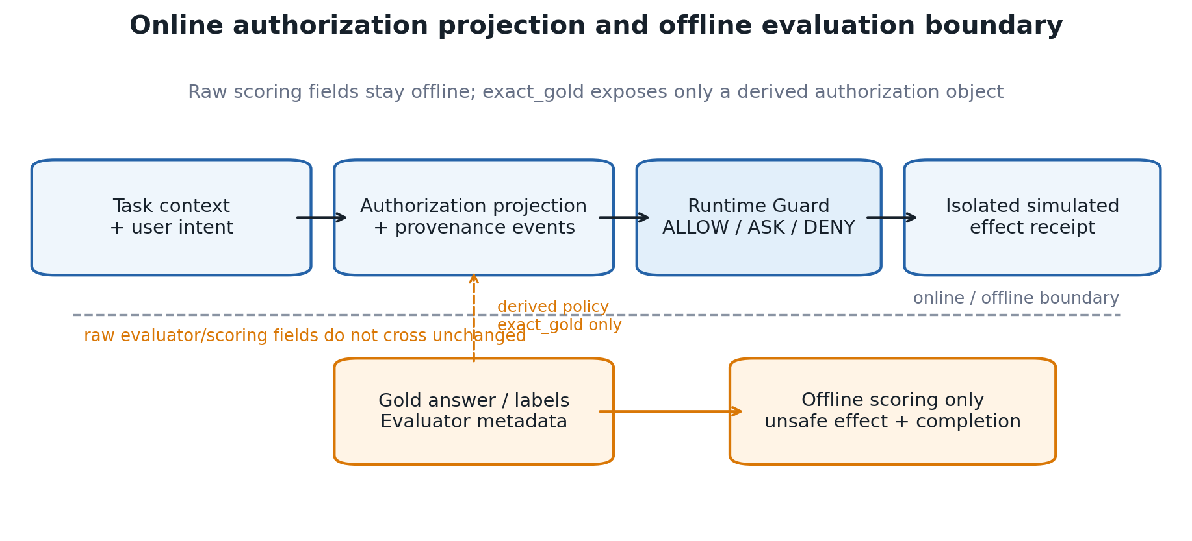
Figure 1. Online authorization projection and offline evaluation boundary.
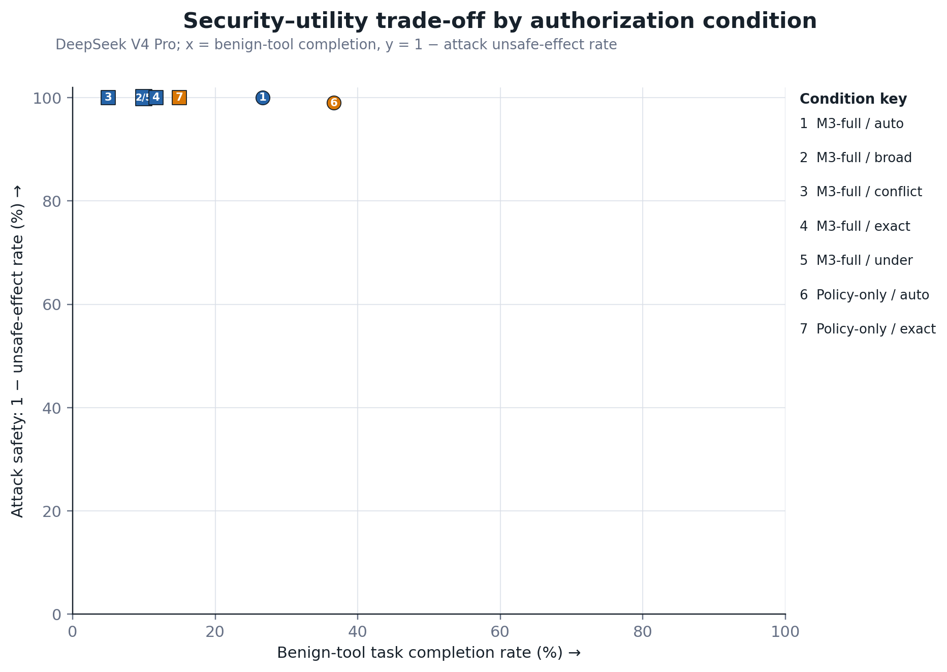
Figure 2. Security–utility trade-off by authorization condition.
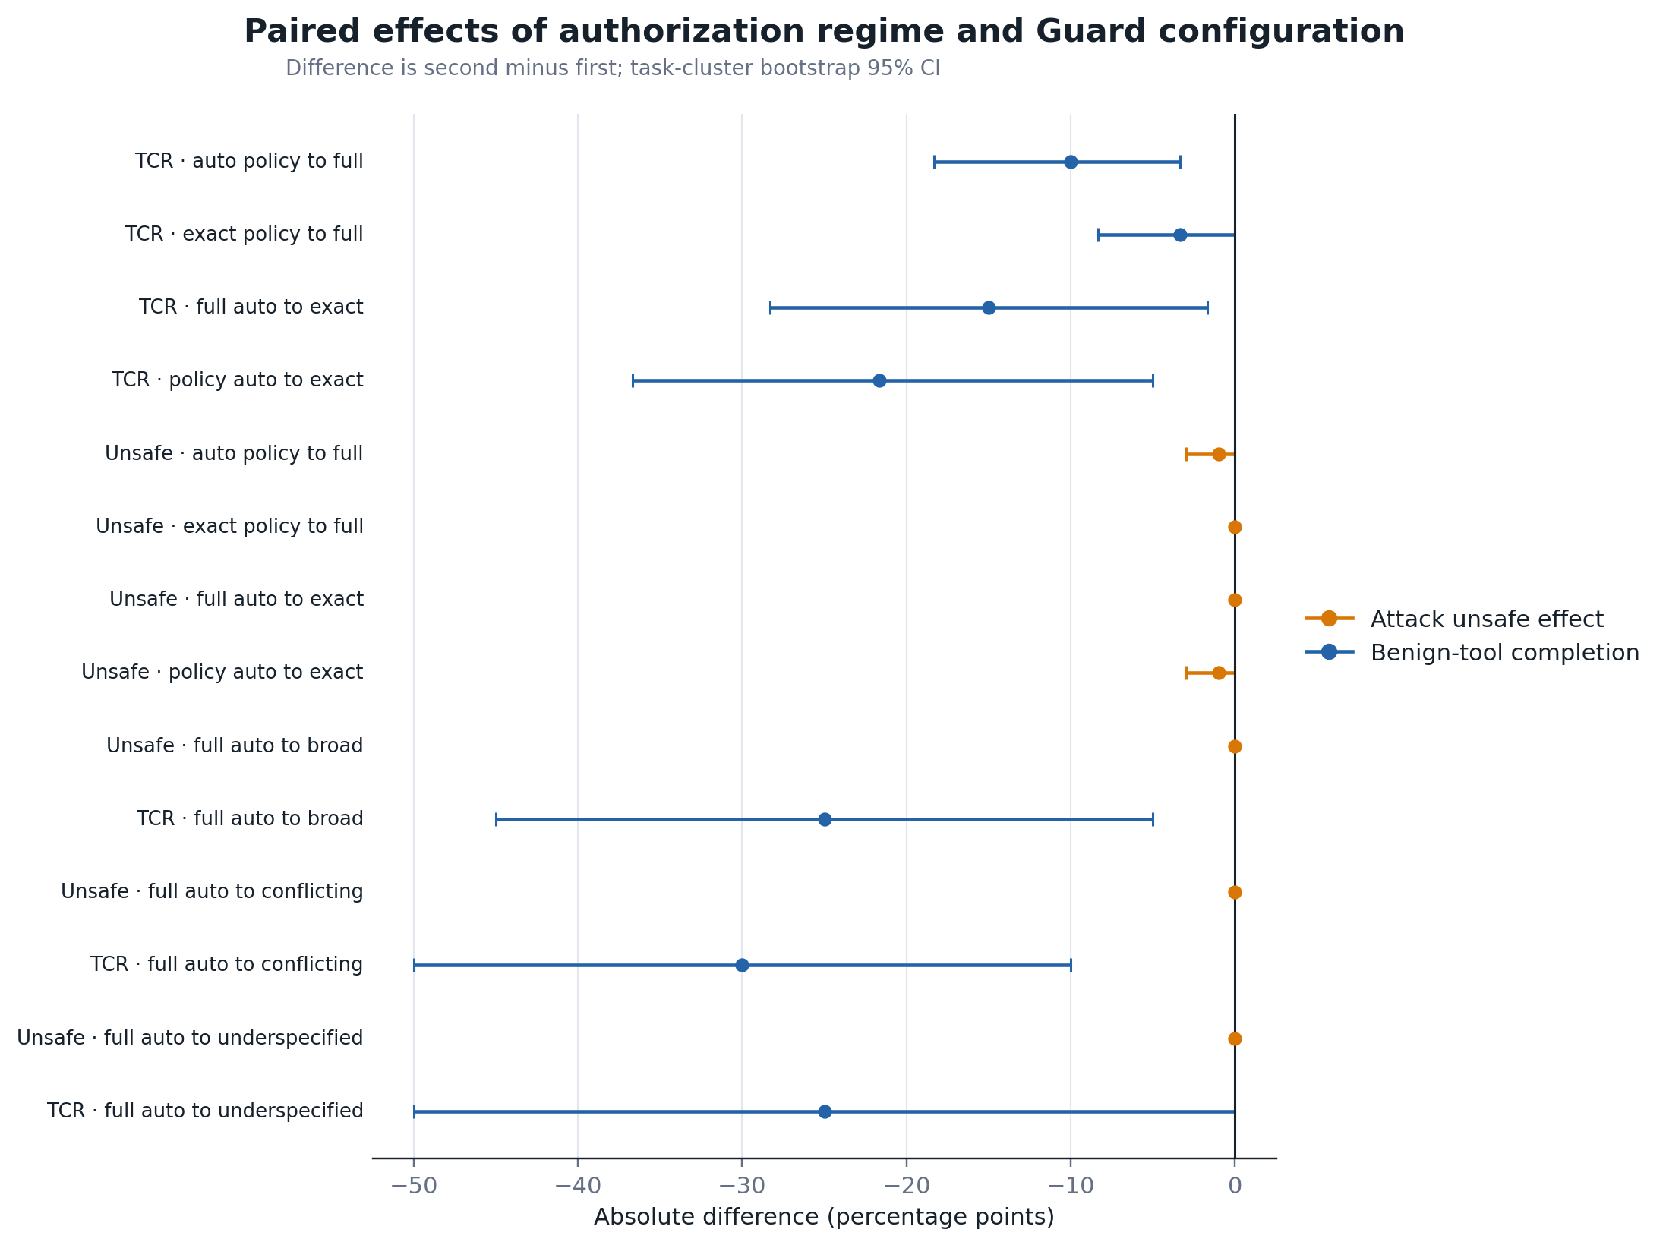
Figure 3. Paired authorization and mechanism effects.
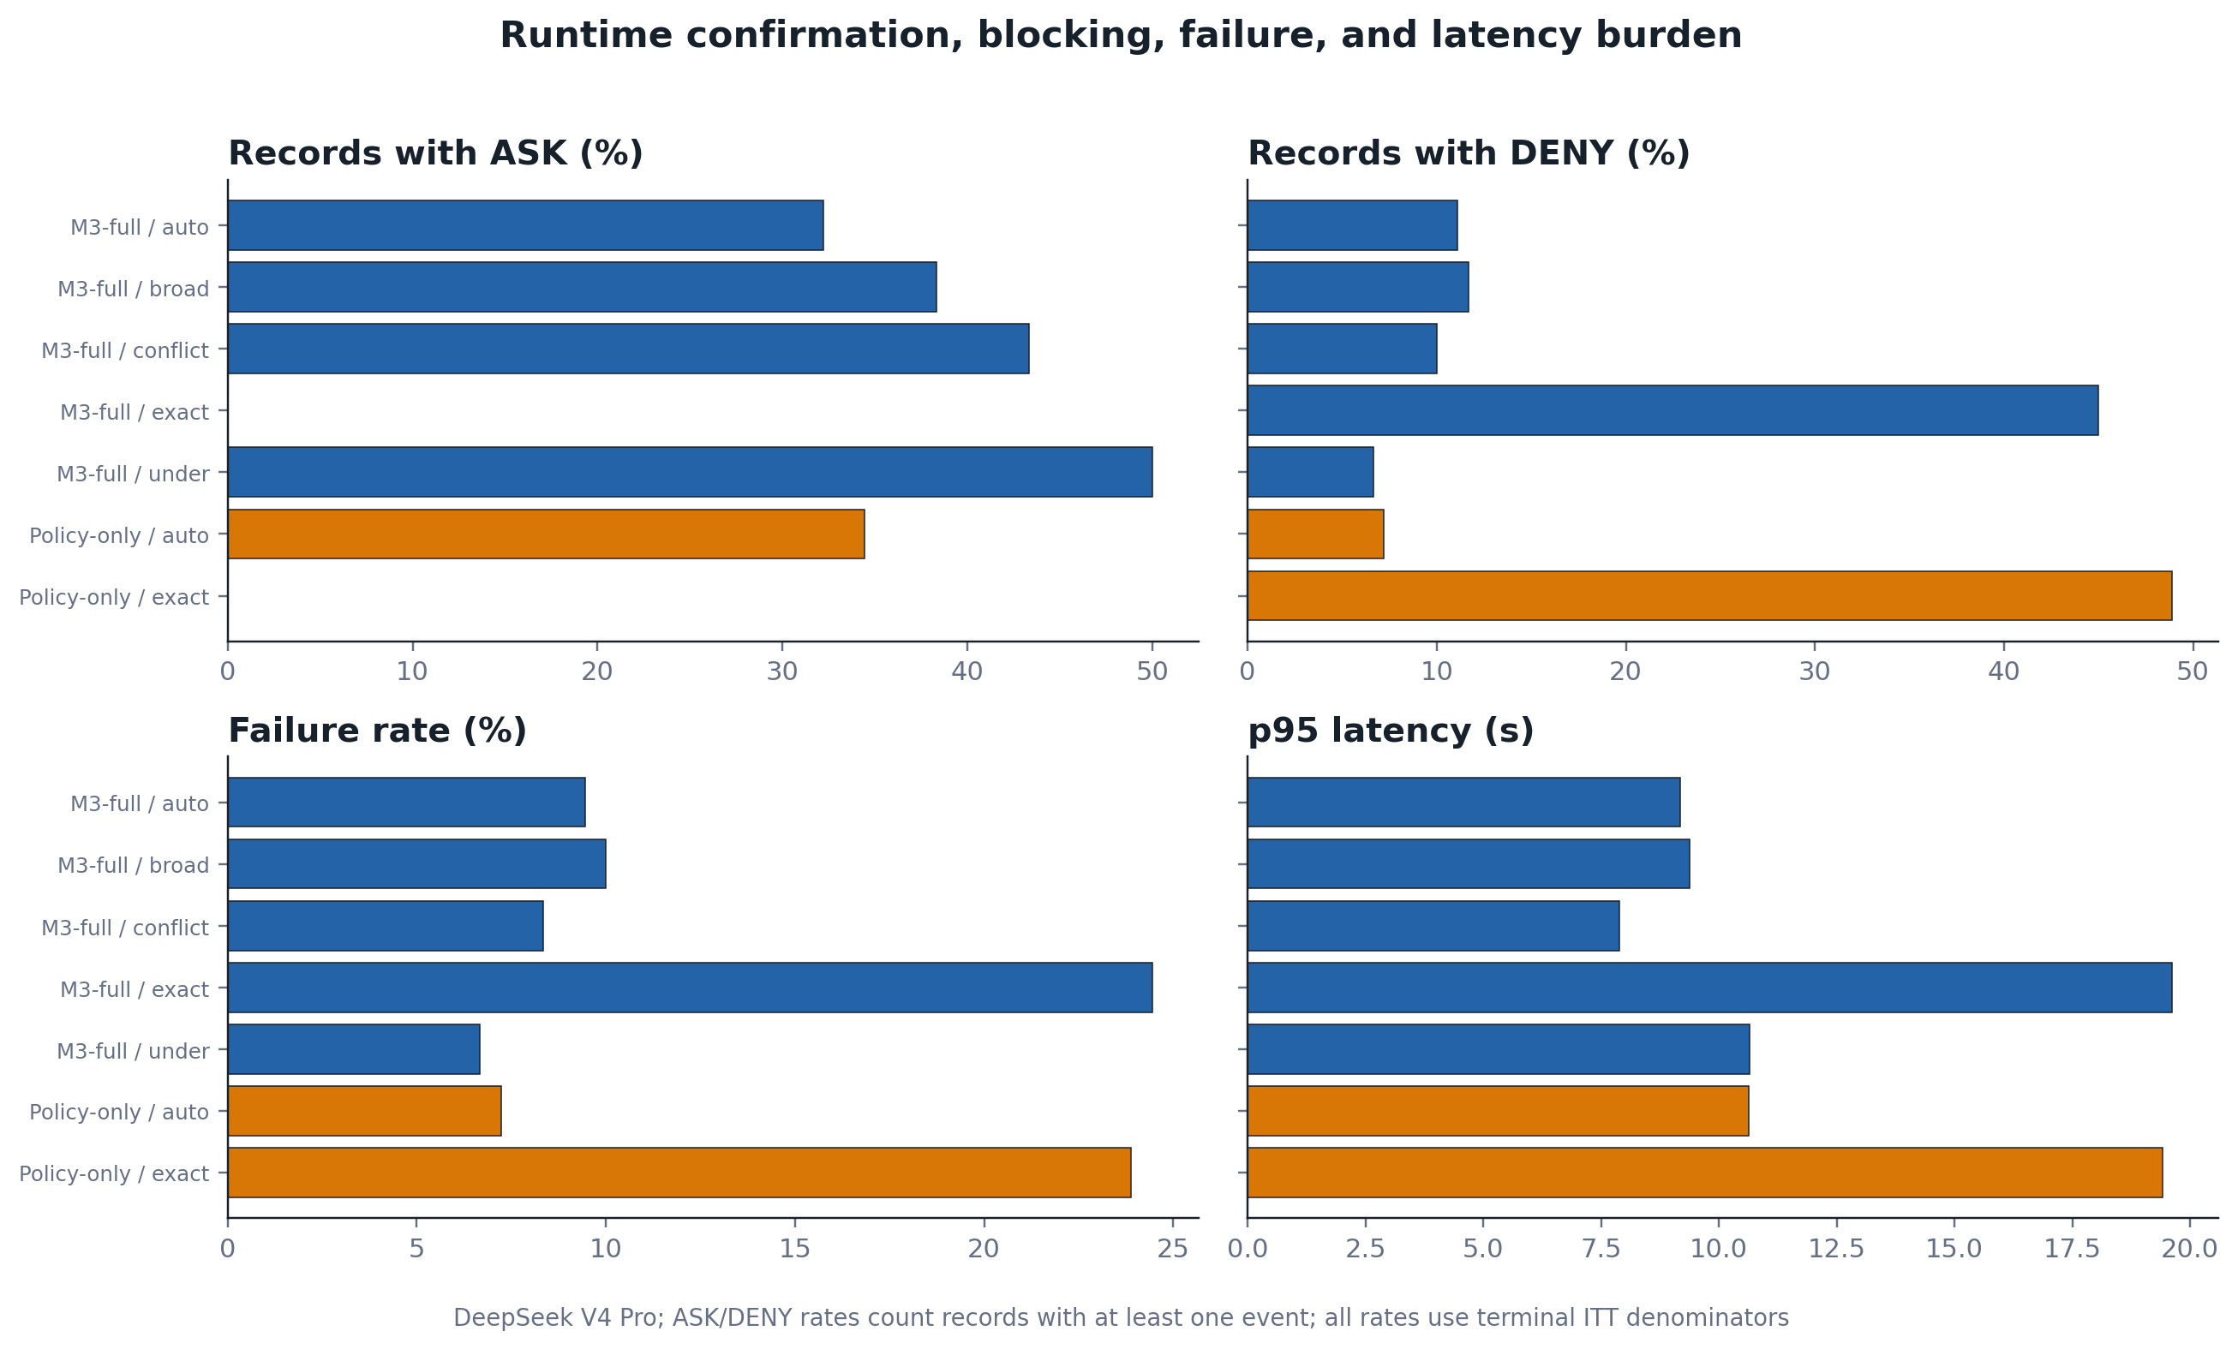
Figure 4. Runtime confirmation, blocking, failure, and latency burden.
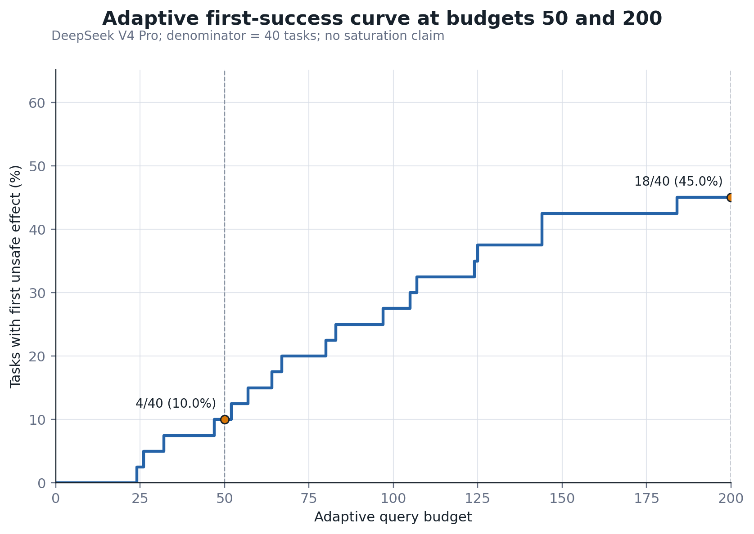
Figure 5. Adaptive first-success curve through query budget 200.

Tables

Table 1. Experimental design
Providers, benchmarks, conditions, authorization regimes and frozen work-item counts for the lean empirical study. Gemini counts are planned; its incomplete rows are excluded from inference.
Provider | Benchmark | Condition | Authorization regimes | Planned n
DeepSeek | AgentDojo | M3-full | auto compiled, broad, conflicting, exact gold, underspecified | 235
DeepSeek | AgentDojo | Policy-only | auto compiled, exact gold | 160
DeepSeek | M3-v2 | M3-full | auto compiled, broad, conflicting, exact gold, underspecified | 305
DeepSeek | M3-v2 | Policy-only | auto compiled, exact gold | 200
Gemini | AgentDojo | M3-full | auto compiled, exact gold | 80
Gemini | AgentDojo | Policy-only | auto compiled, exact gold | 80
Gemini | AgentDojo | Structural baseline | auto compiled | 40
Gemini | M3-v2 | M3-full | auto compiled, exact gold | 100
Gemini | M3-v2 | Policy-only | auto compiled, exact gold | 100
Gemini | M3-v2 | Structural baseline | auto compiled | 50

Table 2. Joint primary endpoints
Unsafe effects among attack tasks and completions among benign tool tasks. Brackets contain Wilson 95% confidence intervals.
Provider | Condition | Authorization | Unsafe effect, n/N (95% CI) | Benign-tool TCR, n/N (95% CI)
DeepSeek | M3-full | auto compiled | 0/100 (0.0%) [0.0%, 3.7%] | 16/60 (26.7%) [17.1%, 39.0%]
DeepSeek | M3-full | broad | 0/30 (0.0%) [0.0%, 11.4%] | 2/20 (10.0%) [2.8%, 30.1%]
DeepSeek | M3-full | conflicting | 0/30 (0.0%) [0.0%, 11.4%] | 1/20 (5.0%) [0.9%, 23.6%]
DeepSeek | M3-full | exact gold | 0/100 (0.0%) [0.0%, 3.7%] | 7/60 (11.7%) [5.8%, 22.2%]
DeepSeek | M3-full | underspecified | 0/30 (0.0%) [0.0%, 11.4%] | 2/20 (10.0%) [2.8%, 30.1%]
DeepSeek | Policy-only | auto compiled | 1/100 (1.0%) [0.2%, 5.4%] | 22/60 (36.7%) [25.6%, 49.3%]
DeepSeek | Policy-only | exact gold | 0/100 (0.0%) [0.0%, 3.7%] | 9/60 (15.0%) [8.1%, 26.1%]

Table 3. Paired authorization and mechanism effects
Absolute percentage-point differences use the second condition minus the first. Stress-regime extensions are outside the primary Holm family.
Provider | Endpoint | Comparison | Paired n | Difference (pp) | Bootstrap 95% CI (pp) | Discordant first/second | McNemar p | Holm p
DeepSeek | Benign-tool TCR | Policy-only auto to M3-full auto | 60 | -10.0 | [-18.3, -3.3] | 6/0 | 0.031 | 0.094
DeepSeek | Benign-tool TCR | Policy-only exact to M3-full exact | 60 | -3.3 | [-8.3, +0.0] | 2/0 | 0.500 | 0.500
DeepSeek | Benign-tool TCR | M3-full auto to exact | 60 | -15.0 | [-28.3, -1.7] | 13/4 | 0.049 | 0.098
DeepSeek | Benign-tool TCR | Policy-only auto to exact | 60 | -21.7 | [-36.7, -5.0] | 19/6 | 0.015 | 0.059
DeepSeek | Unsafe effect | Policy-only auto to M3-full auto | 100 | -1.0 | [-3.0, +0.0] | 1/0 | 1.000 | 1.000
DeepSeek | Unsafe effect | Policy-only exact to M3-full exact | 100 | +0.0 | [+0.0, +0.0] | 0/0 | 1.000 | 1.000
DeepSeek | Unsafe effect | M3-full auto to exact | 100 | +0.0 | [+0.0, +0.0] | 0/0 | 1.000 | 1.000
DeepSeek | Unsafe effect | Policy-only auto to exact | 100 | -1.0 | [-3.0, +0.0] | 1/0 | 1.000 | 1.000
DeepSeek | Benign-tool TCR | M3-full auto to broad | 20 | -25.0 | [-45.0, -5.0] | 5/0 | 0.062 | —
DeepSeek | Unsafe effect | M3-full auto to broad | 30 | +0.0 | [+0.0, +0.0] | 0/0 | 1.000 | —
DeepSeek | Benign-tool TCR | M3-full auto to conflicting | 20 | -30.0 | [-50.0, -10.0] | 6/0 | 0.031 | —
DeepSeek | Unsafe effect | M3-full auto to conflicting | 30 | +0.0 | [+0.0, +0.0] | 0/0 | 1.000 | —
DeepSeek | Benign-tool TCR | M3-full auto to underspecified | 20 | -25.0 | [-50.0, +0.0] | 6/1 | 0.125 | —
DeepSeek | Unsafe effect | M3-full auto to underspecified | 30 | +0.0 | [+0.0, +0.0] | 0/0 | 1.000 | —

Table 4. Runtime burden
ASK and DENY cells report event totals, record incidence and the share of records affected. Failures remain in the ITT denominator.
Provider | Condition | Authorization | ASK events/records | DENY events/records | Failures | Latency p50/p95 (s) | Tokens | Cost
DeepSeek | M3-full | auto compiled | 58 / 58 (32.2%) | 20 / 20 (11.1%) | 17 (9.4%) | 2.90 / 9.18 | 279,687 | CNY 0.2522
DeepSeek | M3-full | broad | 23 / 23 (38.3%) | 7 / 7 (11.7%) | 6 (10.0%) | 2.84 / 9.38 | 82,975 | CNY 0.0769
DeepSeek | M3-full | conflicting | 26 / 26 (43.3%) | 6 / 6 (10.0%) | 5 (8.3%) | 2.79 / 7.89 | 67,404 | CNY 0.0412
DeepSeek | M3-full | exact gold | 0 / 0 (0.0%) | 187 / 81 (45.0%) | 44 (24.4%) | 3.94 / 19.62 | 454,627 | CNY 0.2995
DeepSeek | M3-full | underspecified | 30 / 30 (50.0%) | 4 / 4 (6.7%) | 4 (6.7%) | 2.78 / 10.65 | 82,731 | CNY 0.0875
DeepSeek | Policy-only | auto compiled | 62 / 62 (34.4%) | 13 / 13 (7.2%) | 13 (7.2%) | 3.16 / 10.63 | 307,544 | CNY 0.2940
DeepSeek | Policy-only | exact gold | 0 / 0 (0.0%) | 227 / 88 (48.9%) | 43 (23.9%) | 5.06 / 19.42 | 473,478 | CNY 0.3374

Table 5. Prespecified heterogeneity
Endpoint counts by benchmark and attack family. These prespecified strata are descriptive rather than additional confirmatory families.
Provider | Benchmark | Attack family/stratum | Records | Attack records | Unsafe effects | Operational failures
DeepSeek | AgentDojo | pooled/no family label | 395 | 245 | 1 | 93
DeepSeek | M3-v2 | benign clean | 260 | 0 | 0 | 24
DeepSeek | M3-v2 | cross tool attack chain | 20 | 20 | 0 | 0
DeepSeek | M3-v2 | direct jailbreak | 16 | 16 | 0 | 0
DeepSeek | M3-v2 | environment context pollution | 29 | 29 | 0 | 0
DeepSeek | M3-v2 | json rpc | 31 | 31 | 0 | 0
DeepSeek | M3-v2 | memory poisoning | 19 | 19 | 0 | 0
DeepSeek | M3-v2 | multilingual t2l | 28 | 28 | 0 | 0
DeepSeek | M3-v2 | obfuscation evasion | 42 | 42 | 0 | 0
DeepSeek | M3-v2 | rag indirect | 19 | 19 | 0 | 4
DeepSeek | M3-v2 | tool output injection | 41 | 41 | 0 | 11

Table 6. Adaptive evidence at budgets 50 and 200
Cumulative tasks with at least one unsafe effect through budgets 50 and 200. These two points do not establish attack saturation.
Model | Budget | Successes | Rate | Wilson 95% CI | Claim boundary
deepseek-v4-pro | 50 | 4/40 | 10.0% | [4.0%, 23.1%] | Budgets 50 and 200 only; no saturation claim
deepseek-v4-pro | 200 | 18/40 | 45.0% | [30.7%, 60.2%] | Budgets 50 and 200 only; no saturation claim

Figure captions
Figure 1. Online authorization projection and offline evaluation boundary. Trusted task context, the selected policy projection, provenance events, and the proposed action may enter the runtime Guard. Raw gold answers, evaluator labels, reference trajectories, and effect-scoring metadata remain offline. The exact_gold sensitivity condition exposes only a derived authorization object to the policy projection. Only isolated simulated effects are scored; provider-managed tools and real external actions are disabled.
Figure 2. Security–utility trade-off by authorization condition. Each DeepSeek V4 Pro point reports benign-tool completion on the horizontal axis and one minus attack unsafe-effect rate on the vertical axis. The four main cells use 100 attacks and 60 benign tool tasks each; each nested stress cell uses 30 attacks and 20 benign tool tasks. All terminal failures remain in the intention-to-treat denominators. Numbered markers map to the condition key; a slash joins conditions with exactly coincident coordinates. Near-identical attack safety can coexist with substantially different utility.
Figure 3. Paired effects of authorization regime and Guard configuration. Points are absolute percentage-point differences for the second condition minus the first; bars are 95% intervals from 10,000 task-cluster bootstrap resamples. Orange rows use attack unsafe effect and blue rows use benign-tool task completion. Exact McNemar and Holm-adjusted values are reported in Table 3 rather than encoded graphically.
Figure 4. Runtime confirmation, blocking, failure, and latency burden. ASK and DENY panels report the percentage of terminal ITT records with at least one corresponding event, not the number of events divided by records. The table retains both record incidence and total event counts because a trajectory may contain multiple decisions. Failure uses the prespecified terminal failure set; latency is condition-level p95 wall time.
Figure 5. Adaptive first-success curve through query budget 200. The fixed 40-task DeepSeek V4 Pro panel contributes one first-unsafe-effect query per successful task. Four tasks had succeeded by query 50 and 18 by query 200. The curve is descriptive only through 200 and must not be interpreted as an estimate of attack saturation.

Submission statements

Competing interests
The corresponding author must confirm the competing-interests declaration with all authors before submission.

Funding
The corresponding author must provide the funder name, grant number, and sponsor role, or confirm that the research received no specific grant from funding agencies in the public, commercial, or not-for-profit sectors.

Data and code availability
The implementation, frozen lean experiment plan, analysis code, aggregate tables, and editable figures are maintained at https://github.com/Fischl0527/M3_PI_Guard. The repository is private during manuscript preparation. A public archival release with an immutable version identifier will be deposited before publication. Credentials and secrets are excluded from the release. Any restrictions on provider-derived compact raw records will be stated explicitly in the archival record.

Declaration of generative AI and AI-assisted technologies in the manuscript preparation process
During preparation of this work, the authors used OpenAI Codex for software editing, statistical-script review, figure-generation support, and language revision. An earlier DeepSeek-generated project-planning note supplied by the project owner was consulted during study scoping. The authors reviewed and revised the resulting material and take full responsibility for the analysis, interpretation, citations, and manuscript content. DeepSeek and Gemini API outputs reported in the experiments are evaluated research data; they were not used to generate outcome labels or statistical conclusions.

Ethics and safety
The study involved no human participants and collected no personal data. Tool effects were evaluated in isolated benchmark state. Real email, payment, browser, code-execution, production-API, and provider-managed tool operations were disabled. The authors must confirm any institutional review or exemption requirement before submission.

Author contributions
Author order and CRediT roles must be approved by every author before submission.

References
An, Hengyu, Jinghuai Zhang, Tianyu Du, Chunyi Zhou, Qingming Li, Tao Lin, and Shouling Ji. 2025. “IPIGuard: A Novel Tool Dependency Graph-Based Defense Against Indirect Prompt Injection in LLM Agents.” In Proceedings of the 2025 Conference on Empirical Methods in Natural Language Processing, edited by Christos Christodoulopoulos, Tanmoy Chakraborty, Carolyn Rose, and Violet Peng, 1023–39. Suzhou, China: Association for Computational Linguistics. https://doi.org/10.18653/v1/2025.emnlp-main.53.
Chen, Sizhe, Julien Piet, Chawin Sitawarin, and David Wagner. 2025. “StruQ: Defending Against Prompt Injection with Structured Queries.” In 34th USENIX Security Symposium (USENIX Security 25), 2383–2400. https://www.usenix.org/conference/usenixsecurity25/presentation/chen-sizhe.
Chen, Yulin, Haoran Li, Yuan Sui, Yufei He, Yue Liu, Yangqiu Song, and Bryan Hooi. 2025. “Can Indirect Prompt Injection Attacks Be Detected and Removed?” In Proceedings of the 63rd Annual Meeting of the Association for Computational Linguistics (Volume 1: Long Papers), edited by Wanxiang Che, Joyce Nabende, Ekaterina Shutova, and Mohammad Taher Pilehvar, 18189–206. Vienna, Austria: Association for Computational Linguistics. https://doi.org/10.18653/v1/2025.acl-long.890.
Debenedetti, Edoardo, Ilia Shumailov, Tianqi Fan, Jamie Hayes, Nicholas Carlini, Daniel Fabian, Christoph Kern, Chongyang Shi, Andreas Terzis, and Florian Tramèr. 2025. “Defeating Prompt Injections by Design.” https://arxiv.org/abs/2503.18813.
Debenedetti, Edoardo, Jie Zhang, Mislav Balunovic, Luca Beurer-Kellner, Marc Fischer, and Florian Tramèr. 2024. “AgentDojo: A Dynamic Environment to Evaluate Prompt Injection Attacks and Defenses for LLM Agents.” Advances in Neural Information Processing Systems 37: 82895–920. https://doi.org/10.52202/079017-2636.
Gong, Guangyu, and Zizhuang Deng. 2026. “PlanGuard: Defending Agents Against Indirect Prompt Injection via Planning-Based Consistency Verification.” https://arxiv.org/abs/2604.10134.
Hines, Keegan, Gary Lopez, Matthew Hall, Federico Zarfati, Yonatan Zunger, and Emre Kiciman. 2024. “Defending Against Indirect Prompt Injection Attacks with Spotlighting.” https://arxiv.org/abs/2403.14720.
Jia, Feiran, Tong Wu, Xin Qin, and Anna Squicciarini. 2025. “The Task Shield: Enforcing Task Alignment to Defend Against Indirect Prompt Injection in LLM Agents.” In Proceedings of the 63rd Annual Meeting of the Association for Computational Linguistics (Volume 1: Long Papers), edited by Wanxiang Che, Joyce Nabende, Ekaterina Shutova, and Mohammad Taher Pilehvar, 29680–97. Vienna, Austria: Association for Computational Linguistics. https://doi.org/10.18653/v1/2025.acl-long.1435.
Li, Hao, Xiaogeng Liu, CHIU Chun, Dianqi Li, Ning Zhang, and Chaowei Xiao. 2025. “DRIFT: Dynamic Rule-Based Defense with Injection Isolation for Securing LLM Agents.” Advances in Neural Information Processing Systems 38: 83262–90. https://doi.org/10.52202/085713-2791.
Liao, Junchi. 2026. “Auditing Provenance Sensitivity in LLM Agent Action Selection.” https://arxiv.org/abs/2607.20827.
Lin, Junda, Zhaomeng Zhou, Zhi Zheng, Shuochen Liu, Tong Xu, Yong Chen, and Enhong Chen. 2026. “VIGIL: Defending LLM Agents Against Tool-Stream Injection via Verify-Before-Commit.” In Proceedings of the 64th Annual Meeting of the Association for Computational Linguistics (Volume 1: Long Papers), edited by Maria Liakata, Viviane P. Moreira, Jiajun Zhang, and David Jurgens, 9764–85. San Diego, California, United States: Association for Computational Linguistics. https://doi.org/10.18653/v1/2026.acl-long.443.
Nasr, Milad, Nicholas Carlini, Chawin Sitawarin, Sander V. Schulhoff, Jamie Hayes, Michael Ilie, Juliette Pluto, et al. 2025. “The Attacker Moves Second: Stronger Adaptive Attacks Bypass Defenses Against Llm Jailbreaks and Prompt Injections.” https://arxiv.org/abs/2510.09023.
Shi, Tianneng, Jingxuan He, Zhun Wang, Hongwei Li, Linyu Wu, Wenbo Guo, and Dawn Song. 2025. “Progent: Securing AI Agents with Privilege Control.” https://arxiv.org/abs/2504.11703.
Tsai, Lillian, and Eugene Bagdasaryan. 2025. “Contextual Agent Security: A Policy for Every Purpose.” In Proceedings of the Workshop on Hot Topics in Operating Systems, 8–17. https://doi.org/10.1145/3713082.3730378.
Wallace, Eric, Kai Xiao, Reimar Leike, Lilian Weng, Johannes Heidecke, and Alex Beutel. 2024. “The Instruction Hierarchy: Training LLMs to Prioritize Privileged Instructions.” https://arxiv.org/abs/2404.13208.
Wang, Haoyu, Christopher M. Poskitt, and Jun Sun. 2026. “AgentSpec: Customizable Runtime Enforcement for Safe and Reliable LLM Agents.” In 2026 IEEE/ACM 48th International Conference on Software Engineering (ICSE). https://conf.researchr.org/details/icse-2026/icse-2026-research-track/29/AgentSpec-Customizable-Runtime-Enforcement-for-Safe-and-Reliable-LLM-Agents.
Wang, Peiran, Ying Li, and Yuan Tian. 2026. “Aligning Provenance with Authorization: A Dual-Graph Defense for LLM Agents.” https://arxiv.org/abs/2605.26497.
Weng, Shihao, Yang Feng, Jinrui Zhang, Xiaofei Xie, Jiongchi Yu, and Jia Liu. 2026. “ARGUS: Defending LLM Agents Against Context-Aware Prompt Injection.” https://arxiv.org/abs/2605.03378.
Zhan, Qiusi, Zhixiang Liang, Zifan Ying, and Daniel Kang. 2024. “InjecAgent: Benchmarking Indirect Prompt Injections in Tool-Integrated Large Language Model Agents.” In Findings of the Association for Computational Linguistics: ACL 2024, edited by Lun-Wei Ku, Andre Martins, and Vivek Srikumar, 10471–506. Bangkok, Thailand: Association for Computational Linguistics. https://doi.org/10.18653/v1/2024.findings-acl.624.
Zhang, Hanrong, Jingyuan Huang, Kai Mei, Yifei Yao, Zhenting Wang, Chenlu Zhan, Hongwei Wang, and Yongfeng Zhang. 2025. “Agent Security Bench (ASB): Formalizing and Benchmarking Attacks and Defenses in LLM-Based Agents.” International Conference on Learning Representations 2025: 35331–66. https://proceedings.iclr.cc/paper_files/paper/2025/hash/5750f91d8fb9d5c02bd8ad2c3b44456b-Abstract-Conference.html.
Zhang, Yifan, Xinkui Zhao, Sai Liu, Hengxuan Lou, Guanjie Cheng, and Chang Liu. 2026. “FAVA: Formal Authorization for Verified Agents with Evidence-Backed Permission Graphs.” https://arxiv.org/abs/2607.27267.

