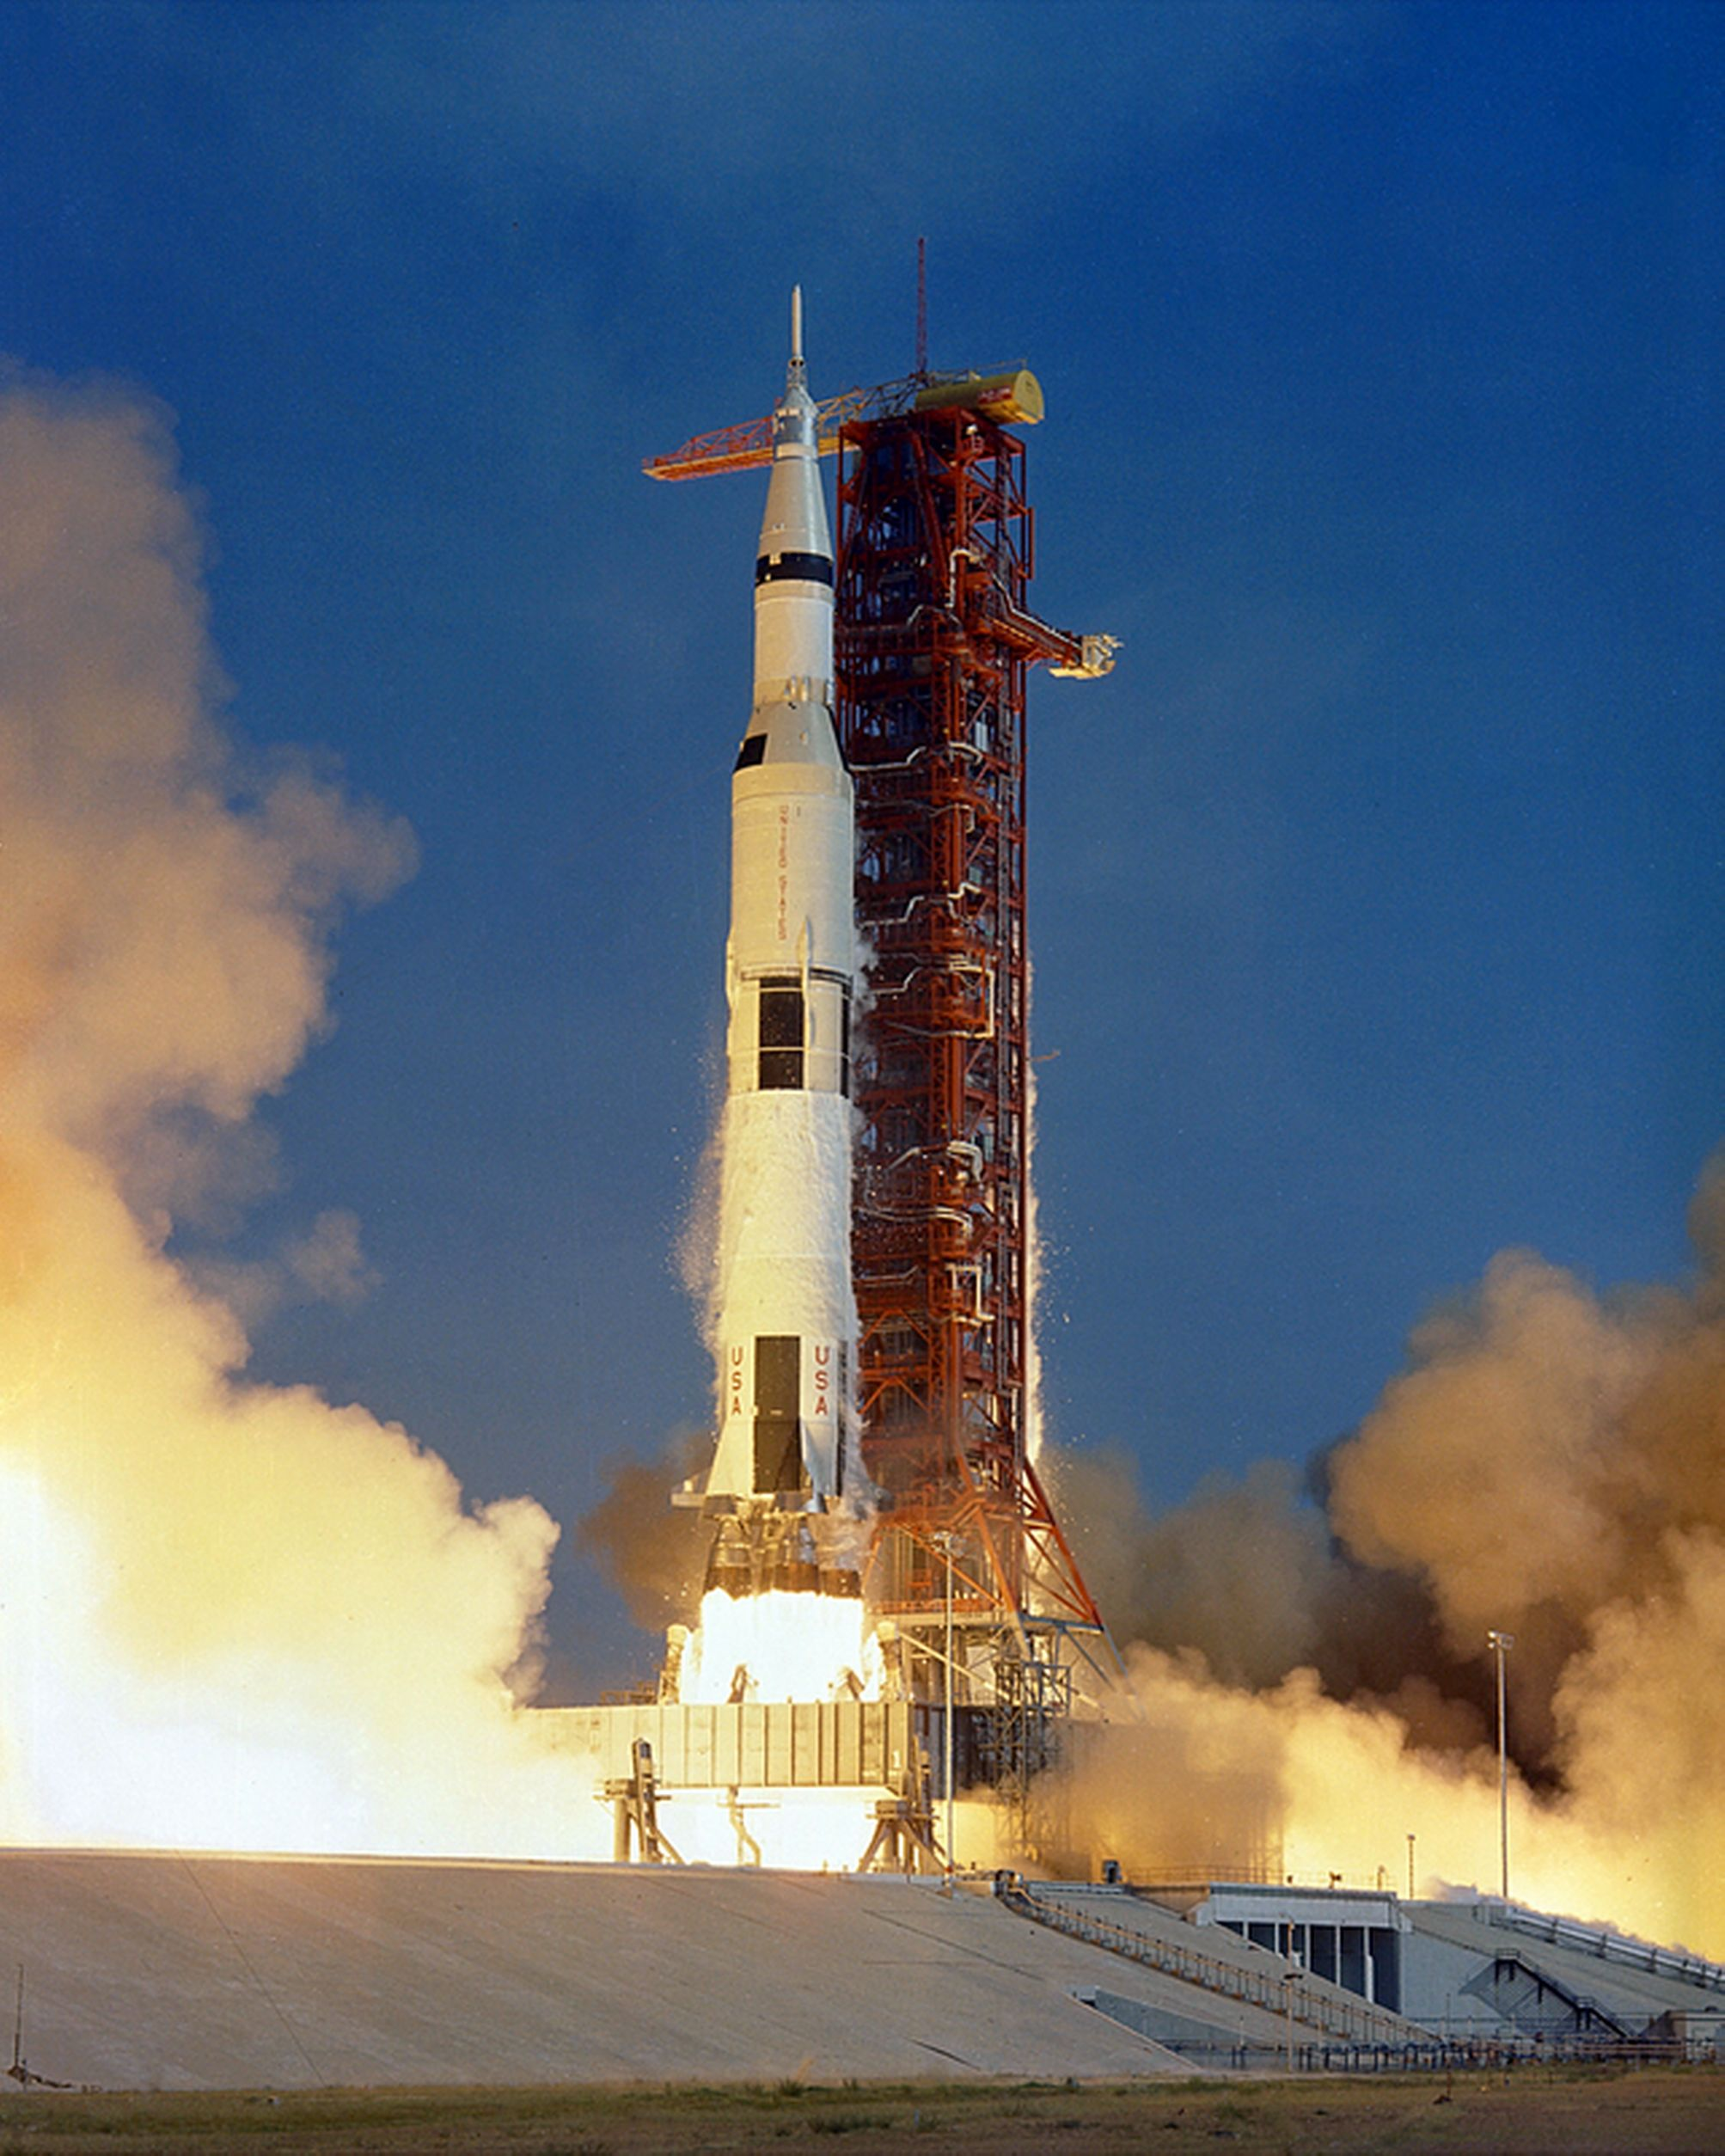
Apollo – Saturn V Rocket

