FISCUS
Brand Identity System
Three Logo Concepts · Rationale · Usage
About These Concepts
Fiscus is positioned at the intersection of elite financial intelligence and consumer-grade accessibility — think Bloomberg terminal meets TikTok for the next generation of investors. These three logo concepts capture different facets of that positioning, from editorial authority to digital-first immediacy to full brand expression.
Each logo is built around the same brand DNA: dark navy depth, warm gold authority, and the visual language of ascending markets. They are designed to work at every scale — from a 16×16 app icon to a full-bleed billboard.

01
The Wordmark
Text Logo · Editorial Contexts · Headlines

Rationale
The Fiscus wordmark draws from the visual language of the world's most trusted financial mastheads — the Financial Times, Bloomberg, and the Wall Street Journal. "FISCUS" in tracked, all-caps serif is immediately authoritative. The warm gold gradient (moving from amber to sunlight) gives it warmth that hard-edged financial brands lack.
Below the letterforms, a thin rising line — a chart sparkline compressed into a single elegant stroke — traces an upward path before lifting off the baseline entirely. It does not announce itself loudly. It simply implies what Fiscus does: it maps the trajectory of value, and it rises.
"FINANCIAL INTELLIGENCE" in widely-spaced small caps grounds the mark in purpose without competing with the brand name.
Best used for:
App headers and navigation bars · Press materials · Co-branding partnerships · Email headers · Website wordmarks

02
The App Icon
Icon Mark · App Stores · Favicons · Small Formats
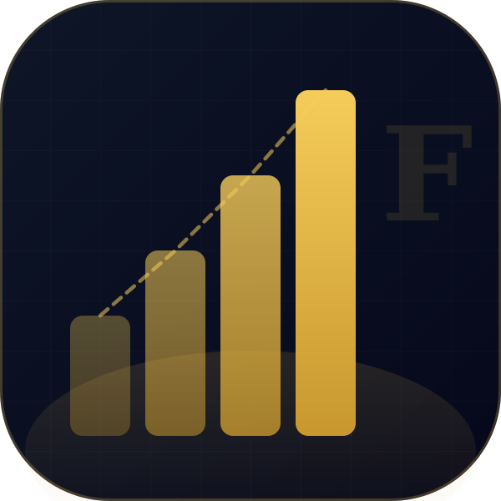
Rationale
The app icon is the moment of truth for a mobile-first brand. It must communicate everything in a 1cm square and survive being seen against hundreds of other icons on a home screen. The Fiscus icon achieves this through a single visual idea executed with precision: four bars, ascending.
This is not a generic bar chart. The bars are weighted and graduated in opacity — each bar is taller, brighter, and more certain than the last. The overall effect reads as momentum. As trajectory. As the quiet confidence of someone who always knows where markets are heading because they've already read Fiscus.
The dark navy background — deeper than midnight — gives the gold bars cinematic contrast. It's a look that belongs on a screen, in a pocket, in the hands of someone who takes their financial future seriously. The subtle "F" ghost in the top-right corner rewards those who look closely.
Best used for:
iOS & Android app icon · Browser favicon · Push notification icon · Watch app · Social media profile picture

03
The Brand Logo
Full Brand Expression · Marketing · Presentations · Pitch Decks

Rationale
The brand logo is the complete system in one mark. The icon and wordmark sit in a lock-up separated by a thin vertical gold line — a visual seam that unites two things: the visual language of markets (the bars) and the verbal authority of the name.
The tagline "YOUR EDGE. EVERY MARKET." sits below the wordmark in widely-spaced small caps. These four words encode the entire Fiscus value proposition: personalised intelligence (YOUR), continuous superiority (EDGE), comprehensive coverage (EVERY), completeness (MARKET). It is a declaration, not a description.
Used together, the icon and wordmark communicate more than either can alone: this is a digital-first brand that respects the weight of money, the gravity of markets, and the intelligence of its users.
Best used for:
Investor presentations · Marketing materials · Social media headers · App store screenshots · Press kits · Partnership decks

Brand Foundations
Colour
GOLD (Primary) #E8B84B · The voice of authority, reward, and premium access.
NAVY (Background) #05081A · Depth, trust, and the feeling of premium dark mode.
GREEN (Gain) #22D48A · Used exclusively for positive market movements.
RED (Loss) #FF4F4F · Used exclusively for negative market movements.
Typography
Playfair Display Serif · Headlines, brand names, and editorial moments. The voice of gravitas.
Plus Jakarta Sans Sans-serif · UI text, body copy, labels. Clean, modern, legible.
IBM Plex Mono Mono · All numbers, prices, percentages, and ticker symbols.
Brand Voice
Fiscus speaks like the smartest person in the room who doesn't need to prove it. Authoritative but never arrogant. Data-driven but never dry. We speak in facts, frame in context, and let the user feel smarter for having read us. We are their edge.
Fiscus · Brand Identity · Confidential

