Example 5A

**Tell me number if the parameter is 687**

# The secret room

As input your function will receive an integer - the total number of doors in the current room. You will need to sort the door numbers in the order in which these numbers, expressed in words, go in the alphabetical order. And then return the position number of the last door (the door with the highest number). The count starts from the 1st position (not from the 0th). The maximum number of doors is 1000. The numbers after 100 are written in the format like - 'one hundred twenty nine'.

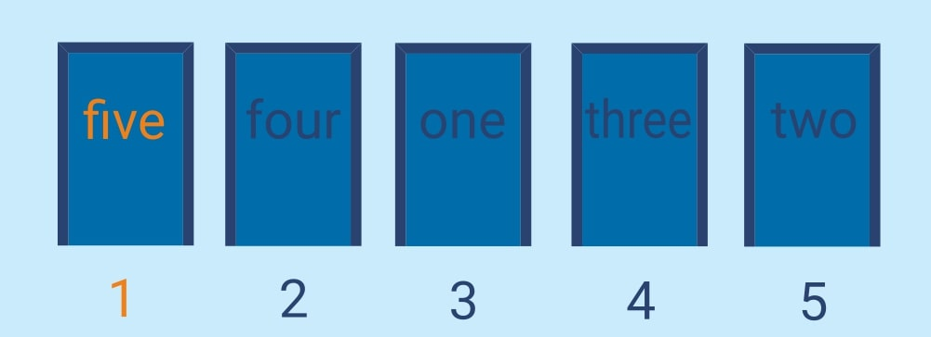

Input: the door number.

Output: the 'right' door number.

Example:

secret_room(5) == 1, #five, four, one, three, two

secret_room(3) == 2, #one, three, two

secret_room(1000) == 551

3

How it is used: For the work with numbers in their alphabetical representation.

Precondition:  
2 <= amount of the doors <= 1000