**Fiserv Onboarding Experience Application**

**User Manual**

**Table of Contents**

1. **Introduction** ……………………………………………………………………... Page 3
2. **User Registration** ………………………………………………………………... Page 3
3. **Application Interface** ……………………………………………………………. Page 4

.1 First Time Login / Teaser Screen

.2 App Tutorial

.3 Home Page

.4 Profile Page

.4.1 Send Introduction

.4.2 Change User Icons

.5 Settings Page

.5.1 Light and Dark Mode

.5.2 Themes

1. **FAQs** …………………………………………………………………………….. Page 8
2. **Onboarding** ……………………………………………………………………… Page 9

.1 General Checklist

.2 Modules

.3 Quiz Tasks

1. **Reward System** …………………………………………………………………. Page 10

.1 Experience

.2 Unlock Themes / Icons

.3 Ranking System

1. **Contact and Support** …………………………………………………………… Page 12
2. **Introduction**

This onboarding application is designed exclusively for new employees at Fiserv. It is accessible on all Android devices and is intended to provide a structured and engaging learning experience. We have gamified the onboarding process to enhance the engagement of new employees, allowing them to prepare for their first day, up to the ninetieth day. With daily and weekly tasks that can be tracked, our application ensures they stay on course to complete their tasks.

1. **User Registration**

As a new employee, you will be given a new account before you start your onboarding.

**How to reset your password**

On the top right of the screen (application bar), press ‘’ this icon. Press the ‘Settings’ option, and it will direct you to the settings page. Click on ‘Change password’ and enter your registered email on the Fiserv Application to reset your password.

**Step 1 Step 2 Step 3 Step 4**

1. **Application Interface**
2. ***First-Time Login / Teaser Screen***

When it is the employee's first time logging in, they are welcomed with a teaser that introduces both the company and provides a preview of the application’s features.

1. ***App Tutorial***

When it is the employee's first time logging in, an instructional guide is shown to help navigate the application.

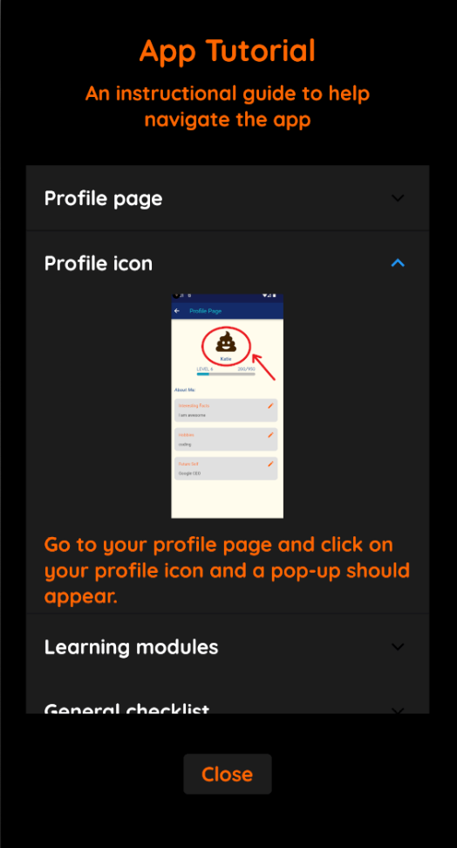 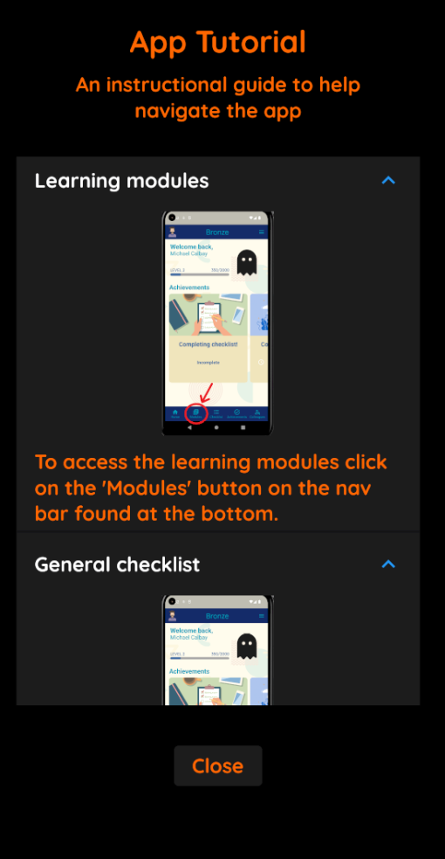

1. ***Home Page***

This is the primary home page. It is accessible by clicking  this button on the bottom left of the screen (navigation bar). The home page shows the user icon, an experience bar, and a horizontally scrollable achievements panel to keep track of your achievements.

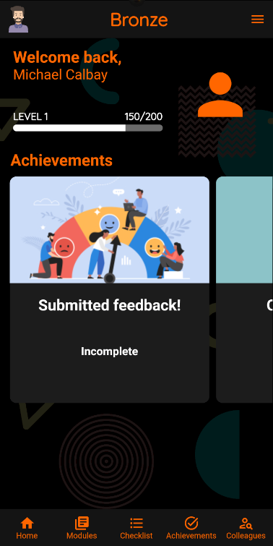

1. ***Profile Page***

This is the profile page. It is accessible by clicking ‘’ this user icon on the top right of the screen (application bar). Then it will direct you to the profile page which contains the user icon, name, experience bar and an about me section where you can send an introduction to your employees.

* 1. ***Send Introduction***

To send an introduction, navigate to the profile page (III.4), where you can complete the necessary text fields about yourself. Click on the button pencil icon on the right to edit, and once you’re finished, simply click ‘Send Introduction’. Your introduction will then be automatically generated in a PDF format and sent to your employees!

* 1. ***Change User Icons***

To change your icon, navigate to the profile page (III.4), and press the icon above your name. Then a popup of your unlocked icons will be displayed, and you can change to whatever desired icon by simply clicking on the icon!

1. ***Settings Page***

Anytime on your application, simply click ‘’ this icon on the top right of your screen (application bar), then press ‘Settings’, which will direct you to the settings page. Within this page, you can edit features with buttons ‘Light/dark mode’, ‘Themes’ and ‘Change password’.

***5.1 Light and Dark Mode***

You can enable light/dark mode to adjust to your phone settings or manually enable light/dark mode.

**OS Dark mode Light Mode enabled**

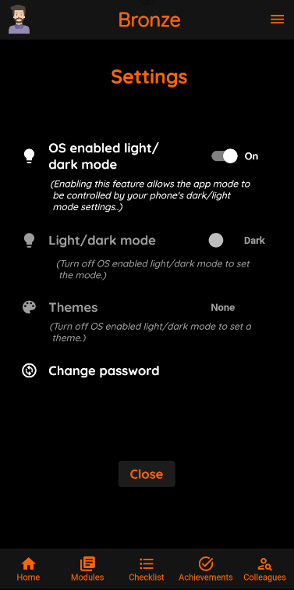

***5.2 Themes***

You can customize the application's appearance by accessing the Themes feature on the Settings Page (III.5). Simply click 'Themes' to be directed to the themes page, choose your preferred theme, and it will be automatically applied to the application.

Disclaimer: light/dark mode is considered a standalone theme; it will override the theme if chosen. There are no light/dark versions of a theme.

1. **FAQs**

You can navigate to the FAQ page by simply clicking ‘’ this button on the top right of the screen, then click on ‘FAQ’ which will direct you to the FAQ page. If you click on a question, it will expand, providing you with a detailed explanation.

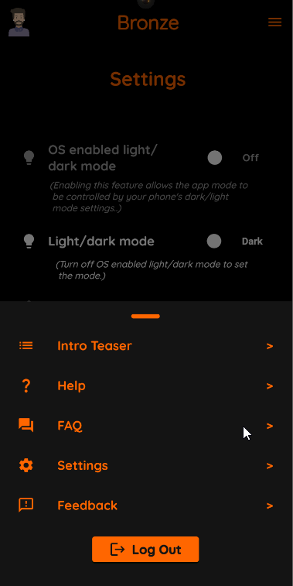 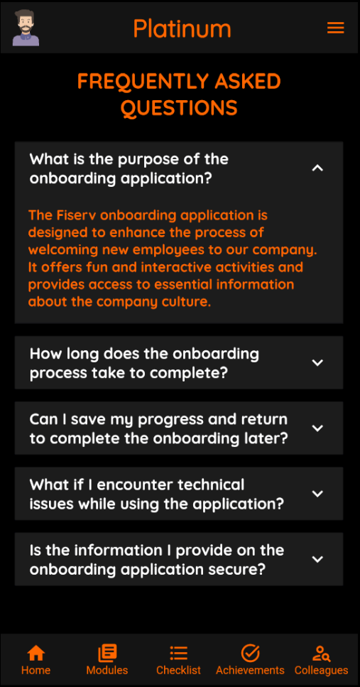 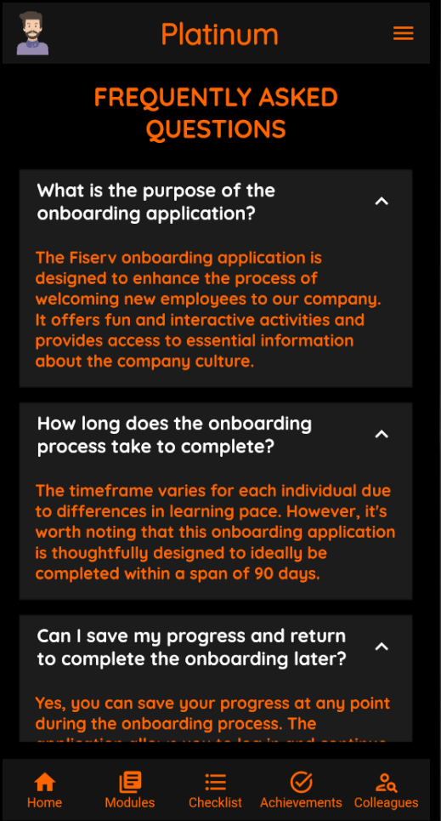

1. **Onboarding**

***5.1 General Checklist***

Simply tap the ‘Checklist’ button located in the center-bottom of the screen ‘’, and it will lead you to the general checklist page. Here, you can easily mark tasks as completed to keep track of your progress.

* 1. ***Modules***

Simply click on ‘Modules’ located at the center-bottom of the screen ‘’ and complete the tasks. There are watching tasks, reading tasks, and quiz tasks.

**Modules Watch Task Read Task Quiz Task**

* 1. ***Quiz Tasks***

Within the modules, you'll encounter quiz tasks, and gain exp after completing them.

1. **Reward System**

***6.1 Experience***

Gain experience by doing modules and level up! The maximum level you can obtain is 9.

* 1. ***Unlock Themes / Icons***

Earn experience to unlock themes and icons. You'll gain access to a new theme every 3rd, 6th, and 9th level, and you'll unlock a new icon with every level you achieve!

**Level 1 Level 9**

* 1. **Ranking System**

At levels 3, 6, and 9, you'll attain a new ranking, which will be displayed at the center-top of your screen!

**Bronze (level 1) Silver (level 3) Gold (level 6) Platinum (level 9)**

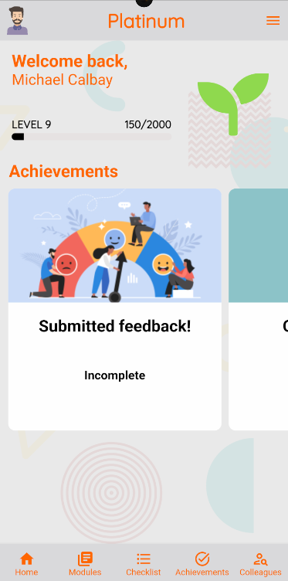

1. **Contact and Support**

For access to customer support or colleague information, it's as easy as clicking 'Colleagues' situated in the bottom-right corner of the screen. Then, simply select a colleague to view their phone number and email address. If you tap their phone number, it will take you to your phone app with the number pre-filled, and clicking the email will open your Gmail with their email address ready to go.

 